844-802-1599 – Main Office

THANK YOU for purchasing one of our LAPTOP CUBBYS

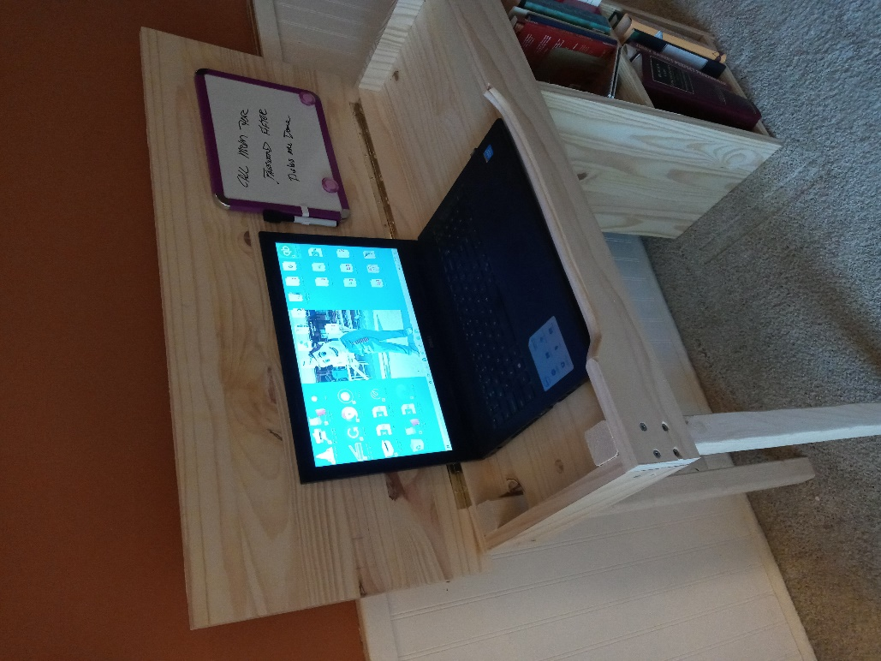

This really is an easy assembly; you will have to make sure which side you want the laptop and bookshelves on – YOUR Right or YOUR Left. In these directions the laptop will sit on the left, while the bookshelves side on the right. If you wish to have everything turned around just put the bookshelves on the left and flip the laptop front to sit on the right. For the sake of these instructions, we have placed the laptop on the left/bookshelves on the right. There are many options for you to choose while setting up this beautiful desk.

**READ THESE INSTRUCTIONS BEFORE ASSEMBLING THIS ITEM**

Need to take everything out of the box to make sure we got it all.

You get:

2 – (1x12) sides, one side is longer than the other – this side goes on the OUTSIDE, while the shorter in size goes into the middle to hold the bookshelves together.

1 – 1x16x36 Top

7 – Brackets, the shorter brackets (5) hold the shelf of the bookshelves together and holds the table top the laptop sits on in place, longer ones are for where the laptop sits (2).

2 – 2x2 legs

1 – Front plate, the cutout one is where the laptop goes

1 – Back Plate, solid no cutout.

1 – smaller plate for the leg side on the desk.

30 – 1-1/4” Screws 18 – 1-5/8 Screws

YOU WILL NEED: A Phillip Screwdriver and a tape measure (ruler)

Let’s have some fun!

Step 1) You will want to start by assembling the brackets to the sides of the 1x12 boards that hold the desk up and are used as the bookshelves. This is where you will need the ruler to adjust the bookshelves to the height you wish to have them. Start at the bottom and measure upward.

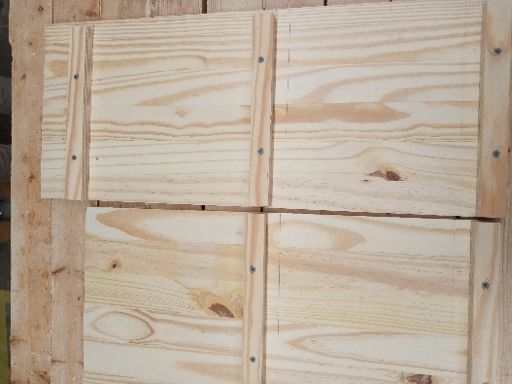 Pencil mark where you want the shelves to go, making sure they are level across the boards. Once you know what side you want to put the bookshelves on when you are done, Left or right, then indent the brackets for the front side of your bookshelves. So the brackets should go flush with the backside of the 1x12 when standing the way you wish to have the bookshelf on. Then using two 1-1/4” screws into each bracket. The upper bracket on the long outside board needs to be able to hold the laptop board in place. This bracket will go down 3-1/2” from the top.

STEP 2) Putting the shelves in place. Using 6 of the 1-1/4” Screws (3 per side) start with the bottom shelf, and screw the shelf to the bracket then work your way up to the second shelf and screw in those 6 1-1/4” screws.

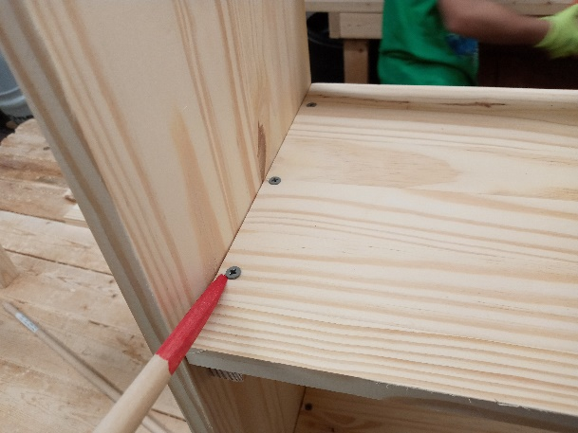

STEP 3) You’re on home street now… Almost done!

You want to be careful and screw in the front and back side panels, depending on where you want your laptop cubby hole.

Using 6 1-5/8” Screws, screw the panels into the shelf unit and the small side plate, plus the 2x2 leg.

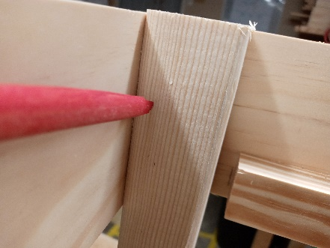 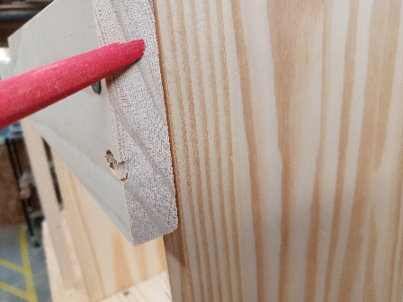

STEP 4) Once the legs, side panel and the bookshelves are attached together you will need to attach the two longer brackets to the front and back panels at the bottom of the panels as shown above.

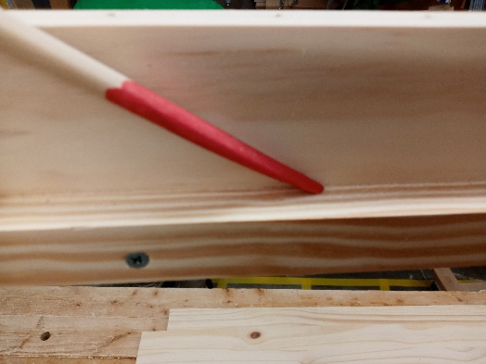

STEP 5) All you must do now is insert the 1x12 cutout that has the hole and 2x2 cutouts in it to the desk. This is what the laptop sits on. This has an extra wide holes in the 2x2 area for air vents for the air to flow in the drawer for the laptop.

STEP 6) Attaching the top with the piano hinge. Now this becomes a little tricky as some like an overhang in the back and some don’t. I like a inch overhang so you measure out an inch from the backside of the 1x16 (come in) and then center the hinge on the 1x16 and then screw it to the top or the back of the back plate. Either way that will work.

STEP 7) Follow the instructions on the LIFT TOP BRACKET (Brass Plated) to assemble the locking parts of the top and side of the desk what suits you the best. Some like it on the left, some on the right so again we give you this option.

**REMEMBER: THIS DEVICE CAN PINCH YOUR FINGERS WHEN CLOSING**

STEP 8) Attach the dry eraser, we used two-way carpet tape but others didn’t like it so we left that out so you need to figure out what you like to hold up the dry eraser board.

