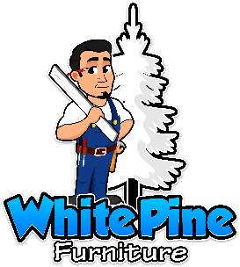
Administrative Address: Shipping/Returns Address: Canadian Address:
417 Forest St. Ste. 460 2002 Charles Ave. 1771 Robson St. Suite 1175
Kalamazoo, MI 49001 Kalamazoo, MI 49048 Vancouver, BC V6G1C9
Wholesale Division: 855-927-3066 * Customer Service: 877-755-2334

Thank You for Purchasing our Dry Eraser Board Hanger
A B 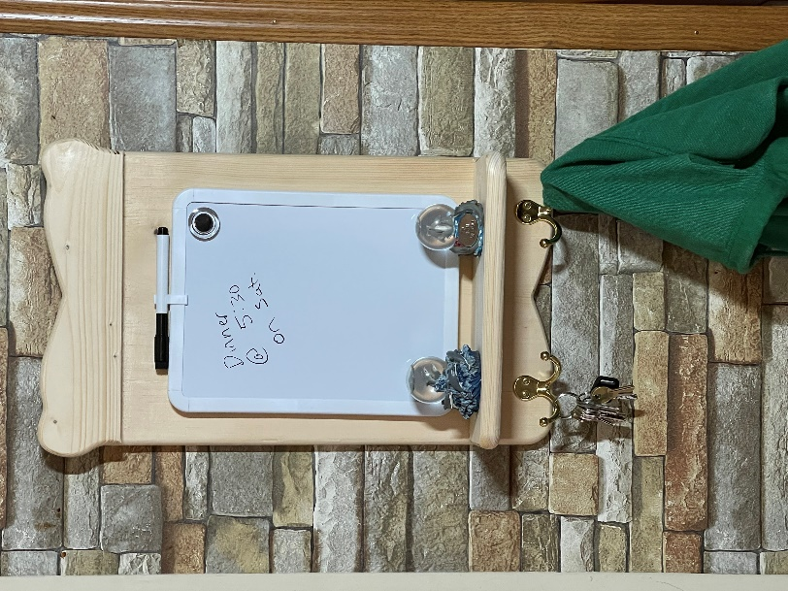 C D E
The Back Board “A”, The Top Trim Board “B”, The Shelf “C”, The Coat/Keys Hook “D”, The Dry Eraser “E”.
STEP 1) Assembling the Top Trim Board “B” to the Back Board “A” you will need two 1-1/4” screws, follow the pencil guidelines for placement about 1-1/2” from the top of “A”. REMEMBER YOU ARE WORKING ON THE BACKSIDE AND PLACING THE TOP BOARD UNDER THE BACK BOARD.
STEP2) Assembling the Shelf Board “C” to the Back Board “A”, you will need two 1-1/4”, the pencil marks on this is only showing the lower side placement of the shelf board on the back board. The pencil mark is at 2-1/2” from the bottom of the back board. REMEMBER YOU ARE WORKING FROM THE BACKSIDE AND THE SHELF SHOULD BE ON THE SAME SIDE AS THE TOP BOARD.
STEP 3) YOU ARE NOW WORKIING ON THE FRONT SIDE OF THE BACKBOARD Assembling the Hooks “E” You can place these anywhere you wish below the Shelf Board.
STEP 4) Hanging on the wall, you will need the two 1-5/8” screws for this. It is recommended that you secure it into a stud. It is also recommended not to place anything over a half-pound on the shelf unit. This is mainly just a light-weight shelf for one or two small figurines.
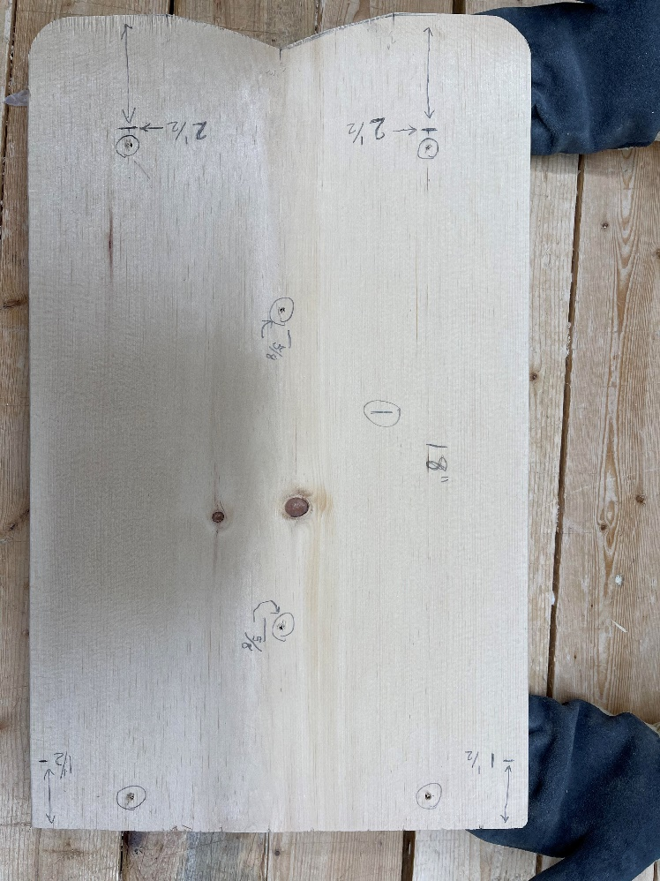 1-1/4” Screws 1-5/8” Screws

STEP 5) Once the wooden Hanger is securely placed on the wall, you will want to open the dry eraser packet and get the double-sided tape out and un-tape one-side of the squares to each corner placement. Make sure the tape does not show from the frontside. Center the dry eraser (left/right) then adjust it where you would like on the wooden hanger then press the dry eraser into place onto the wooden hanger…

