THANK YOU FOR BUYING ONE OF OUR SIDE TABLES
Use the 1-1/4” Phillip Screws to screw the boards as shown in these photos.
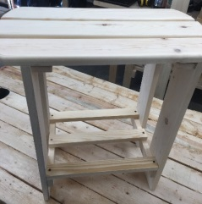 When the product is done it will look like this. You will need to start out with the framing of the side table. Use the spacers, it will save you time.
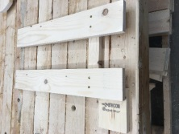Put the legs together first making sure they are the same height. Then put the 3 center boards together so it will look like this: 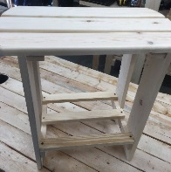 Then attach the work on the top 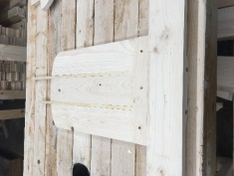 using the spacers to give you the width (space between the boards) boards Then attached the upper boards to the top boards as shown here 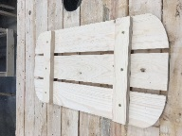 Then attach the top section to the legs. If you have done this right, it will match up as shown here. 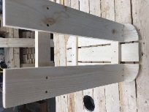Once this is complete, your Picwood USA Living product is done – Enjoy it and Thank You for ordering 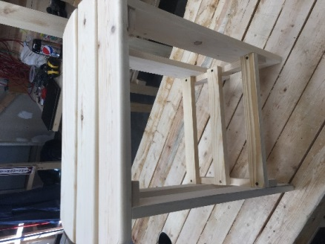 a finished product.

