STEP STOOL

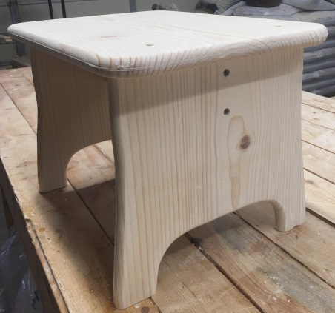

Enclosed you will find everything you need to put step-stool together. There are 8 -1-5/8 screws and you will need a Phillip screwdriver for this easy assembly. I would suggest you paint this before use.

STEP 1) Check your box to make sure you have everything. You should have:

1. Top Plate, 2-Legs (2 Small –**OR**- 2 Large), 1-Brace, 8-1-5/8 Philips Screws

Assembly time: 10 minutes (painting time not included)

STEP 2) Screw four 1-5/8 screws into the legs to the brace as shown in this photo below. Assemble the bottom brace sideways for the feeders as shown here in this photo below.

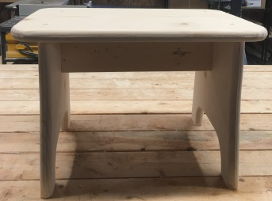 The rounded leg edges go outside..

STEP 3) Center the top plate on the legs then screw four 1-5/8 screws onto the top 