Wall Mounted Wine Rack

In a very short time you will be enjoying your wine on the wall with our Wall Mounted Wine Rack. All you need is a Phillip screw driver and about 10 minutes.
STEP 1) In this step you want to empty out the box and place everything on a table. Then you want the two end pieces and attach them to the wine glass holder piece of wood (the one with slats in it) as show below.
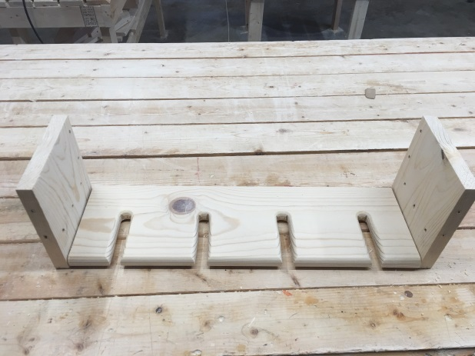
STEP 2) Then you will want to attach the back brace bar – this bar has two holes in it that is 16” centered for wood studs. Need to make sure you are going to be placing this awesome wine rack into the studs. Most houses are 16” center studs. With the holes being off centered, I recommend the holes closer to the side be placed on upward as shown in the photo below.
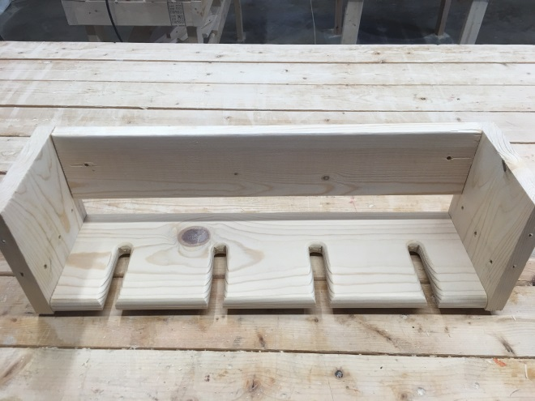

STEP 3) Then attach the wine bottle shelf. This shelf goes at the bottom of the back brace bar as shown below.
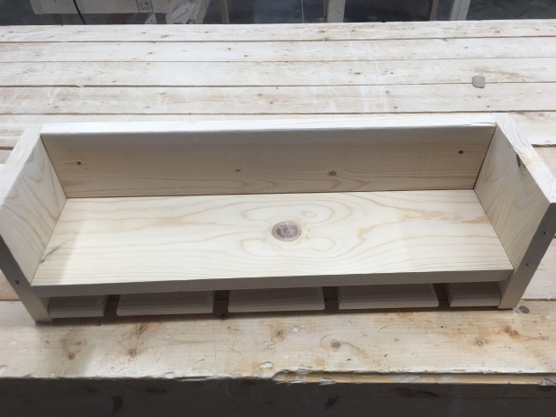

Step 4) Now most people like to attach the wine rack to the wall at this time as you will be able to get to the wall mounting screws. Once this is done, if you decide to do it at this time. Then attach the front plate as shown in the photo below.
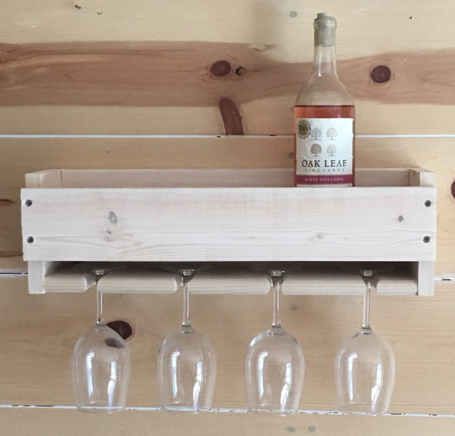

REMEMBER: this Wall Mounted Wine Rack will hold four standard bottles of wine and four glasses. It is not made for more than that.

