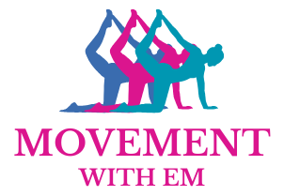
Waiver

Please carefully read and consider the terms outlined in the waiver below.

Health Declaration and Action Responsibility
I confirm that I am physically able to partake in this physical activity/exercise session, and if I deem appropriate, it is my responsibility to contact a health care professional prior to participating in the sessions. I confirm that I have completed my PAR-Q with the relevant information and disclosed all the necessary details; and will update it when and if I see necessary, in addition to updating it during the compulsory yearly update period.

Acknowledgement of Risks and their Liability
I understand that there are some risks when partaking in physical activity/exercise, especially when equipment is involved. I accept that whilst all care has been taken to minimise risk, including extensive risk assessments for both the studio/venue space and the type of activity, as well as up to date First Aid training, (proof of documentation can be provided on request) there is still a possibility of injury and/or harm which cannot be avoided. I confirm that my instructor will not be held liable for any injuries sustained during activity led by Movement with Em. In the event of injury, immediate first aid will be applied and my instructor will contact me regularly to check on my recovery and wellbeing. Beyond this, it is my responsibility to seek appropriate medical care and inform my instructor if any changes need to be made to the exercise programme.

By signing this waiver, I confirm that I have read and understood the terms outlined in the above document.

Full Name ……………………………………………..

Signed …………………………………………

Date ………………………………

