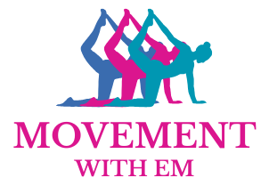
Registration Form

I am delighted that you have decided to join the Movement with Em family, we are very lucky to have you. Please complete this registration form to ensure I have the correct details for you and an emergency contact.

Personal Details:

Name ………………………………………… Home Number ………………………………………

Date of Birth …………………………………. Mobile Number ………………………………………

Gender / Pronouns …………………………. Email Address …………………………………………

Address ………………………………………

………………………………………

………………………………………

Post code …………………………………….

Emergency Contact:

Name …………………………………………. Home Number …………………………………………

Relation …………………………………. Mobile Number ………………………………………

Gender / Pronouns ………………………….. Email Address …………………………………………

Address ………………………………………..

………………………………………..

………………………………………..

Post code ………………………………………

Are you happy to join the Movement with Em community WhatsApp? Please circle or underline answer.

Yes No

Are you happy to have photos or videos of you, or including you, posted on social media or on my (future) website for promotions or advertising purposes? Please circle or underline answer.

Yes No

Your Health Goals:
What is the main thing you would like to achieve / get out of your Movement with Em journey?

………………………………………………………………………………………………………………………………

……………………………………………………….……………………………………….……………………………

