WHAT A PAPER MIGHT LOOK LIKE
Front page instructions:
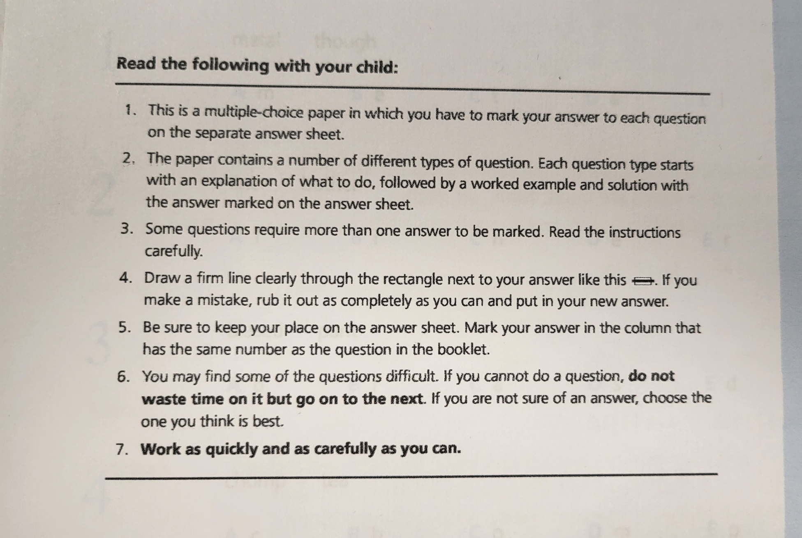
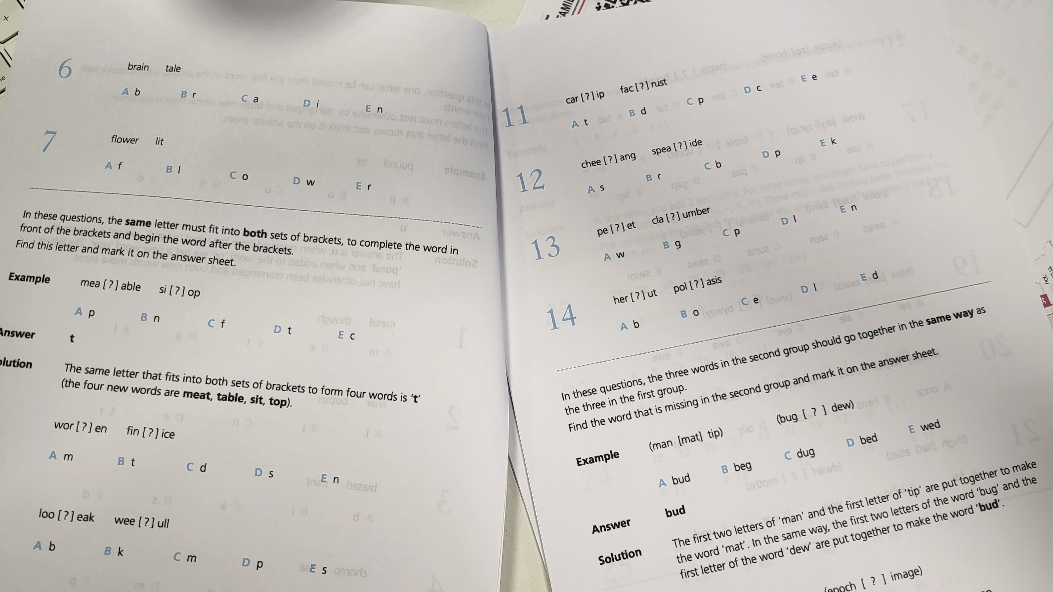
The question booklet example:
ANSWER SHEET (DOUBLE SIDED)
