Appendix A: Categorical Moderators

To test for RV interaction when the moderator is categorical, one simply needs to determine if variance of the dependent variable differs across levels of the moderator. This can be done using equality of variance tests, such as Bartlett’s, Levene’s, or Brown-Forsythe. Below, we demonstrate Bartlett’s test in Excel, R, and Mplus. Because the Bartlett’s test cannot be conducted in SPSS without also using software such as Excel, we do not demonstrate Bartlett’s in Excel. We then demonstrate Levene’s and Brown-Forsythe in Excel and offer a strategy for conducting these tests with latent variable models. Because the test in SPSS and R that is labeled Brown-Forsythe is not in fact the Brown and Forsythe (1974, Journal of the American Statistical Association) test of equality of variances, we demonstrate these only in Excel. All of our Excel files can be found in the other Supplemental Materials.

Our illustrations are based on data examining how the relationship between extraversion and one’s chattiness varies depending on the strength of the situation (i.e., at a funeral vs. at work).

**How to Conduct Bartlett’s Test**

The Bartlett’s test of equal variances generates a test statistic, *B*, which is approximately chi-squared distributed.



Here *sj2* is the variance of group *j*, *MSw* is the pooled variance (i.e, the sample size-weighted average variance) across all groups, *dfj* is *nj*-1, and *dfW* is ∑(*dfj ).* Bartlett’s test is sensitive to departures from normality, but unlike other tests, it doesn’t require raw data to calculate. For this reason, it is particularly useful for latent variable models with categorical moderators.

**In Excel:**

Step 1: Calculate mean and variance for each group.

Step 2: Calculate the degrees of freedom for each group variance (*dfj*) and for the pooled

variance (*dfw*) as described above.

Step 3: Use values from Steps 1 and 2 to calculate the *MSw* as $\frac{\sum{\left({df}_{j}*s_{j}^{2}\right)}}{{df}_{W}}$

Step 4: Take the inverse of *dfj* and *dfw*

Step 5: Take the natural log of the variance for each group and of the *MSw*

Step 6: Calculate *df* for the test itself as *k* – 1, where *k* equals the number of groups

Step 7: Calculate the numerator of the *B* statistic by subtracting the sum of the products of the natural log of the variance for each group and the *df* for each group from product of the *df* of the pooled variance and the natural log of the pooled variance *MSw*.

Step 8: Calculate the denominator by subtracting the inverse of the *dfw* from the sum of the

inverse of *dfj* and then multiplying this number by the inverse of three times *dfB*. Add one to this product.

Step 9: Calculate the *B* statistic by dividing the computed numerator by the computed

denominator. Compare to a chi-squared critical value with *k*-1degrees of freedom, where *k* equals the number of groups (cutoffs for p<.05 for 1, 2, and 3 *df* respectively are 3.84, 5.99, and 7.81. For moderators with more than 4 groups, please consult a chi-squared table).

Sample Output

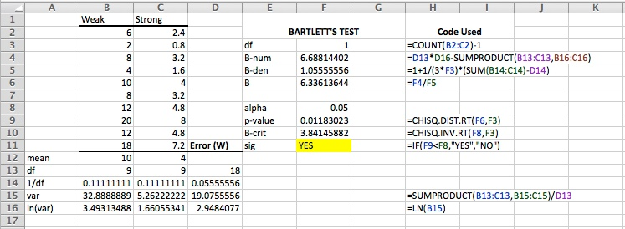

**In R:**

Within R, conducting the Bartlett’s test is fairly straightforward using the following packages and syntax. Note that R syntax is case sensitive. Packages must be installed and active in order to run analyses.

library(stats)

bartlett.test(y~z,data=mydata)

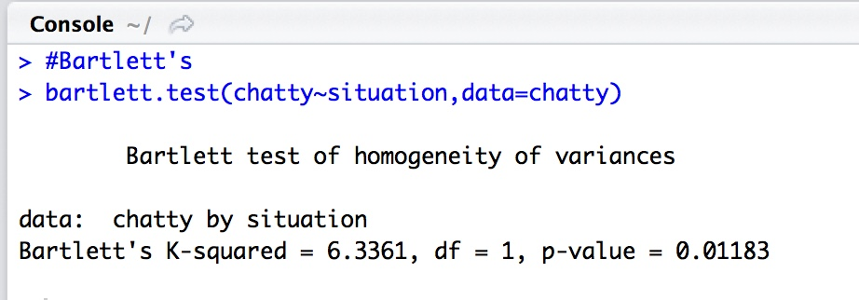

**In Mplus:**

To conduct Bartlett’s test for a latent variable model, one needs to obtain the latent variances for the compressed variable at each level of the moderator. This can be combined with a test for interaction by conducting a multiple groups analysis (MGA) with the moderator as the grouping variable. After obtaining the latent variances from the MGA, use Excel to run the Bartlett’s test as described above.

Our example comes from a data set that examines how the relationship between Perceived Organizational Support (POS), tenure, and Life Satisfaction (LS) differs between supervisors and non-supervisors. POS and LS are latent variables. Supervisor status is a categorical moderator.

Step 1: Run MGA for the different levels of the moderator

Step 2: Obtain the latent variances for the dependent variable

Step 3: Use the latent variances to conduct the Bartlett’s test in Excel

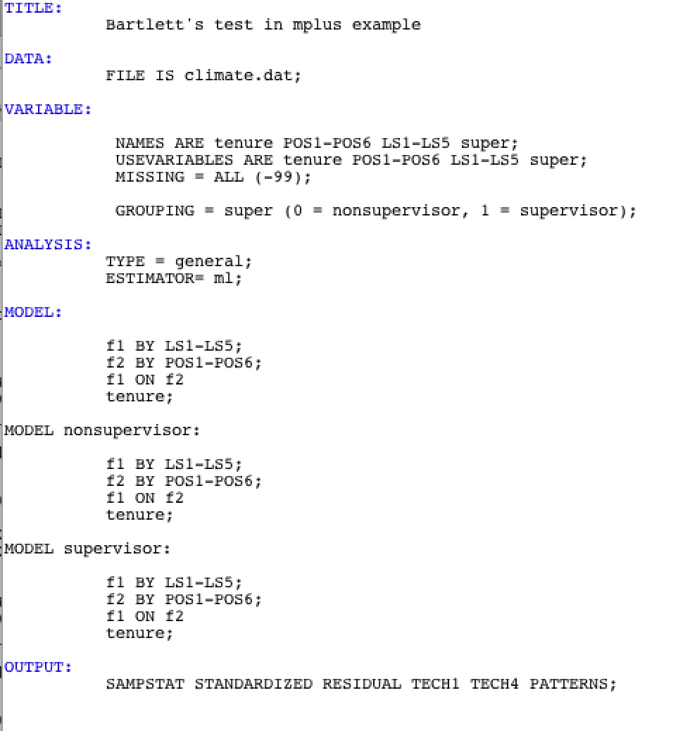

By requesting TECH4 in the OUTPUT command, we obtain the latent variances for supervisors (0.737) and for non-supervisors (0.805). We then enter these values into the Excel formulas described above. As can be seen in cell G7, the Bartlett’s test is not significant, indicating that the latent variances of Life Satisfaction do not differ between supervisors and non-supervisors. Thus, it seems that RV is not the reason for any interaction.

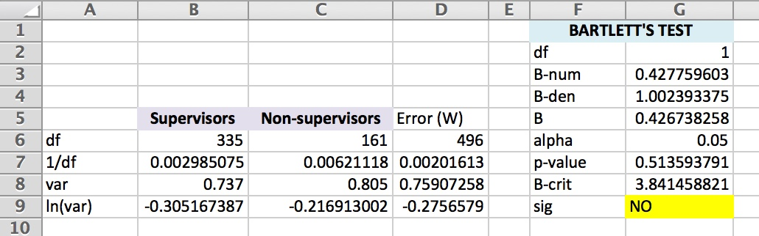

**How to Conduct Levene’s and Brown-Forsythe Tests**

The Brown-Forsythe test and the Levene’s test for variance differences are both based on a one-way ANOVA conducted on *absolute values of deviation scores* using the formula below. Brown and Forsythe (1974) demonstrated that when the underlying distribution is approximately normal, it is appropriate to use group means to form the deviation scores, which is what Levene (1960) recommends. When the distribution is heavily skewed, then the median is more appropriate. Thus, in the Brown-Forsythe test, deviation scores are computed using medians rather than simple means, but both tests generate an F-statistic (often labeled as W) using the following:

$$F_{k-1, N-k}=\frac{N-k}{k-1}\frac{\sum_{i=1}^{k}{n_{i}{(Z_{i.}-Z_{..})}^{2}}}{\sum_{i=1}^{k}{\sum_{j=1}^{n_{i}}{{(Z_{ij}-Z_{i.})}^{2}}}}$$

Where

k = # of groups

ni = # of cases in group i

N = total # of cases

Zij = the absolute value of the deviation score for case j in group i, $|y_{ij}-\tilde{y_{i}|}$

$\tilde{y_{i}}$ = either the mean or the median of y for group i depending on whether one is computing Levene’s F or Brown-Forsythe’s F

Zi. is the mean of Zij for group i

Z.. is the mean of all Zij

In order to avoid confusion, we should mention that, although the df stipulated by Brown and Forsythe in the 1974 paper in which they developed their test for equality of variances (the JASA paper) are in fact, k-1 and N-k as we state above, some have suggested that the df in their *other* influential 1974 paper (in Technometrics, it’s enough to make you cry) on testing mean differences be used instead. These df, usually attributed to Satterthwaite (1941, Psychometrika) and Welch (1951, Biometrika) are k-1 as before, and for the denominator, df are

$$\frac{1}{\sum_{i=1}^{k}{\frac{m_{k}^{2}}{n_{k}-1}}}$$

Where

$$m_{k}=\frac{\left(\frac{n_{k}}{N}\right)*s_{k}^{2}}{\sum_{i=1}^{k}{\left(\frac{n_{k}}{N}\right)*s_{k}^{2}}}$$

Although there may be technical reasons to use these df, the difference in cut values for studies with adequate sample sizes is negligible. We suggest that one keep it simple and use k-1, N-k.

But enough about degrees of freedom. A simpler way to think about the Levene and Brown-Forsythe tests is as a oneway ANOVA on absolute deviation scores. This is demonstrated in Excel below.



The input for the oneway ANOVA is the two columns of *absolute deviation scores*. In this case, because we are conducting a Levene’s test, these are absolute deviations from the mean. The ANOVA is a Single Factor ANOVA conducted with the Analysis Toolpak add-in (If you don’t see Data Analysis under the Data tab, hold down (alt T I) and check off Analysis Toolpak). Of course, this ANOVA can be conducted with any statistical software, a fact that may be relevant for some Mac users.

As can be seen, the F value on 1 and 18 df, is significant, showing that the variances are significantly different at p<.05.

If one had reason to believe that there was substantial skew in the dependent variable in this analysis, then the Brown-Forsythe test is recommended instead. This test is identical to Levene’s test except that deviations from the *medians* are used instead of deviations from the mean.



The Brown-Forsythe F is also significant, suggesting that the variances differ.

WARNING: If one requests Levene’s and Brown-Forsythe tests in SPSS or in R, one gets the correct Levene’s value, but the value labeled Brown-Forsythe is *not* the test for equality of variances. Instead, it is a robust test for the difference between means from their 1974 Technometrics article. If one wished to generate Brown-Forsythe variance difference values in SPSS or R, one would have to generate the appropriate absolute deviation scores and then use these as input for a Oneway ANOVA. At that point, one may as well use Excel. Nevertheless, the SPSS syntax and R code for generating Levene’s values are as follows.

**In SPSS:** With y as the compressed variable and z as the categorical moderator, use the following syntax:

ONEWAY y BY z

/STATISTICS HOMOGENEITY

/MISSING ANALYSIS.

**In R:**

Levene’s Test

library(car)

with(data, leveneTest(y, z, center=mean))

If one is not able to add the Analysis Tookpak, then the values for Brown-Forsythe F test can be computed directly as follows:

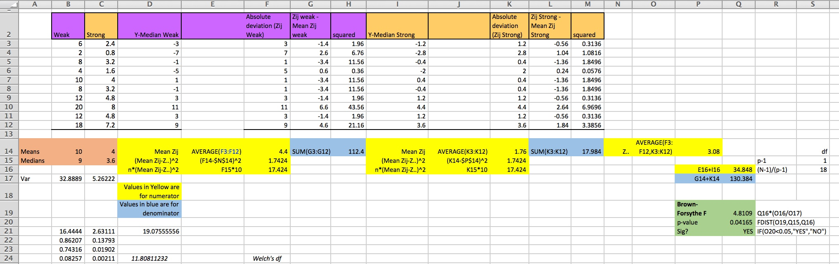

Levene’s F can be generated instead simply by replacing deviations from the median with deviations from the mean in columns F and K.

**What if it is the predictor whose values are compressed?** The analysis is the same. The inputted values are always those associated with the compressed variable regardless of where it is in a causal chain. By extension, if both the predictor and the outcome are hypothesized to be compressed, then each can be tested in turn.

**What if the compressed variable is a latent variable?**  We recommend that users create scale scores from the indicators of the latent variable and follow the same steps in SPSS, Excel, or R using the scale scores. Again, one will need to convert the scale scores to absolute deviations from the mean or the median, and then conduct a one-way ANOVA.

Appendix B: Continuous Moderators

One possible way of handling a continuous moderator is to categorize it in some way (e.g., median split, top and bottom quartile) and then conduct one of the tests described above. A more elegant approach that maintains all of the information in the continuous moderator is to use the Breusch-Pagan test for constant error variance. This can be conducted directly in R. In SPSS and Excel, one generates residuals and then uses these to conduct the test. Mplus must be tricked into conducting the test.

**How to Run the Breusch-Pagan Test in Excel and SPSS**

Our illustrations are from data used to generate Figure 6 of the manuscript.

Step 1: Regress the dependent variable onto the moderator and save the residuals

Step 2: Square the residuals

Step 3: Regress the squared residuals onto the moderator

Step 4: Multiply the R2 value obtained in Step 3 by the sample size

Step 5: This value is approximately chi-squared distributed with *k* degrees of freedom, where *k* is equal to the number of predictors.

Excel output

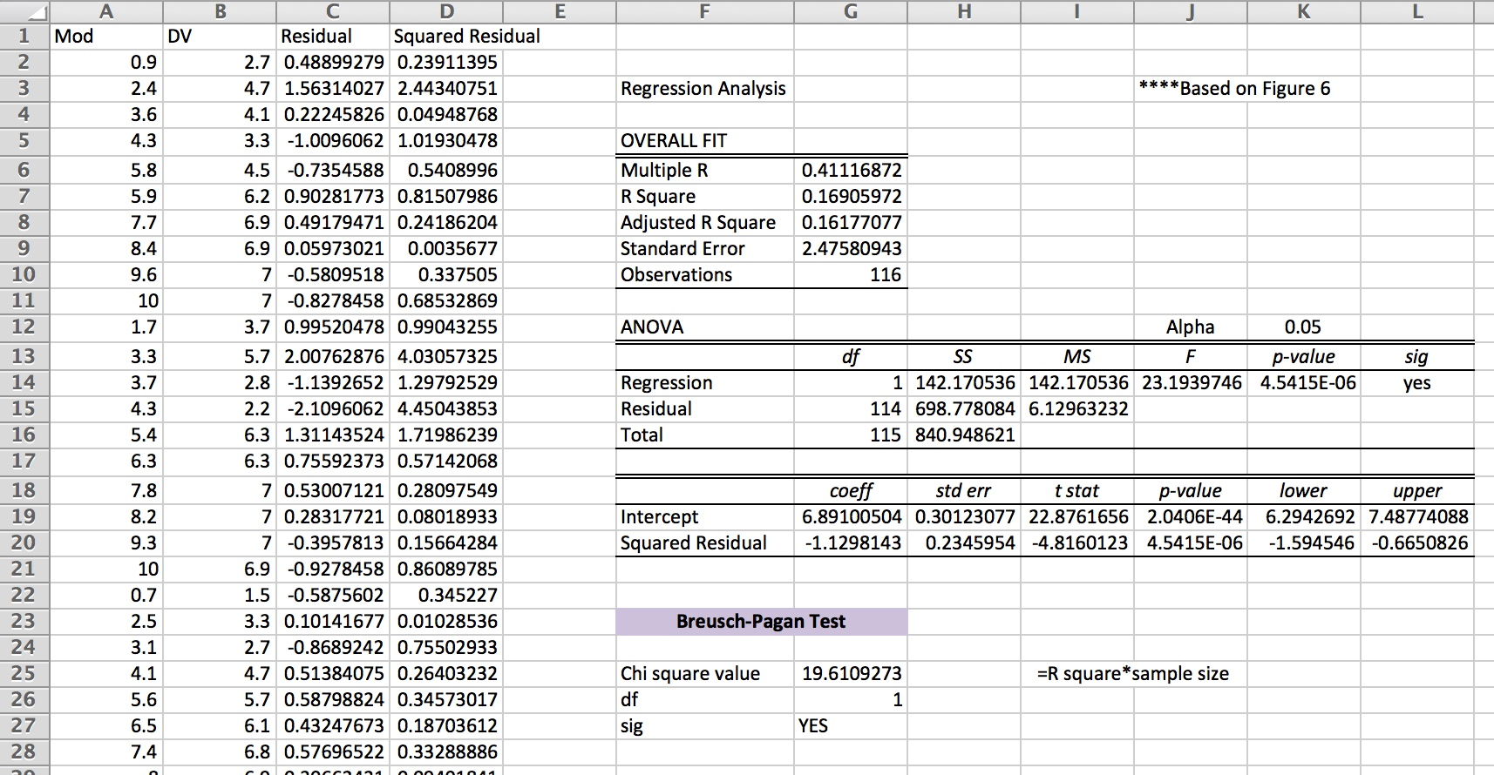

SPSS syntax and output

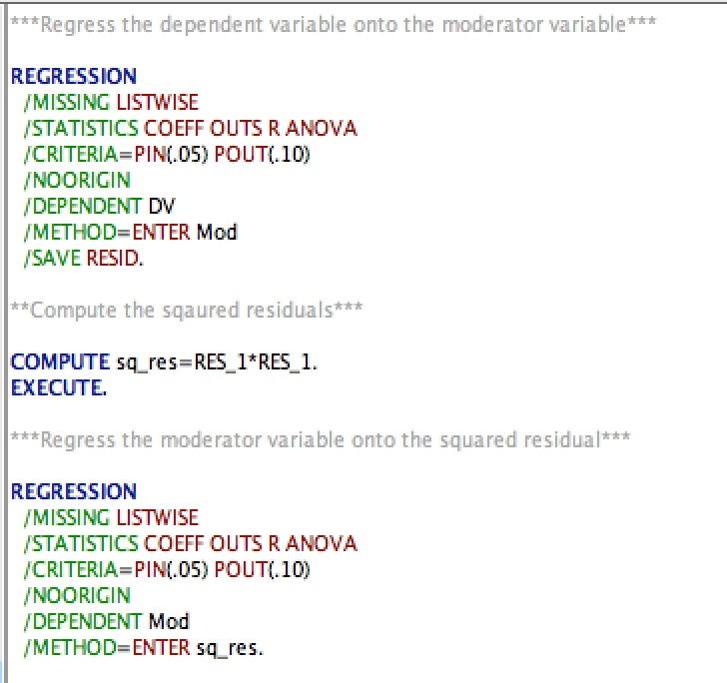

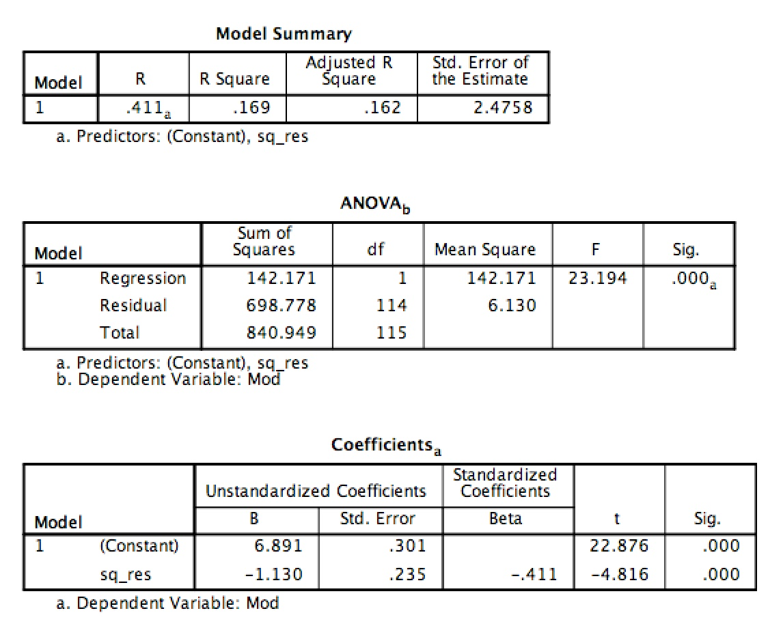

Multiplying R2 by the sample size (i.e., 0.169*117 = 19.61) gives the chi-square value.

**How to run the Breusch-Pagan test in R**

library(lmtest)

bptest(lm(y~z, data=mydata))

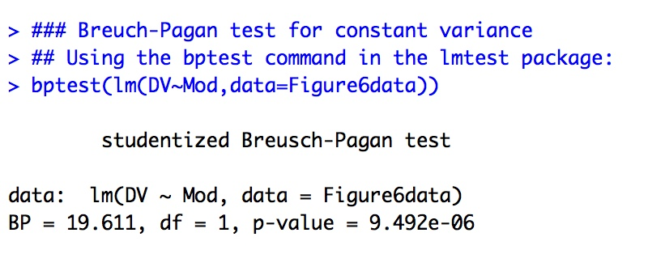

**How to run the Breusch-Pagan test in Mplus**

This example uses the same data as the latent variable example for Bartlett’s test. In this example, age is the continuous moderator. POS is a latent endogenous variable with six indicators.

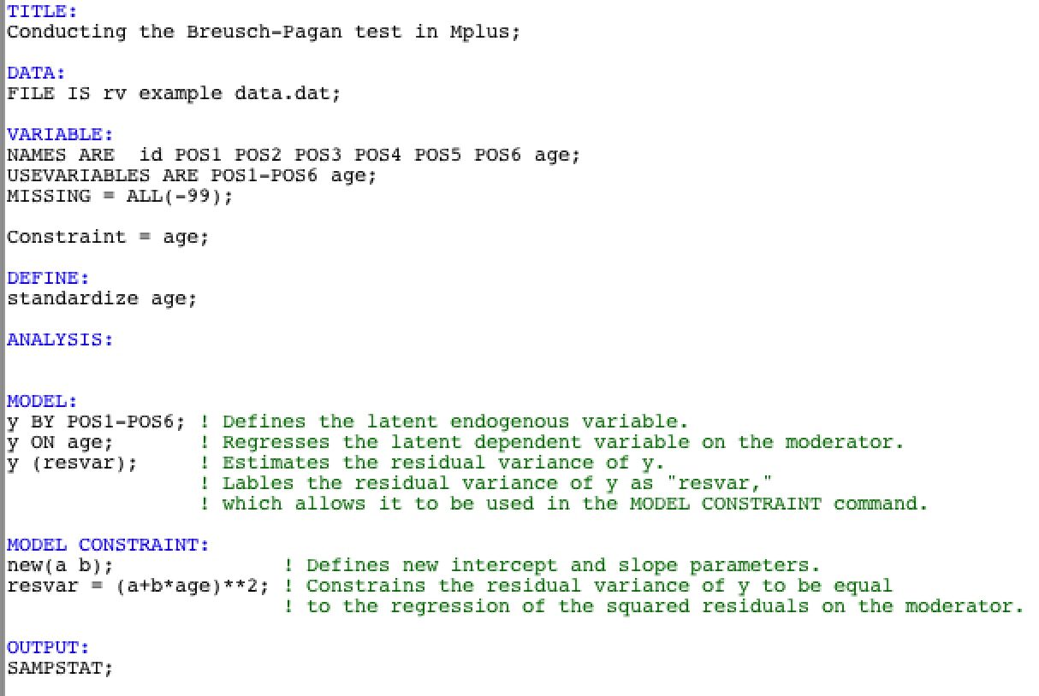The Breusch-Pagan test is conducted using the syntax below:

To determine if there is support for non-constant factor variance, users examine the value of the “b” parameter created using the MODEL CONSTRAINT command. If this value is significant, then this indicates that the Breusch-Pagan test is significant (i.e., there is non-constant factor variance). In this example, the value for “b” is not significant, which means that the variance for the latent variable is not significantly different across levels of the moderator.

