Blue High Belt Basics
STANCES
HIGH LEVEL OF DIFFICULTY FOR BLUE HIGH BELT BECAUSE OF MANY SHIFTING STANCES. TAKING MANY ½ SIDE STEPS TO SWITCH STANCES, INSTEAD OF TAKING A REGULAR FULL STEP.
 |  | 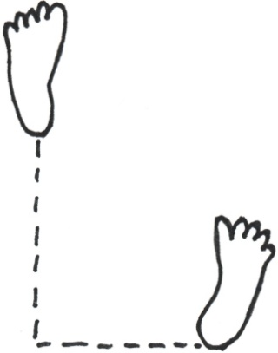
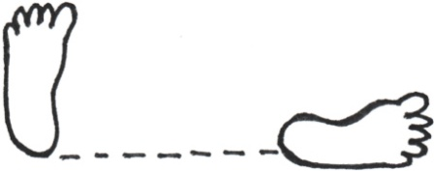 | 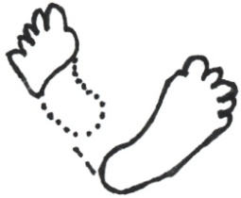
BACK | REAR FOOT STANCE
 |  | FRONT
KICKS
PRACTICE ALL KNOWN KICKS. CONCENTRATE ON…
*FRONT LEG FRONT SNAP *BACK LEG SIDE KICK
STRIKES/BLOCKS
PRACTICE ALL. CONTINUE PRACTICING PROPER TECHNIQUE & CHAMBERING. MANY NEW TO ADD…
*RIDGEHAND STRIKE *UPWARD PALM BLOCK*UPWARD ELBOW *TWIN UPSET PUNCH * HOOK PUNCH *POLE PUSHING BLOCK *ALTERNATING PALM BLOCK
KICKING COMBINATIONS
PRACTICE ALL KNOWN. HIGH-LEVEL COMBOS AS CLASS ALLOWS.
1 STEP SPARRING
*CONTINUE 1 – 10. MORE IF CLASS ALLOWS. (30 IN ALL.)
TERMINOLOGY
*1 - 10 (IN KOREAN) *AIMS TO ACHIEVE *TKD PLEDGE *DEFINITION OF JOONG-GUN (BLUE HIGHBELT)

ALWAYS REVIEW WHITE BELT BASICS – THE FOUNDATION.

