Food, Symptom and Mood diary Instructions
- Food & drinks - Record the amounts, types and brands of foods eaten.
- Symptoms - Rate your symptoms (1 =mild; 10 =severe).
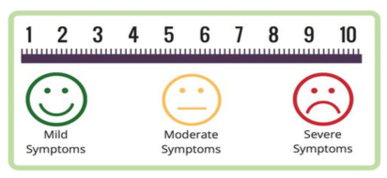
- Mood - Severe or chronic stress, anxiety and depression can make gut symptoms worse. Record and rate your stress, anxiety and mood (1 =calm; 10 =very stressed).
Symptoms Key
- N – Nausea
- V – Vomiting
- B – Bloating
- G – Gas & Flatulence
- P – Abdominal Pain
- D – Diarrhoea
Meal | Food & Drinks | Symptoms (1-10) | Mood | Bristol Stool Chart number (1-7)
Breakfast | 2 slices white toast, 1 glass OJ, ½ avo | 2x bowel motions  D5, P6, B3 | Stressed, running late | 6
- C - Constipation
Sample diary:

Food, Symptom and Mood diary
Date:
Meal | Food & Drinks | Symptoms (1-10) | Mood | Bristol Stool Chart number (1-7)
Breakfast
Snack
Lunch
Snack
Dinner
Snack
Comments

Food, Symptom and Mood diary
Date:
Meal | Food & Drinks | Symptoms (1-10) | Mood | Bristol Stool Chart number (1-7)
Breakfast
Snack
Lunch
Snack
Dinner
Snack
Comments

Date:
Meal | Food & Drinks | Symptoms (1-10) | Mood | Bristol Stool Chart number (1-7)
Breakfast
Snack
Lunch
Snack
Dinner
Snack
Comments
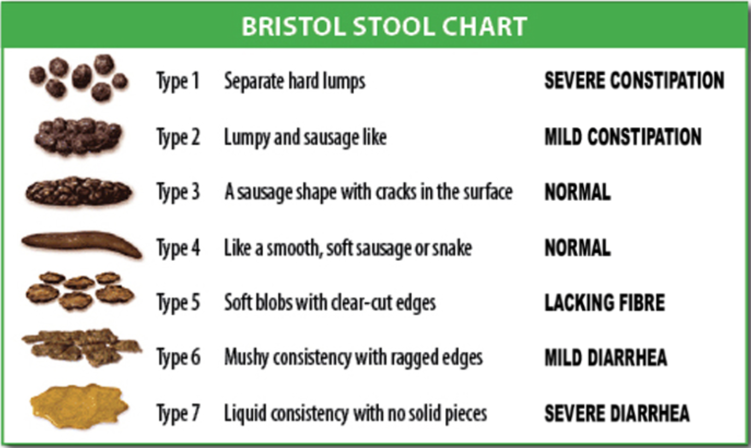
https://en.wikipedia.org/wiki/Bristol_stool_scale#/media/File:BristolStoolChart.png

