## Directions to Geisel School of Medicine

## VAIL Entrance

## (Formerly Dartmouth Medical School)

**Google Dewey Field Road in Hanover. This is the lot where you will park.** [Google Maps](https://www.google.com/maps/place/Dewey+Field+Road,+Hanover,+NH+03755/@43.7090503,-72.284432,18z/data=!3m1!4b1!4m5!3m4!1s0x4cb4c9dada6eb1cb:0x312c889e8341a91b!8m2!3d43.7088512!4d-72.2838018)

**If you look at a map of Dartmouth campus the Vail Building will be in the northern part of campus. (G-1)**

**Directions from I-89N**  
Get off I-89 at Exit 18 in Lebanon, NH onto Route 120.  
Bear right (from the south) off the exit, heading north on Rt.120 (Lebanon St) into Hanover.  
4.1 miles from the exit, Rt. 120 forks at a traffic light. (Hanover Co-op)  
Bear right at the fork, following Rt. 120 (now S. Park St) for one mile.

At the end of Rt 120 is the intersection for Rt 10. Go straight at this light into the Medical School parking lot. (Dewey Field Road) Park anywhere at the bottom of the hill. (red star) As you look from the parking lot to Vail: the entrance will be to the right of the loading dock. (red arrow)

**Directions from I91** (If you are coming from the North on 89, its quicker to get on 91 North for about 5 miles and take exit 13.)

Exit 13 onto US-5, VT-10A towards Norwich

At bottom of ramp head towards Hanover

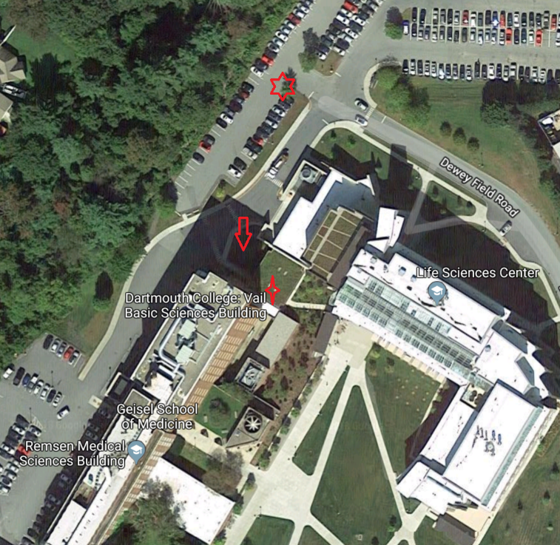Over the bridge and continue straight onto Wheelock Street (Dartmouth Green will be on your left and Hanover Inn on your right.)

Continue to stop light and turn left onto Park Street (also known as Rt 120). About half a mile will be the intersection of Rt 10 and Rt 120. Continue straight into parking lot. This is Dewey Field Road. Park anywhere at the bottom of the hill. (red star) As you look from the parking lot to Vail: the entrance will be to the right of the loading dock. (red arrow)

The picture on the right shows the parking and the arrow is the entrance to Vail.

When you enter Vail – go through a double door and take a right. You will pass through two more sets of double doors and the lab is at the end of this hallway.

During the weekend all entrances are locked. I will have someone check the VAIL entrance periodically to let you in.

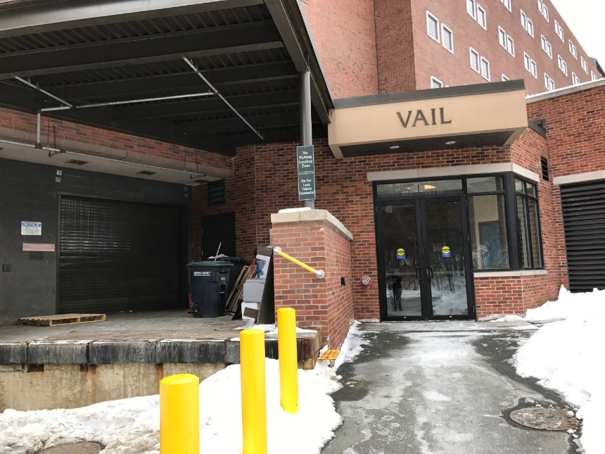

Here is a picture of the entrance.

With or without snow!!!

## General Information

**Waivers**- Since we are handling embalmed cadavers the college and myself will not be held liable should an accident occurs. Whether it be a fall or some kind of allergic reaction to the embalming scents. I will have waivers for you to sign when you check in.

**Clothing** – I will provide plastic aprons, safety glasses and gloves. **You must bring a change of clothing.** Recommended lab wear are pants and short sleeve shirt as the lab tends to run on the warm side. I will be wearing scrubs so if you have a set those would be perfect. If you are sensitive to smells and odors I will have some Vics Vapo Rub to dab under your nose. Some people bring their own essential oils. There is a large restroom when you first enter the building where you can change. There are also locker rooms that I can direct you to once you arrive. It is important that we follow universal precautions.

The format for the day is a little lecture and lots of self-discovery. You will have probes and tweezers to help move tissue and muscle. I will be close by to help guide you and there are plenty of anatomy books available. Do not bring anything into the lab that you don’t want to pick up residual odors such as your own anatomy books and notes. If there are any notes you want to take we can refer to a white board and I’ll take a picture at the end to share with everyone. **Out of respect: Absolutely NO pictures will be allowed of the donors bodies.** To get the most out of this time it will be best to review your anatomy books!

The following procedures are given to each medical student.

LABORATORY POLICIES

Our cadavers are the remains of generous people from New Hampshire and Vermont who willed their bodies to GSOM for the purpose of education and research. As a medical student, you are *privileged* to have the opportunity to use this material. **The cadavers are to be treated with the utmost respect**. For this reason, the following regulations will be observed in Sanborn Laboratory: (my notes are in Blue) VB

* As professionals, you are expected to dress and act appropriately in the laboratory. Open-toed shoes, sandals, shorts and skirts are not permitted. **Eye protection is required** (glasses or safety glasses, contact lenses are permitted but not recommended). Food and/or drinks, pets, and music are not allowed in the laboratory. Smoking is prohibited. The use of photographic or video equipment is not permitted unless approved by a faculty member for an educational project.
* For this workshop you will be provided with a plastic apron, gloves and protective eyewear. Your lab attire should include a short sleeve shirt or T-shirt. Your clothes will absorb the smells in the lab so plan on bringing an extra set of clothes to change out of at the end of the day.
* The Human Anatomy laboratory is a Restricted Area. Only authorized persons are allowed to enter the lab (i.e. students enrolled in the course, faculty and staff). We do not allow visitors (e.g. family members during White Coat weekend) out of respect for our donors and to protect the integrity of our body donation program. Do not share the combinations to the anatomy lab or study room with anyone!
* Bones and human tissue may not be removed from the laboratory under any circumstance. A single violation of this rule will likely result in expulsion from medical school. Anatomical models should not be removed from the laboratory or anatomy study room.
* The anatomy study room (“bone room”) is a grease-free area. Do not wear aprons or gloves in this room.
* This room will be our “break” room. It is small but will be adequate. Remove gloves and aprons before entering this room.
* Instructional material may not be removed from the laboratory or anatomy study room (bone room) without prior approval.
* There are plenty of anatomy books available in the lab for you to use as reference material. Specially Netters Anatomy 5th edition and Thieme Atlas of Anatomy. You are welcome to bring notes into the lab but again – you will want to dispose of them after the day is done.
* It is very important to keep tissues from each body separate, so that the remains can be cremated and returned to the donor’s family. Do not remove the cadaver ID tag for any reason. Small bits of tissue must be kept in the tissue waste bucket under your table. Do not put anything other than human tissue in this bucket (NO paper towels).
* At the end of our lab day please dispose of gloves and aprons in appropriate containers. Also wash and return protective eyewear.
* The laboratory is to be kept neat at all times and you are expected to clean your area after each day’s dissection (see the detailed procedure on the next page). Proper trash disposal in the laboratory is as follows:

cadaver (tissue) waste – waste containers under your table

gloves, paper towels – gray trash containers

blades – red sharps disposal boxes or turquoise blade removal boxes

**Embalming for Anatomical Study**

Embalming is the art and science of temporarily preserving human remains through artificial means. While the practice of human embalming has been in use since Dynastic Egypt, the techniques used by modern practitioners were not developed until the rise of the Anatomists in the 17th century. Modern embalming can be broken down into two categories, funeral and anatomical.

When embalming human remains for the purpose of a funeral service, the primary goals is to restore the body to a more lifelike appearance and temporarily preserve the remains until a service of some kind can be conducted. Embalming solutions used for this process will generally contain a dye to aid in creating a lifelike appearance, as well as humectant to prevent desiccation of the tissue, and will typically contain formaldehyde as a primary preservative.

Anatomical embalming is designed to achieve long-term preservation for the process of dissection and instruction. Embalming solutions used for this process are generally not dyed and are far more concentrated than those used in a funeral home. To reduce chemical exposure during dissection, very little formaldehyde is used, as it can cause irritation to the mucous membranes of the face. Instead, the primary preservative in an anatomical embalming solution will usually be phenol, alcohol, quaternary ammonia, or a combination of the three.

To achieve long-term preservation through anatomical embalming, the human remains are first thoroughly cleansed with an antibacterial soap. Next, an injection site is selected where a major artery can be easily accessed. A typical injection site would be the right common carotid artery, the right axillary artery, or either femoral artery. Embalming solution can be introduced to the body by either an embalming machine or gravity feed system. After a suitable amount of solution is injected, the remains are again washed and inspected to ensure thorough distribution throughout the entire body. If necessary, additional solution can be injected hypodermically.

If the embalming process is successful, the cadaver is placed into a thick plastic body bag and stored in a refrigerated room for several months before use. This is done to provide adequate time for the embalming solution to preserve all tissue and destroy any pathogens that may be present. It is important to note that while a powerful sanitizer, embalming solution can not destroy all blood borne pathogens, making universal precautions necessary in any dissection lab.

When dissecting a human cadaver, it is important it be treated with dignity and respect at all times. All tissue should remain with each individual cadaver, and tissue should never leave the laboratory area. After dissection is complete, the cadaver is sent to a crematory and finally returned to a designated agent, usually a family member, funeral director, or cemetery.