**Vickie E. Branch D.Sc.O, DOMP, LMT  
PO Box 1731 19 Newport Road New London, NH 03257**

**603-369-8830**

[**branchanatomy@gmail.com**](mailto:branchanatomy@gmail.com)

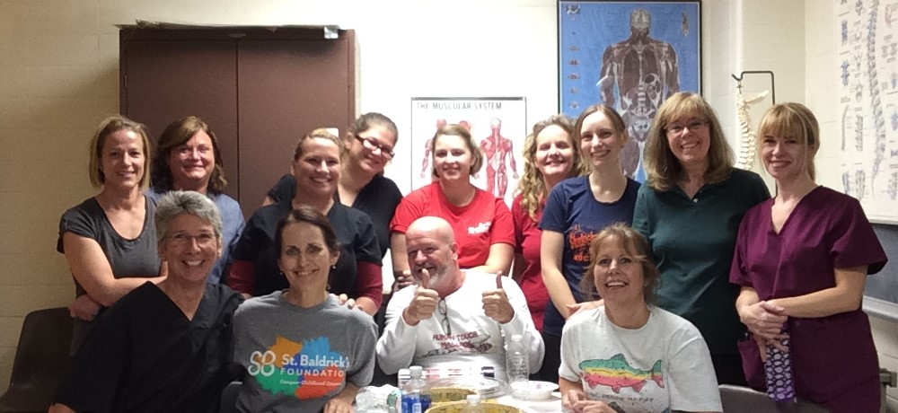

**NH AMTA Members after a day in the Anatomy Lab at Geisel School of Medicine**

**Workshop Descriptions**

**ANATOMY LAB:**

**Cadaver Anatomy Lab Overview  8CE's**

Join me as we explore human anatomy in this one-day, eight hour cadaver anatomy overview. We have 2-4 embalmed cadavers that I have dissected ahead of time to reveal the musculo-skeletal system, fascial layers and visceral attachments. In addition, we will be able to examine the major nerves and vasculature. The format of this class will be lecture and lots of hands on. The class is limited to a small number of participants to allow for maximum participation. No dissection will be performed. You will be able to touch and move tissue to examine all dissected structures. Out of respect to the donors no pictures will be allowed in this lab.

This class can be taken in one day or divided into two sections of lower and upper extremities.

*Cadaver Anatomy Lab: Lower Extremities 4 CE's*

*Cadaver Anatomy Lab: Upper Extremities: 4 CE's*

**Regional Cadaver Anatomy 3 CE’s**

Offering in depth coverage of specific anatomy regions of the Shoulder Complex, Hip & Pelvis, Cranial Sacral System, Thoracic and Abdominal Viscera. Each lab is 3 hours in length.

**IN THE CLASSROOM:**

**Functional Anatomy 4 CE’s**

A classroom lecture and hand on evaluation of how we move and steps to understand the anatomy in order to increase health. Regions covered are

* Shoulder Complex and Upper Extremities 4 CE’s
* Neck, Back and Spine 4 CE’s
* Hip & Pelvis 4 CE’s
* Knee, Ankle & Foot 4 CE’s

**Cranial Sacral Basics 12 CE's**

This introductory cranial course is based on the work of William G. Sutherland, DO and other early Osteopaths and will cover the history, theory, and anatomy of the cranial sacral system. This is a hands on class and will focus on palpation of anatomy and how to integrate cranial work into your present practice.  
This class qualifies for 12 CE's and is offered in a 2 day block.

​**Introduction to Positional Release Therapy 6 CE's**

This course will introduce you to Positional Release;  a different approach when treating tender points in muscles. We will target common areas such as the neck, shoulder, back and pelvis and learn how to incorporate this technique into a massage session. Details of muscle origin, insertion and action will be reviewed.

**Treating Back Pain with Visceral Manipulation  6 CE's**

Do you have clients who come to you with recurrent back issues?  Visceral Manipulation works with the structure and functional imbalances within the body. It evaluates and treats the dynamics of motion and suspension in relation to organs, membranes, fascia and ligaments.   By evaluating the relationship of the organs to the spinal column you can assist with improving posture, decreasing pain and increasing range of

motion.  
           Visceral manipulation has its roots in many aspects of manual therapies. This introductory course is based on American and European osteopathic visceral work. The focus will be on anatomy, theory and palpation. You will learn hands on techniques that you can immediately take into your practice. Please wear loose comfortable clothing suitable for easy access to the abdominal area.

​**Full payment** is required to reserve a space. Enrollment is limited. Fee includes course handouts, seminar instruction, hands-on workshop training, afternoon refreshments, and seminar certificate. Written confirmation will be sent via Email after payment is received in our office.  Course material is property of instructor and must not be shared with any other organizations or persons.  
  
**Cancellation/Refund Policy:**  
You may cancel your registration up to 8 days before the class and receive a 100% credit valid for any future workshop.  If you cancel 7 days or less prior to the class, you will incur a 50% forfeiture of funds and receive a 50% credit valid for any future workshop.  Cancellations on the day of the course will forfeit full tuition amount. All cancellation credits must be applied to another workshop within one year from the date of the original class.  
We reserve the right to cancel any workshop, in which case the tuition fee will be returned in full. Vickie Branch PLLC is not responsible for any guaranteed airline/hotel reservation.