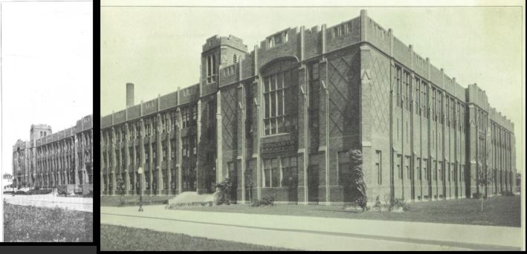
Project

The Foreman
- Foreman High School Documentary Vol 1 1928 – 1939.pdf (781 pages)
First volume in the five (5) volume set covering the decade of the 1930s.

- Foreman High School Documentary Vol 1 1940 – 1949.pdf (1066 pages)
Second volume in the five (5) volume set covering the decade of the 1940s.

- Foreman High School Documentary Vol 1 1950 – 1959.pdf (711 pages)
Third volume in the five (5) volume set covering the decade of the 1950s.

- Foreman High School Documentary Vol 1 1960 – 1969.pdf (1218 pages)
Forth volume in the five (5) volume set covering the decade of the 1960s.

- Foreman High School Documentary Vol 1 1970 – 1976.pdf (1231 pages)
Fifth volume in the five (5) volume set covering the decade of the 1970s.

- Foreman Exterior School Pictures.pdf (96 pages)
Collection of pictures of the different views of the outside of Foreman High School from each of the yearbooks. Some pictures are accompanied with a current day photo.

- Foreman High School All Things Sports.pdf (487 pages)
Extract of all the sports pictures from each yearbook.

- Foreman High School Baseball Teams.pdf (45 pages)
Collection of just baseball team pictures from each yearbook.

- Foreman High School Bowling Teams.pdf (31 pages)
Collection of just bowling team pictures from each yearbook.

- Foreman High School Cheerleaders – Majorettes.pdf (56 pages)
Collection of just cheerleaders and majorettes from each yearbook.

- Foreman High School Faculty Over The Years.pdf (256 pages)
Collection of pictures of each faculty member over the years.

- Foreman High School Football Teams.pdf (83 pages)
Collection of just football team pictures from each yearbook.

- Foreman High School Foremanual Covers 1928 – 1976.pdf (44 pages)
Collection of pictures of each Foremanual from 1930 – 1976.

- Foreman High School Swim Teams.pdf (20 pages)
Collection of just swim team pictures from each yearbook.

- School Shootings Starting in the 18th Century Volume 1 1764 – 1980.pdf (264 pages)
Volume 1 of all school shootings from 1764 thru 1980.

- School Shootings Starting in the 18th Century Volume 2 1980 – 1994.pdf (262 pages)
Volume 2 of all school shootings from 1980 thru 1994.

