What’s Next  As we finish out the tourist season, we tend to begin thinking about what’s next…. The Holidays! With the holidays brings staff and customer appreciation. We would like to be a part of your holiday season this year and share a little about what we can offer you as a special sweet treat.  We have baskets with lots of goodies and many options with items such as truffles, fudge, hot cocoa bombs and lots of items dipped in milk, white, or dark chocolate such as pretzels, twinkies, and Oreos to name a few.  And let’s not forget the great tasting taffy, flavored popcorns, and freeze-dried items.  You can order a specific item, ask for a variety plate, or different sized pre-made baskets.  You can call either location to place your order.  Wendy at Candyland  605-574-2824  Or  Marcy or Ty at Rushmore Candy Co.  605-342-1489 |  | We also have tons of stuff made right here in our store such as chocolate bars, chocolate pretzels, and other goodies. We also have South Dakota’s own Dry Creek Coffee for sale as well.  BeardBQ features their Coffee Blend and Spicy Blend seasoning along with Dipping Sauces | Our South Dakota Made Product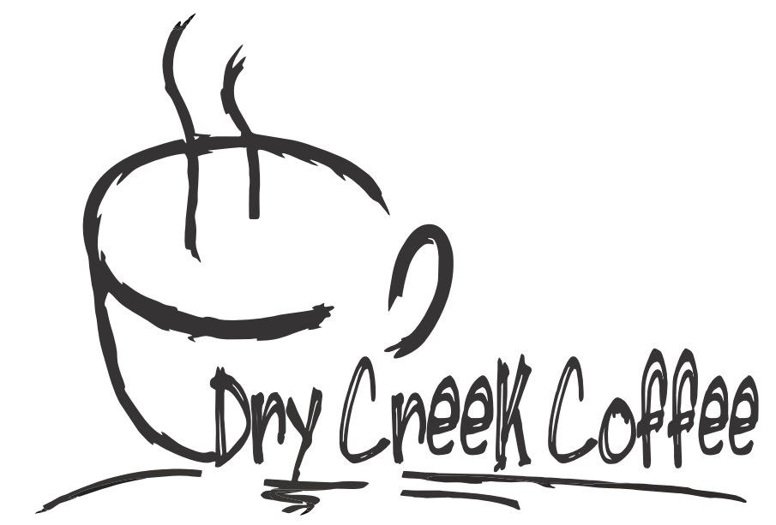s  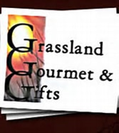  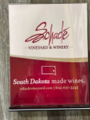  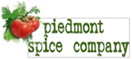  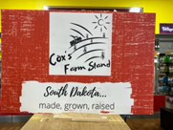  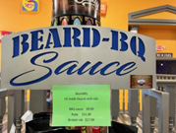  Grassland Gourmet supply us with the best mixes in all of South Dakota including their muffin, pot pie, chili, and soup mixes  Schade Vineyard & Winery also supply us with some of the best wine in the area including their Mt. Rushmore, Deadwood Aces, and Buffalo Wine  Cox’s Farm Stand offers amazing products such as salsas, ranch dressings, honey mustards, jams, honey and so much more  Made right here in Piedmont, South Dakota their company features many amazing products such as Beer Bread, Jambalaya, and Meat Loaf Mixes |  |  | Rushmore Candy Company Candyland SD  Holiday Baskets  - 9815 S Highway 16  Rapid City, SD  (605)342-1489  23835 Mill Iron Road  Rapid City, SD  (605)574-2824  Online Store  rushmorecandycompany.com/shop

Our Basket Options  Gold Basket- $25  Blue Basket- $50  Red Basket- $75  White Basket- $100 |  |  | What Each Basket Includes  Gold Basket  The gold basket includes a couple South Dakota specials, candies from the past and present, gourmet flavor of popcorn and more  Blue Basket  The blue basket includes a few South Dakota items along with some chocolate items, popcorn, and candies from the past and present.  Red Basket  The red basket includes multiple South Dakota items, multiple different candies from the past and present, gourmet popcorn a couple different chocolate items.  White Basket  The white basket includes multiple different South Dakota specials, multiple different candies from the past and present, gourmet popcorn, multiple different cholate items, and other specialty candies.  Hot Cocoa Bombs  - $5.50  4- $20.99 |  |  | Other Options  Besides all our basket options, we do also have some other options that work great for gifts, parties, and special occasions as well.  Box of Christmas Goodies  $12.99 per Box  Plate of Christmas Cookies  6pk- $5.50  12pk-$10.50  Plate of Chocolate Goodies  Call for Prices  Contact Us  Wendy at Candyland  605-574-2824  Or  Marcy or Ty at Rushmore Candy Co.  605-342-1489

Order Form

Order Date:_________Pick Up Date: ____________
Name: _____________________Phone # ______________
Baskets: Can specify some items in basket
#1 $25 ________
#2 $50 _______
#3 $75________
#4 $100 _______
Hot Cocoa Bombs – White, Milk Choc, Dark Choc (Please Circle One)
1 – $5.50 _______ 4 pk - $20.99 ________
Holiday Cookies
6 pk $5.50 __________ 12 pk $10.50 _______
Hot Chocolate Charcuterie boxes: $10.99 _______
Small box of Christmas goodies: $12.99 __________
Platters of Christmas goodies: any price $_______
Platters of cold case items: any price $__________
Special requests:
__________________________________________________________________________________________________________________________________________________
__________________________________________________________________________________________________________________________________________________

