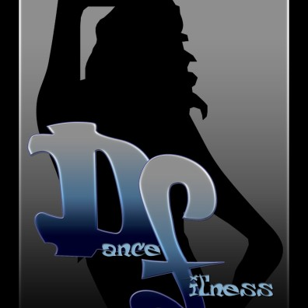
Dance Fitness - Pole Fitness Classes @ SNAP
WHERE: SNAP FITNESS STARR’S MILL LOCATION

WHEN: FRIDAYS @ 8:30PM: Rookie (Beginner) Pole
SATURDAYS @ 11:30 AM: Pole Fitness
SATURDAYS @ 1:00 PM: Intermediate (NOT Beginner) Pole

WHAT:
Pole Fitness: “Pole Boot Camp” - Strengthening and toning exercises/drills using the pole and YOUR own body weight, and learn/practice various tricks and spins. “Killer Abs” session and stretch.
Rookie Pole: Basic techniques, one trick, one spin, some transition moves, practice time involving one on one time with instructor, then put it all together in one routine to a HOT song!
Intermediate/Advanced Pole: Approval is required for this class. This one is NOT for the beginner! (Advanced class includes many aerial and inverted tricks, spins, and transitions.)

WEAR: Workout clothes, shorts preferred, NO JEWELERY (rings, watches, bracelets)
*NO LOTION OR OIL ON BODY!* (For YOUR safety as well as success)*

WHO: ALL AGES!!! BRAND NEW, beginner, intermediate, advanced and professional levels.

HOW: MUST PRE-REGISTER at facebook.com/dancefitnessptc or
call/text 770-361-0425 or email dancefitnessptc@gmail.com

$10 for first class, $15 per class –
Class Bundles are 5 classes for $65, 10 classes for $120

*One-on-one sessions available and private group sessions available for events such as Birthdays, Bachelorette Parties, or Girls Night Out!*

*Newbies are welcomed with open arms to a positive environment.
NO negativity allowed!!! * LAUGHTER is encouraged!!! *

Snap Fitness-2905 Redwine Road, Fayetteville, GA 30215

