

Shaping Workplace Behavior:
Leadership Development Course
EPT-HR-TT-LDC-03.01



Table of Contents
Table of Contents 2
Outline 3
Section 1: Foundations of Employee Behavior Change 5
1.1 Section Purpose 5
1.2 Key Concepts 5
1.3 Reflection Activity: Behavior Versus Label 7
Section 2: The Behavior Change Framework 8
2.1 Section Purpose 8
2.2 Factors for Changing Behavior 8

Outline

Revision Dates: 05/01/2026
Lesson Number: EPT-HR-TT-LDC-03.01
Department: Human Resources - Training & Development
Course Title: Behavioral Changes
Course Description: Mid-level leaders are often responsible for translating organizational expectations into day-to-day employee behaviors. They are expected to improve performance, strengthen accountability, reinforce culture, and help employees adopt new ways of working. However, many leaders default to reminders, corrections, or one-time conversations when employees do not change. This workshop helps leaders move beyond “telling people what to do” and toward a more structured, practical, and ethical approach to behavior change.
Participants will explore why employee behavior changes or fails to change, diagnose common barriers, practice coaching conversations, and build a behavior-change action plan they can apply immediately with their teams. The session emphasizes observable behavior, root-cause thinking, psychological safety, consistent reinforcement, and appropriate accountability.
Training Contact Hours: 4 Hours
Creator: Christopher Moore
Creation Date: 02/04/2024
Target Audience: Mid-level leaders, managers, supervisors, team leads, and emerging leaders
Target Audience Size: 8-24 Participants
Delivery Format: ILT (Instructor-Led Training)
Terminal Objective:
At the conclusion of this training, the learner will be able to apply a structured behavior-change approach to diagnose employee behavior barriers, communicate clear expectations, coach employees toward desired workplace behaviors, and reinforce accountability.
Enabling Objective:
- Explain why employee behavior change requires more than communication or correction.
- Distinguish between performance, motivation, capability, and system-related barriers to behavior change.
- Use a behavior-change framework to diagnose why a desired behavior is not occurring.
- Write clear, observable behavior expectations for employees.
- Conduct a coaching conversation that names behavior, explores barriers, agrees on next actions, and establishes follow-up.
- Identify reinforcement strategies that support sustainable behavior change.
Lesson Support:
- Lesson: EPT-HR-TT-LDC-03.01 - Train-the-Trainer – Course Manual
- Presentation: EPT-HR-TT-LDC-03.01-AV01.01 - Presentation
- Written Exam and Exam Key

Section 1: Foundations of Employee Behavior Change

1.1 Section Purpose
This Section introduces the leader’s role in influencing employee behavior and establishes the importance of focusing on observable workplace actions rather than assumptions, labels, or personality judgments.

1.2 Key Concepts

1.2.1 Behavior Change Is a Leadership Responsibility
Leaders are not responsible for controlling every employee choice. However, they are responsible for creating conditions that make desired workplace behaviors more likely to occur. These conditions include clear expectations, appropriate support, timely feedback, reinforcement, and consistent follow-up.

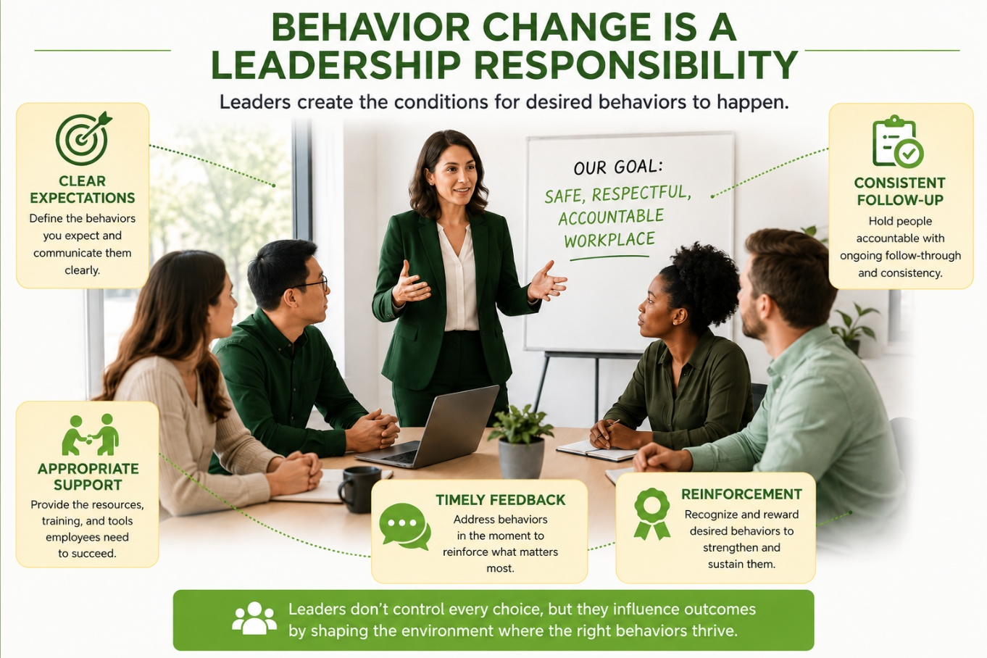

1.2.2 Behavior Is Shaped by Context
Employee behavior is influenced by more than individual willpower or attitude. Workplace behavior is shaped by:
- Expectations
- Habits
- Workload
- Tools and systems
- Incentives
- Peer norms
- Manager behavior
- Consequences
- Confidence and skill level
- Past experiences with change

When leaders overlook these factors, they may misdiagnose the issue and select an ineffective response.

1.2.3 Focus on Observable Behavior
Effective behavior change begins with observable behavior. Leaders should describe what they see or hear rather than making assumptions about intent, character, or personality.
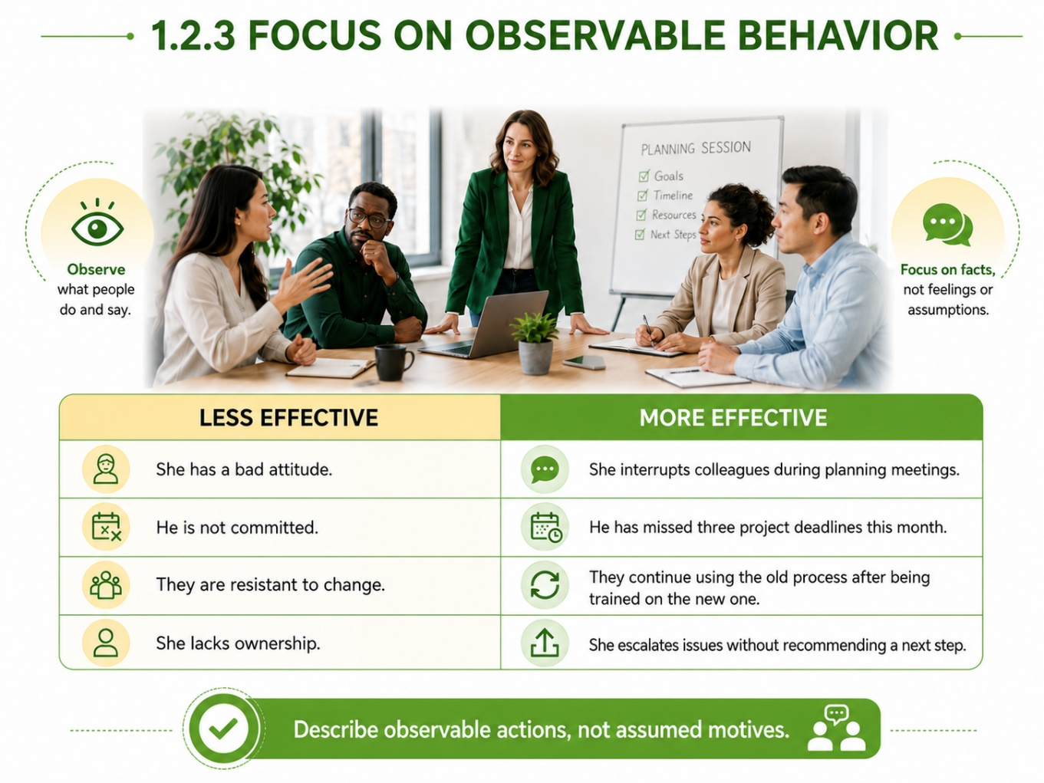

1.2.4 Leadership Principle
A leader can coach behavior more effectively than attitude, personality, or intent. Observable behavior creates a fairer and more productive starting point for discussion.
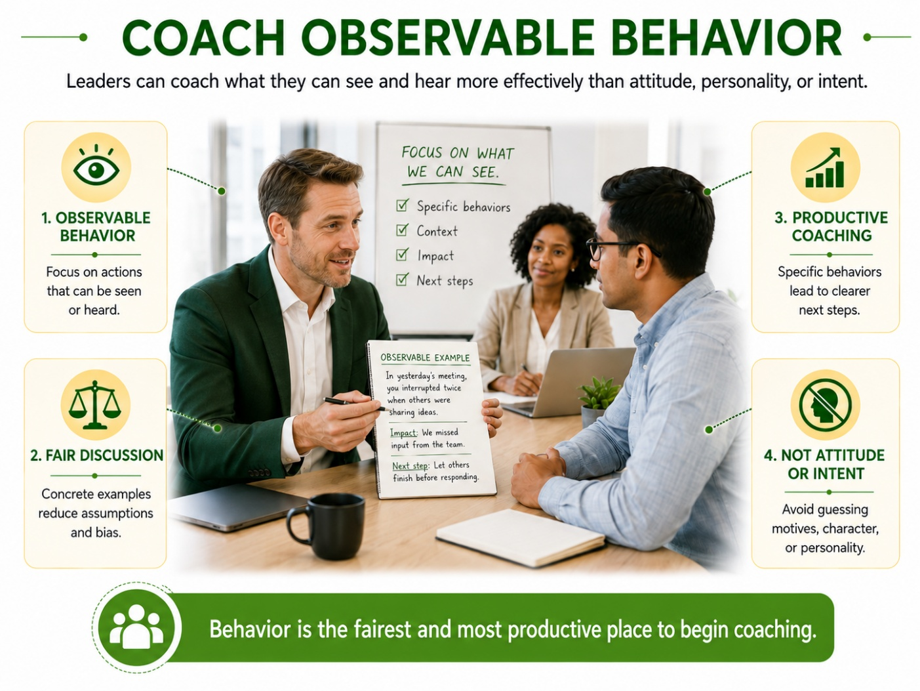

1.3 Reflection Activity: Behavior Versus Label
Review the statements below and rewrite each one as an observable behavior.
- “The employee is negative.”
- “The team lacks accountability.”
- “The employee is disengaged.”
- “The employee is not strategic.”
- “The team is resistant to change.”

Reflection Questions
- What makes behavior easier to coach than labels?
- How might labels create defensiveness?
- What risks emerge when leaders assume intent too quickly?

Section 2: The Behavior Change Framework

2.1 Section Purpose
This Section provides a practical framework leaders can use to understand why employee behavior does or does not change.

2.2 Factors for Changing Behavior
Employee behavior is more likely to change when 5 factors are present:
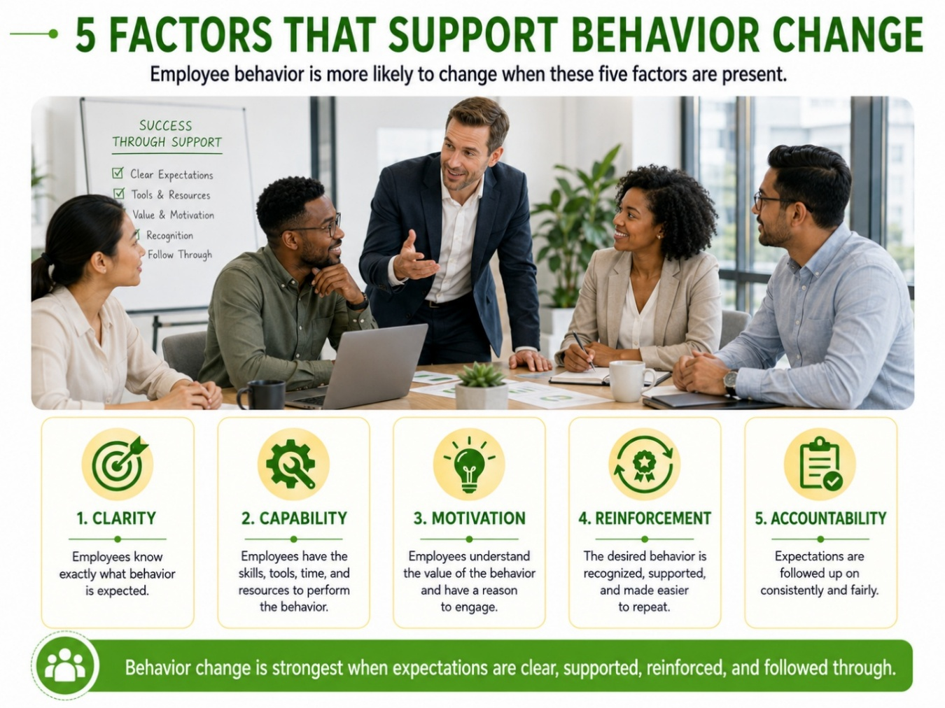.

2.3 Factor 1: Clarity
Clarity means the employee understands what is expected in specific, observable terms.
2.3.1 Signs of a Clarity Gap
- The leader uses broad language such as “be proactive” or “take ownership.”
- Employees interpret the expectation differently.
- The desired behavior has not been defined by timing, standard, or frequency.
- The employee says, “I didn’t know that was expected.”
- The leader has repeated the message but has not clarified what success looks like.
2.3.2 Leader Actions
Define the expected behavior.
- Give examples and non-examples.
- Confirm understanding.
- Clarify timing, quality standards, and decision rights.

2.4 Factor 2: Capability
Capability means the employee has what they need to perform the behavior successfully.
2.4.1 Signs of a Capability Gap
- The employee understands the expectation but does not know how to meet it.
- The employee lacks training, tools, information, or access.
- The workload or process makes the desired behavior unrealistic.
- The employee lacks confidence or practice.
- The employee does not have authority to make needed decisions.
2.4.2 Leader Actions
- Provide training or coaching.
- Remove process barriers.
- Clarify decision rights.
- Adjust workload or priorities if appropriate.
- Provide tools, examples, templates, or job aids.

END OF EXAMPLE LESSON PLAN

