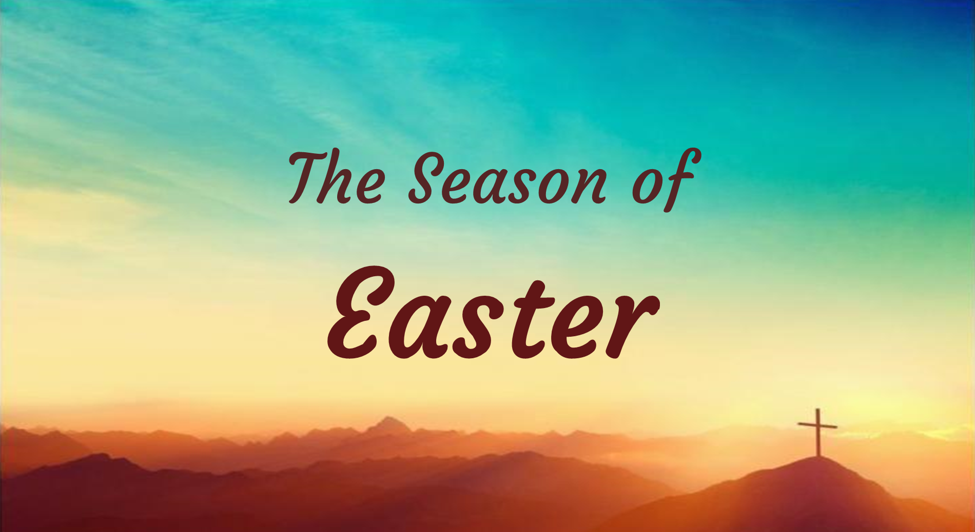

Worship Celebration

May 14, 2023

Twin Towers United Methodist Church
1411 Oak Street, Alameda, CA 94501

510.522.6744 | twintowers.office@gmail.com | www.twintowersumc.org
WORSHIP GUIDE
Before you begin your time of worship, find a comfortable place to be and gather whatever you might need: your Bible, something to write on and with, your computer/connected device (if you intend to listen to music online), etc. Feel free to adapt this worship guide in any way that makes best sense to you and those you might be gathered with. (Consider inviting someone – a friend, a family member – to worship with you.) Commit to spending the next hour with God.

PRELUDE – Listen and sing along to a song or hymn that blesses and centers your spirit. This song, The Father’s House by Cory Asbury, is an option for you this week.

OPENING HYMN – “Because He Lives” UMH #364

OPENING PRAYER - Let us join our hearts and spirits in prayer:

Gracious God, Jesus promised us his Spirit, and returned from death to give us his Spirit. Open our hearts now, so that as we listen to your scriptures read and your good news proclaimed, we might receive your Spirit, grow in our love of Christ, and be moved more deeply to obey his commandments of love. Amen.

SCRIPTURE READING – John 14:15-21 (NIV)

¹⁵ “If you love me, keep my commands. ¹⁶ And I will ask the Father, and he will give you another advocate to help you and be with you forever— ¹⁷ the Spirit of truth. The world cannot accept him, because it neither sees him nor knows him. But you know him, for he lives with you and will be in you. ¹⁸ I will not leave you as orphans; I will come to you. ¹⁹ Before long, the world will not see me anymore, but you will see me. Because I live, you also will live. ²⁰ On that day you will realize that I am in my Father, and you are in me, and I am in you. ²¹ Whoever has my commands and keeps them is the one who loves me. The one who loves me will be loved by my Father, and I too will love them and show myself to them.”

LISTEN – Sermon– You can read Pastor Akesa’s sermon transcript here or below.

HYMN OF RESPONSE – “There’s Within My Heart a Melody” UMH #380

PRAYERS of the PEOPLE – Spend time in prayer. What did you hear for yourself through today’s scripture and reflection? Talk to God about it. Then lift up the joys and concerns that are in your heart. You might write them down, speak them aloud, or pray for them in silence.

We would be honored to pray with you and for you.
Please send a note via text, mail, or email or give a call to our Healing Prayer Team.

SHARING OUR GIFTS
How might you offer yourself and all that you have to God this week? How are you being invited to practice generosity? Spend a moment listening for God’s direction.
You are invited to contribute financially towards the purpose and ministry of TTUMC. We are a congregation committed to being conduits of God’s healing in our neighborhood and beyond, and in so doing, impact the last and the least. You can contribute by mailing in a check, dropping off cash, or giving online (visit https://twintowersumc.org/give).

CLOSING HYMN – “Joyful, Joyful, We Adore Thee” UMH #89

BENEDICTION

NOW GO AND PASS CHRIST’S PEACE!

UPDATES AND INVITATIONS

Support the Christ Episcopal Church (CEC) Community Art Show

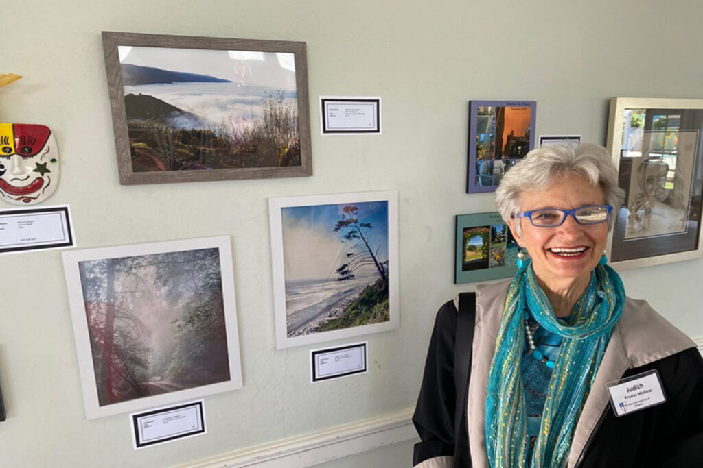
Pieces by our very own Deacon Judith and Joyce Simmons will be on display and other art may be available for purchase. Proceeds will benefit The Midway Shelter, helping women break the cycle of homelessness and domestic abuse. Pictured here is Deacon Judith at last year’s art show.

WHEN
Sunday, May 14 and May 21
11:30 AM - 1:30 PM

WHERE
Christ Episcopal Church
1700 Santa Clara Ave.
Alameda, CA 94501

Join the “Healing the Sick” Book Study
This Book Study is meeting every 3rd and 5th Thursday via Zoom facilitated by Jen Tellier and Deacon Judith Pruess-Mellow. If you have registered but did not get information about the meetings, please email P. Akesa at tttumc.pastor@gmail.com so you can receive the Zoom details.

The Healing Prayer Team is participating in this book study of the book Healing the Sick by Alex and Hannah Absalom which introduces not only how to pray for healing in real-life situations, but also how to respond with love and wisdom when there is both success and disappointment.
You’re Invited to Celebrate Brian Z’s 60th Birthday!

Join us in the church gym at 1pm this Saturday, May 20 for fellowship and in celebration of Brian’s 60th birthday!
Midway Shelter Needs Our Help
We support Midway Shelter, the only women and children shelter operating in Alameda, by providing 30 meals twice a month (2nd Tuesday and 4th Wednesday of each month). Donors can participate as financial donors or as meal preparers. To participate, please complete the information by clicking here and we will contact you.

We can really use more help with this needed ministry. Thank you!
Sign-up for Refreshments After Sunday Morning Worship
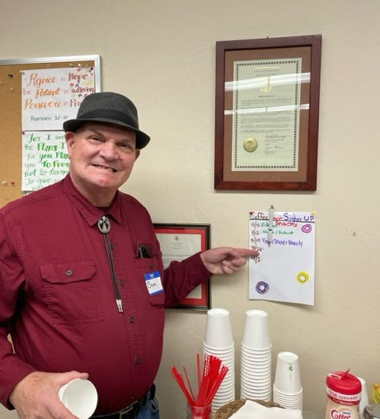
Those of you who attend Sunday morning worship in person are welcome to stop by for a cup of coffee and fellowship in the Wesley Room after worship service. You’re invited to bring your favorite refreshment to share.

Our brother Brian can be seen here showing us where the sign-up sheet is posted in the Wesley Room.

5/14 Sermon Transcript - Pastor Akesa Po’oi Fakava

