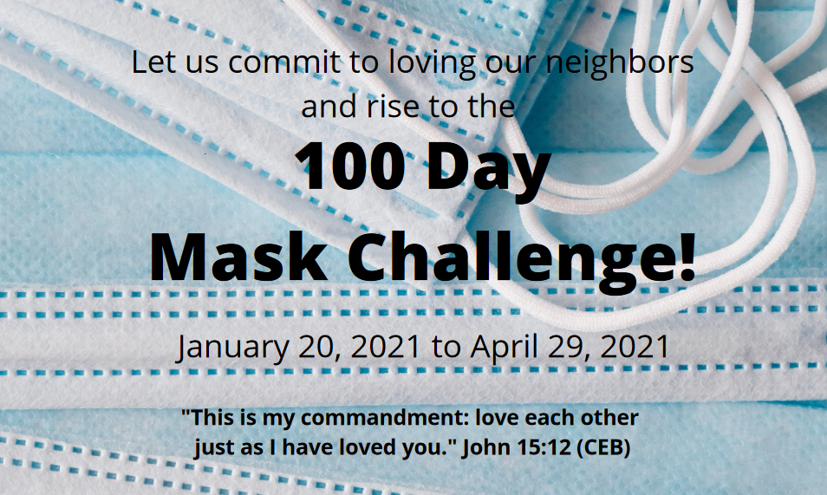

January 2021

Greetings Brothers and Sisters in Christ!

As with you, the Community Health Team at Twin Towers United Methodist Church in Alameda, California, has become deeply concerned about the spread of Covid-19. As we all wait for vaccines that prevent infection and transmission of this virus, we are reminded of the importance of wearing masks. Even after we receive the COVID-19 vaccine, mask usage will remain an essential means of prevention. As Christians and disciples in training, we are not powerless! We can be guided with the power of God’s words and His love for us. Jesus, the Christ, has given us the message that loving one another is more powerful than all the debates about personal freedoms, political affiliations, and the efficacy of masks as tools of prevention. We urge you to join us in our nation’s 100-day mask challenge.

***“A new command I give you: Love one another. As I have loved you, so you must love one another. By this everyone will know that you are my disciples, if you love one another.” John 13:34-35***

***“Love the Lord your God with all your heart and with all your soul and with all your mind and with all your strength. The second is this: Love your neighbor as yourself. There is no commandment greater than these". Mark 12:30-31***

**The Challenge**

**For You**

* Personally commit to wearing masks in public for 100 days following the inauguration of our new President.
* Reach out to at least 5 people about your commitment to wearing masks based on our Christian faith and Holy Scriptures. Become knowledgeable about the importance of mask wearing even with the vaccine.
* Reach out to members of other churches and organizations to invite them to join the challenge.
* Should you wish to reach out to others using this letter, please feel free to modify it to suit your needs.

**For your Church or Organization**

* Organizationally commit to the use of masks for 100 days following the inauguration of our new President.
* Hang a banner on your Church or building. (We are happy to share our design and where to order it.)
* Should you wish to reach out to others using this letter, please feel free to modify it to suit your needs.
* Share a copy of this letter by posting it on your website.

**As I wear a mask to defeat this pandemic,**

**I remember Jesus.**

**As I wear a mask,**

**I love my neighbors**

**Even as I love myself.**

**Amen.**

Rev. Don Cunningham, Pastor Emeritus

Peace and Grace,

Community Health Team, Twin Towers United Methodist Church, Alameda, California

For information, contact: Fred Fielding at (925) 708-8382 or [fredfielding@comcast.net](mailto:fredfielding@comcast.net)