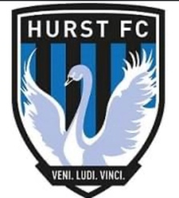

**HOW WE COACH - COACH SUPPORT & DEVELOPMENT**

Coaches and Assistant Coaches are encouraged to openly discuss and improve their knowledge of football in order to offer the players the best possible guidance throughout their development.

All coaches and assistant coaches are FA Level qualified and maintain up to date Safe Guarding Children, First Aid Certificate, and are all DBS checked.

Hurst FC will support coaches to undergo all training and development to ensure that a high standard of coaching is provided at all times.