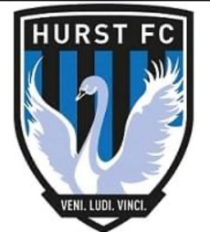

**WHO WE ARE - CLUB PURPOSE**

**HURST FC** is a youth development football club that represents and supports the players, parents, coaches and helpers.

The Club’s aim is to encourage and develop players at all levels.

We strive to improve every player’s footballing skills and develop their physical, psychological and social skills into competent and confident players and young people.

Teams are managed fairly and give opportunity for all members to participate equally in matches throughout the course of the season.

Parents, coaches and supporters are encouraged to praise effort and attitude of our players, opponents and officials and not simply consider winning results or goal scoring achievements.

**Hurst FC** abides to the FA's Safeguarding Children Policy and Procedures and supports the FA'S Respect campaign

**CORE VALUES FOR HURST FC**

**H – ARMONIOUS**

**U -NDERSTANDING**

**R - ESPECT**

**S - AFE**

**T -OGETEHER**