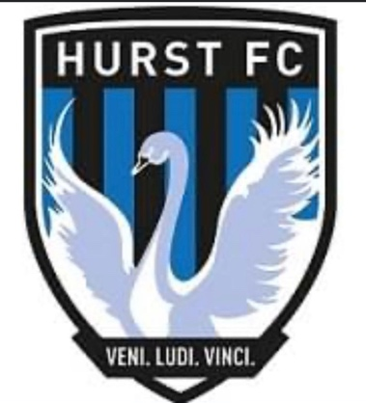 HOW WE SUPPORT - COMPLAINTS

HURST FC expects players, their parents or guardians and other spectators to respect the Clubs Codes of conduct
Nevertheless there may be occasions when someone feels aggrieved and therefore the Club Committee has agreed that the following steps should be taken by anyone wishing to make a complaint:
● In the first instance the person should discuss the issue with the Team Head Coach.
● If the issue concerns the behaviour of a member of another Club then the matter should be raised with the
Club Secretary and/or Club Welfare Officer (It is not acceptable for individuals to take the law into their own
hands nor should anyone contact the constituent youth league or the FA directly).
● If the issue concerns the behaviour of one of the Club’s coaches, players or spectators then the matter should
be taken up with the Club's Welfare Officers.
● If the issue is about a perceived departure from the Club’s Philosophy or Codes of Conduct and if the matter
is not resolved following the discussion with the Team Head Coach, then the person should raise the matter
with the Club's Development & Mentoring Coordinator/s and request that it is discussed by the Club's
Committee.

