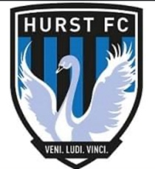 **HOW WE BEHAVE - SPECTATORS & PARENTS /CARERS**

We all have a responsibility to promote high standards of behaviour in the game **Hurst FC** supports the FA’s Respect programme to ensure football can be enjoyed in a safe and positive environment.

Please play your part and observe The FA’s Respect Code of Conduct for Spectators & Parents/Carers at all times.

**I will:**

• Remember that children play for FUN.  
• Applaud effort and good play as well as success.  
• Always respect the match officials (Referee/Assistant Referees) decisions.  
• Remain outside the field of play and within the Designated Spectators’ Area (where provided).  
• Let the Coach do their job and not confuse the players by telling them what to do.  
• Encourage the players to respect the opposition and match officials (Referee/Assistant Referees).  
• Avoid criticising a player for making a mistake, mistakes are part of learning.  
• Never engage in, or tolerate, offensive, insulting, or abusive language or behaviour.

I understand that if I do not follow the Code, any/all of the following actions may be taken by my Club, County FA, League or The FA:

**I may be:**

• Issued with a verbal warning from a Club or League Official  
• Required to meet with the Club, League or County FA Welfare Officer/s  
• Required to meet with the Club Committee  
• Obliged to undertake an FA education course  
• Obliged to leave the match venue by the Club  
• Requested by the Club not to attend future games  
• Suspended or have my Club Membership removed  
• Required to leave the Club along with any dependents.

**"*I as a parent, will do everything I can to support my child, other children, Club staff, Referee/Assistant Referees and parents in training and at games – through a positive involvement*"**