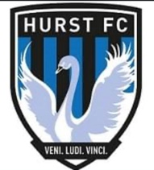**CODE OF CONDUCT -HOW WE BEHAVE - PLAYERS**

We all have a responsibility to promote high standards of behaviour in the game **Hurst FC** supports the FA’s Respect programme to ensure football can be enjoyed in a safe and positive environment.

Please play your part and observe The FA’s Respect Code of Conduct for Young Players at all times.

**When playing football, I will:**

• Always play my best for the benefit of the Team.  
• Play fairly and be friendly.  
• Play by the rules and respect the match officials (Referee/Assistant Referees) and their decisions.  
• Shake hands with the other team - win or lose.  
• Listen carefully to what my Coach tells me.  
• Understand that a Coach has to do what’s best for the team.  
• Talk to someone I trust or the Club Welfare Officer if I’m unhappy about anything at my Club.  
• Encourage my team mates.  
• Respect the facilities home & away.  
 **I understand that if I do not follow the Code, I may:**  
• Be required to apologise to my team-mates, the other team, match officials (Referee/Assistant Referees)   
or team manager.  
• Receive a formal warning from the Coach or the Club Committee.  
• Be dropped or substituted.  
• Be suspended from training.  
• Be required to leave the Club.