Certification by Translator

I,_______________________), certify that I am fluent in the English and Spanish languages, and the attached document is an accurate translation of the document attached titled United Mexican States Birth Certificate.

__________________________
DATE: 11/26/2021

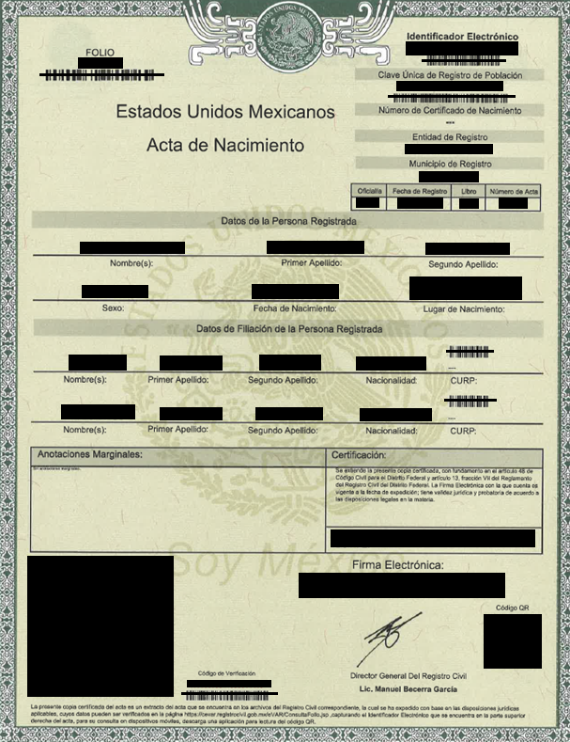
[document features decorative frame with background watermark showing seal of Mexico]
Seal of Mexico has “UNITED MEXICAN STATES” and “I AM MEXICO” written on top and in the bottom, respectively.

FILE  (copy from BC)  [barcode] | [seal of Mexico]  UNITED MEXICAN STATES | Electronic Identification  (copy from BC)  [barcode]
UNITED MEXICAN STATES
BIRTH CERTIFICATE
Unique Code of Population Registry
(copy from BC)
[barcode]
Birth Certificate Number
---
Registration Entity
(copy from BC)
Registration Municipality
(copy from BC)

Registry Office | Date of Filing | Book Number | Certificate Number
(cc BC) | (cc BC) | (cc BC) | (cc BC)

Data of the Registered Person

(COPY FROM BC) (COPY FROM BC) (COPY FROM BC)
Name(s): First Last Name: Second Last Name:

(COPY FROM BC) (COPY FROM BC) (COPY FROM BC)
Sex: Date of Birth: Birthplace:

Data of the Parents of the Registered Person
[barcode]
(COPY ALL NAMES FROM BC) (TRANSLATE FROM BC) ---
Name(s): First Last Name: Second Last Name: Nationality: CURP:

[barcode]
(COPY ALL NAMES FROM BC) (TRANSLATE FROM BC) ---
Name(s): First Last Name: Second Last Name: Nationality: CURP:

Marginal Notes: | Certification:
No marginal notes. | This certified copy is given in accordance with Article 48 of the Civil Code of the Federal District and Article 13 Section VII of the Vital Statistics Regulations of the Federal District. The Electronic Signature presented is valid on the date of issue; it has legal and evidentiary validity in accordance with the legal provisions on the subject.
 | ON THE (ENTER DAY) DAY OF THE MONTH OF (ENTER MONTH/YEAR). I ATTEST.

Electronic Signature:
[three lines of two-letter unique combinations series]
[large QR code]
[QR code]

[signature]

Verification Code General Director of the Office of Vital Statistics
(copy from BC) Manuel Becerra Garcia, licensed professional
[barcode]

This certified copy of birth certificate is an extract of the certificate that is found in the archives of the corresponding office of vital statistics, which has been issued based on the applicable legal provisions and which contents can be verified at https://cevar.registrocivil.gob.mx/eVAR/ConsultaFollo.jsp using the Electronic Identification found in the top right corner of the certificate. To consult on mobile devices download the mobile application to scan the QR code.

