Certification by Translator

I, ___________________, certify that I am fluent in the English and Spanish languages, and the attached document is an accurate translation of the document attached titled United Mexican States Death Certificate.

( ___________________,)

Dated 04/29/2022

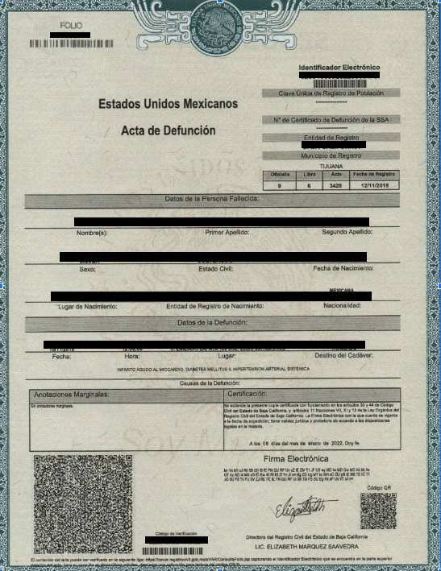

[document features decorative frame with background watermark showing seal of Mexico]
Seal of Mexico has “UNITED MEXICAN STATES” and “I AM MEXICO” written on top and on the bottom, respectively.

 | [seal of Mexico]  UNITED MEXICAN STATES | Electronic Identification  (02004000920220000178)  [barcode]
UNITED MEXICAN STATES
DEATH CERTIFICATE
Unique Code of Population Registry
(--------------------------------)
[barcode]
SSA Death Certificate Number
(--------------------------------)
Registration Entity
(OAXACA)
Registration Municipality
(SALINA CRUZ)

Registry Office | Book Number | Certificate  Number | Date of Filing
(9) | (6) | (3428) | (12/11/2019)

Data of the Deceased Person

NAME OF PERSON
Name(s): First Last Name: Second Last Name:

FEMALE SINGLE 10/02/1930 (FEB 10TH 1930)
Sex: Civil Status: Date of Birth:

SALINA CRUZ, OAXACA SINGLE MEXICAN
Place of Birth: Civil Status: Nationality:

Data of the Death

10/11/2019 12:000 C. EMILIANO ZAPATA 109 COL. EJIDO MATAMOROS TRANSPORTED
Date: Time: Place: Fate of Corpse :
acute myocardial infarction, diabetes mellitus ii, systemic arterial hypertension
Cause of Death:
Marginal Notes: | Certification:
No marginal notes. | This certified copy is issued based on articles 35 and 44 of the Civil Code of the State of Baja California and articles 11 sections Vl1, X1 and 12 of the Organic Law of the Civil Registry of the State of Baja California. The Electronic Signature you have is valid on the date of issue; It has legal and evidentiary validity according to the legal provisions on the matter.
 | ON THE (06) DAY OF THE MONTH OF (JANUARY 2022). I ATTEST.

Electronic Signature:
[three lines of two-letter unique combinations series]
[large QR code]
[QR code]
[signature]
Verification Code General Director of the Civil Registry of Baja California
202004000981 LIC. ELIZABETH MARQUEZ SAAVEDRA
[barcode]
This certified copy of birth certificate is an extract of the certificate that is found in the archives of the corresponding office of vital statistics, which has been issued based on the applicable legal provisions and which contents can be verified at https://cevar.registrocivil.gob.mx/eVAR/ConsultaFollo.jsp using the Electronic Identification found in the top right corner of the certificate. To consult on mobile devices, download the mobile application to scan the QR code.

