NORTHERN AZ BOWLERETTES
PLAZA BOWL | TOURNAMENT NUMBER 5 | LANE FEES | $ 8.25
127 Plaza Drive | January 17, 2026 | PRIZE FUND | $16.75
Prescott, AZ 86303  PH: 928-445-8300 | SIGN IN AT 10:00 A.M. BOWL AT 11:00 A.M. | TOTAL | $25.00

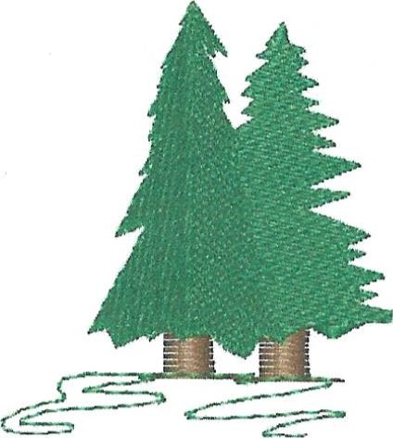
THIS TOURNAMENT WILL BE 3 REGULAR GAMES.
ENTRY DEADLINE: Jan. 13, 2026
NO REFUNDS AFTER Jan. 15, 2026
MAKE CHECK PAYABLE TO: NORTHERN AZ BOWLERETTES

MAIL ENTRIES TO: PAM CIRASOLE
1575 W RD 4 N

CHINO VALLEY, AZ 86323
928-227-1258 landline
360-951-3683 cell/text

This is a Northern AZ Bowlerettes tournament for NAZB members ONLY! ALL MEMBERS WELCOME!

Website: https://northernazbowlerettes.com/
Facebook page:
https://m.facebook.com/groups/440727224248320?group_view_referrer=search

PLEASE RETAIN THE ABOVE FOR TOURNAMENT INFORMATION AND RETURN THE ENTRY BELOW TO PAM CIRASOLE. IF SOMETHING HAS CHANGED SUCH AS ADDRESS, EMAIL OR PHONE NUMBER PLEASE WRITE IT ON THE BACK OF THE BELOW ENTRY FORM.

PLAZA BOWL January 17, 2026

NAME
Check-in starts at 10:00 a.m. Bowling starts at 11:00 a.m.

