NORTHERN AZ BOWLERETTES
ANTELOPE LANES | TOURNAMENT NUMBER 6 | LANE FEES | $11.46
6301 E. Second St. | February 21, 2026 | PRIZE FUND | $13.54
Prescott Valley, AZ 86314  PH: 928-772-7331 | SIGN IN AT 10:00 A.M. BOWL AT 11:00 A.M. | TOTAL | $ 25.00

THIS TOURNAMENT WILL BE 9 PIN NO TAP. THIS MEANS THAT IF YOU KNOCK DOWN AT LEAST 9 PINS ON YOUR FIRST BALL IT IS CONSIDERED A STRIKE. FOR ANYTHING LESS THAN 9 PINS ON YOUR FIRST BALL YOU WILL SHOOT THE SPARE AS USUAL.
ENTRY DEADLINE: Feb. 17, 2026
NO REFUNDS AFTER: Feb. 19, 2026
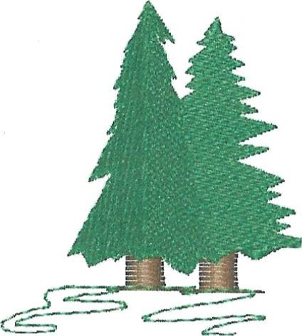
MAKE CHECK PAYABLE TO: NORTHERN AZ BOWLERETTES

MAIL ENTRIES TO: PAM CIRASOLE
1575 W RD 4 N

CHINO VALLEY, AZ 86323
PH: 928 227 1258
This is a Northern AZ Bowlerettes tournament for NAZB members ONLY! ALL MEMBERS WELCOME!
Website:
https://northernazbowlerettes.com/
Facebook page:
https://m.facebook.com/groups/440727224248320?group_view_referrer=search

PLEASE REMEMBER: If there is someone you want to bowl with please either mail in your entries together OR write their name also on your entry form. I will do my best to put you together on the same pair of lanes!

PLEASE RETAIN THE ABOVE FOR TOURNAMENT INFORMATION AND RETURN THE ENTRY BELOW TO PAM CIRASOLE.

IF SOMETHING HAS CHANGED SUCH AS ADDRESS, EMAIL OR PHONE NUMBER PLEASE WRITE IT ON THE BACK OF THE BELOW ENTRY FORM.

ANTELOPE LANES February 21, 2026

NAME
. Check in time 10 a.m. Start time 11 a.m.

