NORTHERN AZ BOWLERETTES

|  |  |  |  |
| --- | --- | --- | --- |
| SHAKE, RATTLE and BOWL | TOURNAMENT NUMBER 1 | LANE FEES | $ 9.00 |
| 555 W Middle Verde Road | September 20, 2025 | PRIZE FUND | $16.00 |
| Camp Verde, AZ 86322  PH: 928 567 7900 | SIGN IN AT 10:00 A.M. BOWL AT 11:00 A.M. | TOTAL | $25.00 |

# THIS TOURNAMENT WILL BE 3 REGULAR GAMES.

ENTRY DEADLINE: Sep. 16, 2025.

NO REFUNDS AFTER: Sep. 18, 2025.

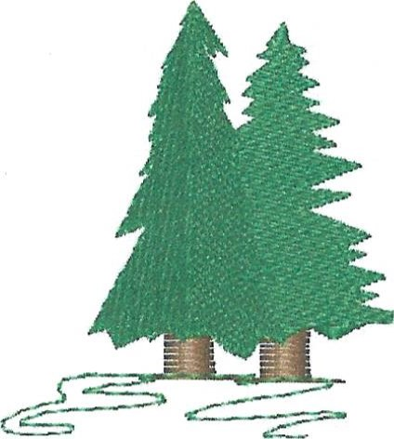MAKE CHECK PAYABLE TO: NORTHERN AZ BOWLERETTES

## MAIL ENTRIES TO: PAM CIRASOLE

1575 W RD 4 N

## CHINO VALLEY, AZ 86323

Home: 928 227 1258; cell: 360 951 3683

cirasolepamela@gmail.com

Website:

<https://northernazbowlerettes.com/>

Facebook page:

<https://m.facebook.com/groups/440727224248320?group_view_referrer=search>

This is a Northern AZ Bowlerettes tournament for NAZB members ONLY! ALL MEMBERS WELCOME! PLEASE REMEMBER: If there is someone you want to bowl with please either mail in your entries together OR write their name also on your entry form. I will do my best to put you together on the same pair of lanes!

**PLEASE RETAIN THE ABOVE FOR TOURNAMENT INFORMATION AND RETURN THE ENTRY BELOW TO PAM CIRASOLE**

**IF SOMETHING HAS CHANGED** SUCH AS ADDRESS, EMAIL OR PHONE NUMBER PLEASE WRITE IT ON THE BACK OF THE BELOW ENTRY FORM.

SHAKE, RATTLE and BOWL September 20, 2025

# NAME

. Check in time: 10 a.m. Start time: 11 a.m.