NORTHERN AZ BOWLERETTES
PLAZA BOWL | TOURNAMENT NUMBER 4 | LANE FEES | $ 8.25
127 Plaza Drive | December 20, 2025 | PRIZE FUND | $16.75
Prescott, AZ 86303  PH: 928-445-8300 | SIGN IN AT 10:00 A.M. BOWL AT 11:00 A.M. | TOTAL | $ 25.00

THIS TOURNAMENT WILL BE 9 PIN NO TAP. THIS MEANS THAT IF YOU KNOCK DOWN AT LEAST 9 PINS ON YOUR FIRST BALL IT IS CONSIDERED A STRIKE. FOR ANYTHING LESS THAN 9 PINS ON YOUR FIRST BALL YOU WILL SHOOT THE SPARE AS USUAL.
ENTRY DEADLINE: December 16, 2025
NO REFUNDS AFTER December 18,2025
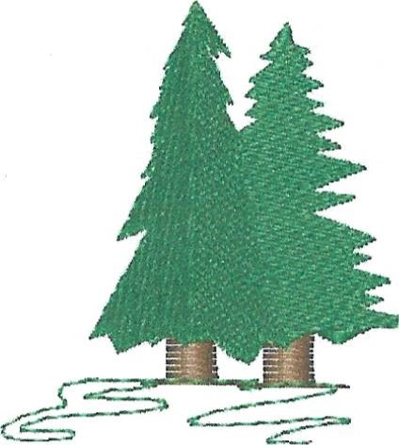
MAKE CHECK PAYABLE TO: NORTHERN AZ BOWLERETTES
MAIL ENTRIES TO: PAM CIRASOLE
1575 W RD 4 N
CHINO VALLEY, AZ 86323
928-227-1258
THIS IS OUR HOLIDAY TOURNAMENT…OPTIONAL GIFT EXCHANGE…BRING A GIFT AND GET A GIFT ON YOUR 1ST REAL STRIKE! WEAR EITHER 1) A HOLIDAY SHIRT FOR THE CONTEST, OR 2) YOUR NAZB SHIRT. COME CELEBRATE WITH US!
This is a Northern AZ Bowlerettes tournament for NAZB members ONLY! ALL MEMBERS WELCOME!
Website:
https://northernazbowlerettes.com/
Facebook page:
https://m.facebook.com/groups/440727224248320?group_view_referrer=search
PLEASE REMEMBER: If there is someone you want to bowl with please either mail in your entries together OR write their name also on your entry form. I will do my best to put you together on the same pair of lanes!
PLEASE RETAIN THE ABOVE FOR TOURNAMENT INFORMATION AND RETURN THE ENTRY BELOW TO PAM CIRASOLE
IF SOMETHING HAS CHANGED SUCH AS ADDRESS, EMAIL OR PHONE NUMBER PLEASE WRITE IT ON THE BACK OF THE BELOW ENTRY FORM PLAZA BOWL DECEMBER 20, 2025

NAME_____________________________________________________________________
Check in starts at 10:00 a.m. Bowling starts at 11:00 a.m.

