NORTHERN AZ BOWLERETTES
JOHNSON LANES SPORTS PAVILION | TOURNAMENT NUMBER 2 | LANE FEES | $ 9.75
19803 N. RH JOHNSON BLVD. | October 18, 2025 | PRIZE FUND | $15.25
SUN CITY WEST AZ 85375 | SIGN IN AT 10:00 A.M. BOWL AT 11:00 A.M. | TOTAL | $25.00
623-544-6140

THIS TOURNAMENT WILL BE 3 REGULAR GAMES.
ENTRY DEADLINE: Oct. 14, 2025
NO REFUNDS AFTER: Oct. 16, 2025
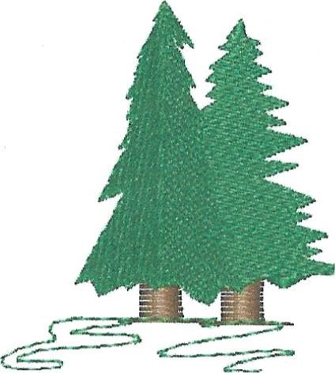
MAKE CHECK PAYABLE TO: NORTHERN AZ BOWLERETTES

MAIL ENTRIES TO: PAM CIRASOLE
1575 W RD 4 N

CHINO VALLEY, AZ 86323
PH: 360-951-3683
This is a Northern AZ Bowlerettes tournament for NAZB members ONLY! ALL MEMBERS WELCOME!
Website: https://northernazbowlerettes.com/
Facebook page:
https://m.facebook.com/groups/440727224248320?group_view_referrer=search

PLEASE REMEMBER: If there is someone you want to bowl with please either mail in your entries together OR write their name on your entry form. I will do my best to put you together on the same pair of lanes!
PLEASE RETAIN THE ABOVE FOR TOURNAMENT INFORMATION AND RETURN THE ENTRY BELOW TO PAM CIRASOLE. IF SOMETHING HAS CHANGED SUCH AS ADDRESS, EMAIL OR PHONE NUMBER PLEASE WRITE IT ON THE BACK OF THE BELOW ENTRY FORM.

JOHNSON LANES SPORTS PAVILION October 18, 2025

NAME
10:00 a.m. Check-in starts 11:00 a.m. Bowling begins

