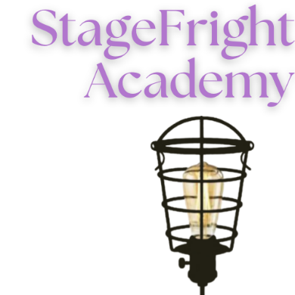
StageFright Spring Class Registration Form 2025
Pricing: $275/per student/per class.
*Reach out via email to info@stagefrightacademy.org if you are in need of a payment plan or scholarship information.
Student Information:
Name: | Age:
Medical issues:
Allergies: | Shirt Size:

Parent Information:
Caregiver 1: | Phone:
Caregiver 2: | Phone:
Primary Email:
Emergency Contact:

Pick Up Information: *People approved to pick up child
Name:
Name:
Class options:
- Musical Theatre 1 (Ages 7-11)  - Musical Theatre 2 (Ages 12+) | - Acting 1 (Ages 5-8)  - Acting 2 (Ages 9+)
Please list below which classes you are signing up for:

Spring Class Schedule 2025
Classes will meet weekly between January 13-May 9 excluding the week of March 16 in observation of the Spring Break.

