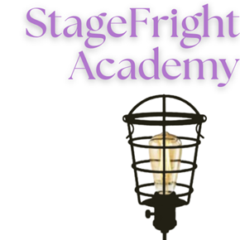

Scholarship Application: Summer 2025
Fill out this application and send it to info@stagefrightacademy.org.

Student Information:
Name: | Age:

Parent Information:
Caregiver 1: | Phone:
Primary Email:

Please identify below which project you need financial assistance with and how much assistance you are looking for.

Please discuss your previous involvement in StageFright Academy (performance and/or tech).

Please share how this scholarship would benefit you.

By signing below, you recognize you or your parent/guardian understand that the StageFright Academy Scholarship program requires an assistance on the StageFright Show you are registering for. This may include technical assistance, house managing, costume work or working night of show (concessions or merch table).

