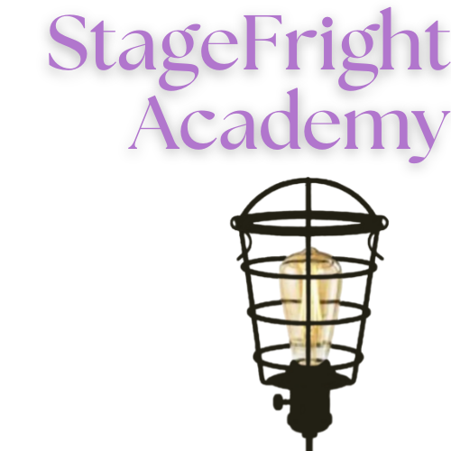
Fall Semester 2025
Elementary Acting & Musical Theatre:
$125/per semester
Junior Troupe Dues: $125/per semester
Senior Troupe Dues: $125/per semester
Peter Pan Jr: $175 show fee

Please reach out to 772-579-2012 with questions.
*Email this completed form to info@stagefrightacademy.org to reserve your spot now!

Student Information:
Name: | Age:
Student Email:
Medical issues:
Allergies: | Shirt Size:

Parent Information:
Caregiver 1: | Phone:
Primary Email:
Emergency Contact:

Please circle the program(s) you’re registering for.
Elementary Acting Junior Troupe (Middle School)

Elementary Musical Theatre Senior Troupe (High School)

