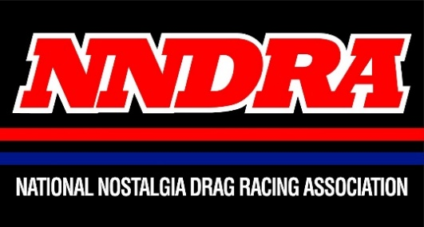
NNDRA Membership Form

The National Nostalgia Drag Racing Association (NNDRA) is an organization dedicated to the early days of drag racing, the glory days, as many of drag racing’s pioneers and racers from the 50’s thru the 70’s established their place in the history of the sport. We highlight historic moments of the past and contributions by the legends who set a pattern for the future of the sport of drag racing. The association covers the gamut of this history not only for racers, but for the many people who contributed their genius of engineering skills in the development of the latest trick equipment to make drag racing vehicles excel. The personalities who created the color at many events nationwide. NNDRA covers the realm of nostalgia drag racing and keeps it alive for the future generations who follow in the sport.
NNDRA membership dues help support the Legion of Honor Awards at Dragfest / York US Reunion held annually at the Lebanon Valley Fair Grounds in Lebanon, PA. the second weekend of January. Membership dues go into supporting the acquisition of industry guests for the show, securing historical vehicles for the show and the costs for awards and plaques for the annual class of inductees. Your membership helps to provide recognition for deserving individuals who have contributed so much to drag racing history.
- Annual Membership (New) ($20.00)
Membership card and decals will be mailed to you. Membership includes $5.00 discount into several Motorama
Production shows with valid membership card present.
- Annual Membership (Renewal) ($20.00)
Updated membership card and new decals will be mailed to you. Membership includes $5.00 discount into several
Motorama Production shows with valid membership card present.
- Lifetime Membership ($100.00)
Charter membership card and exclusive decals will be mailed to you. Membership includes $5.00 discount into all
Motorama Production shows for member's lifetime with charter membership card present.

First Name __________________________________________ Last Name______________________________________
Email _____________________________________________________________________________________________
Phone Number _____________________________________________________________________________________
Address ___________________________________________________________________________________________
City ________________________________ State ________________________________ Zip Code__________________
Please return this form to: Motorama Productions NNDRA Membership - 476 Barbara Drive - Mechanicsburg PA. 17050
The NNDRA is a Motorama Productions Organization contact us at 717-307-5466 or andy@agoodman.net
www.motoramaproductions.com

