***FURBALL FARM MERCHANDISE – to order email*** [***furballmerch@gmail.com***](mailto:furballmerch@gmail.com)



V-Neck Tee will also have FF logo.



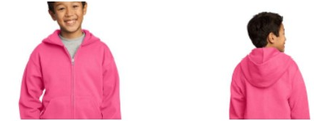



Brushed Cotton Twill Adjustable Cap - $25 – Black, Yellow, Orange, Royal, also available in Gray (not shown)

Beach Wash Visors – $25 - Denim, Red Rock, Blue, Coal, White

Tumblers - $25 – Coral, Royal, Black, Red, also available in Seafoam and Purple (not shown)

