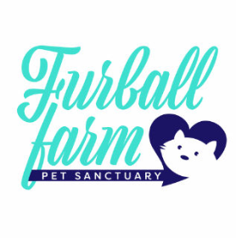 WAIVER OF LIABILITY AND HOLD HARMLESS AGREEMENT FOR
Visitation / Volunteer of Furball Farm Pet Sanctuary
In consideration for being allowed to visit/volunteer at Furball Farm Pet Sanctuary, I hereby RELEASE, WAIVE, DISCHARGE AND COVENANT NOT TO HOLD RESPONSIBLE Furball Farm Pet Sanctuary from any and all liability, claims, demands actions, including court costs and attorney fees, and causes of action whatsoever arising out of or related to any loss, damage, or injury, including death, that may be sustained by me, or any of the property belonging to me.
IN SIGNING THIS RELEASE, I ACKNOWLEDGE AND REPRESENT that I have read the forgoing Waiver of Liability and Hold Harmless Agreement, understand it and sign it voluntarily as my own free act and deed; no oral representations, statements, or inducements, apart from the foregoing written agreement, have been made. I am at least 18 years of age and fully competent; and I execute this Release for full adequate and complete consideration fully intending to be bound by same.
At times we make videos and live streaming on social media I consent____ I do not consent____ to be on video
Signed on Month __________ Day__________ , 2022
PARTICIPANTS (legal guardian or scout/troop leader signing for minor/minors, list all minors on bottom)

________________________________________ ______________________________________
Print Name Witness Print Name

________________________________________ ______________________________________
Signature Witness Signature

List all minors / family members_

Furball Farm Pet Sanctuary 3405 220th St E Faribault, Mn 55021 (612-298-7634) Created 8/10/2022
www.furballfarmpetsanctuary.com www.facebook.com/FurballFarmPetSanctuary
furballfarmpetsanctuary@gmail.com furballfarmmerch@gmail.com

