Below are photos of all the winners from the ECSCSC Specialty held 8/28/21.  They are captioned with the dog’s name so the photos would appear as large as possible.  The armband number is noted so if you want more info (i.e. date of birth, sire, dam, breeder, owner) you can easily look up the data from the catalog as published in the 09-21 *Courier* or online at Jack Bradshaw Dog Show Superintendents.  In case you are not aware, there is a protocol for assigning armband numbers at most all-breed dog shows.  Since this was a designated Specialty at an All-Breed show, that protocol was followed.  Therefore if the caption has an odd numbered armband you are looking at a dog and if it has even numbered, at a bitch.

All photos by Bettina Bienefeld ([https://www.bestinshowphoto.com](https://linkprotect.cudasvc.com/url?a=https%3a%2f%2fwww.bestinshowphoto.com&c=E,1,fVIUM1pDcXGOdXyTzWZMPwTVNMiLUXaLo_JZU_-fT5bctcnr0mjI2kTBqaLJheq6aucttSG8l8hJdwbI9M1yEc0zY6mcGJlZ8Ke7x5BY_sC6&typo=1)) except as noted.

**AWARD WINNERS AT THE ECSCSC SPECIALTY 8/28/21**

**BEST OF BREED**

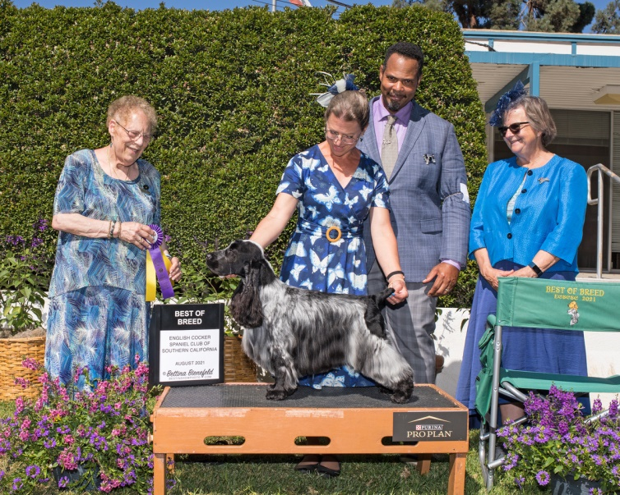

|  |  |
| --- | --- |
|  | **(39) GCH MANDERLEY'S BLUE MOUNTAIN AMBASSADOR** |

**BEST OPPOSITE SEX**

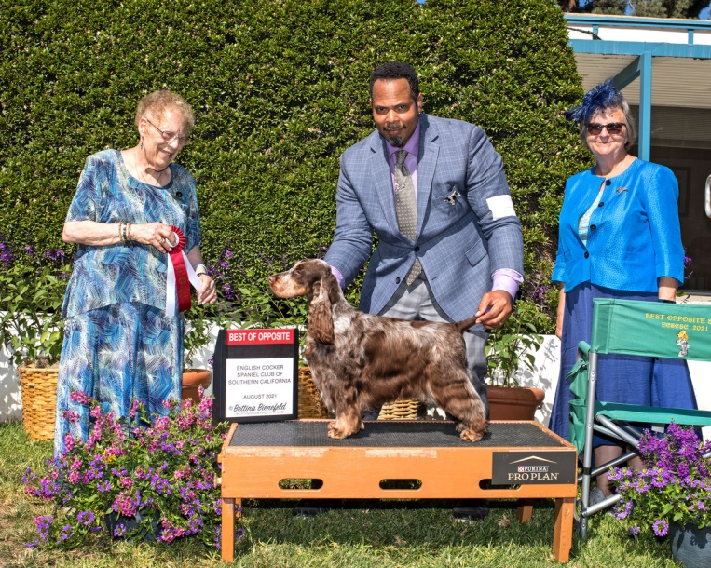

**(44) GCH JARDE' N MANDERLEY'S CHOCOLATE BLISS**

**SELECT DOG/BOBOH**

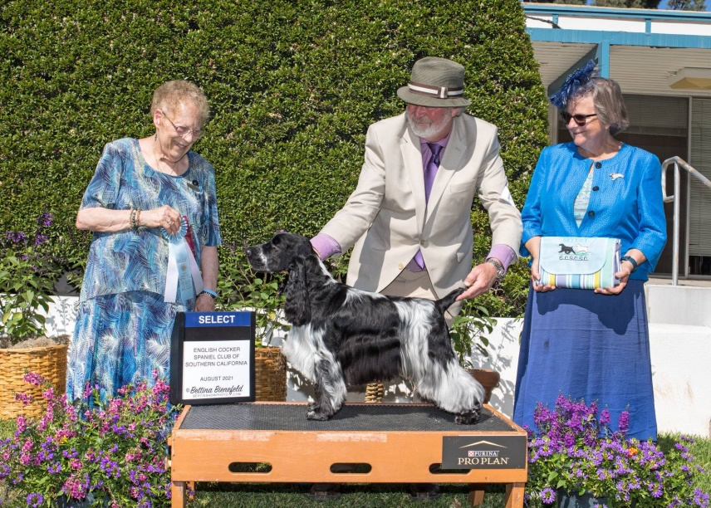

**(350 CH ENTWOOD FUTURE LEGEND**

**SELECT BITCH**

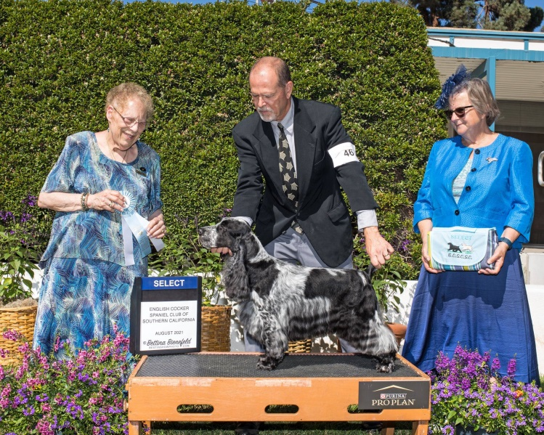

**(46) CH SONGBIRD 'N STIRLING AFTER THE STORM**

**AWARD OF MERIT**

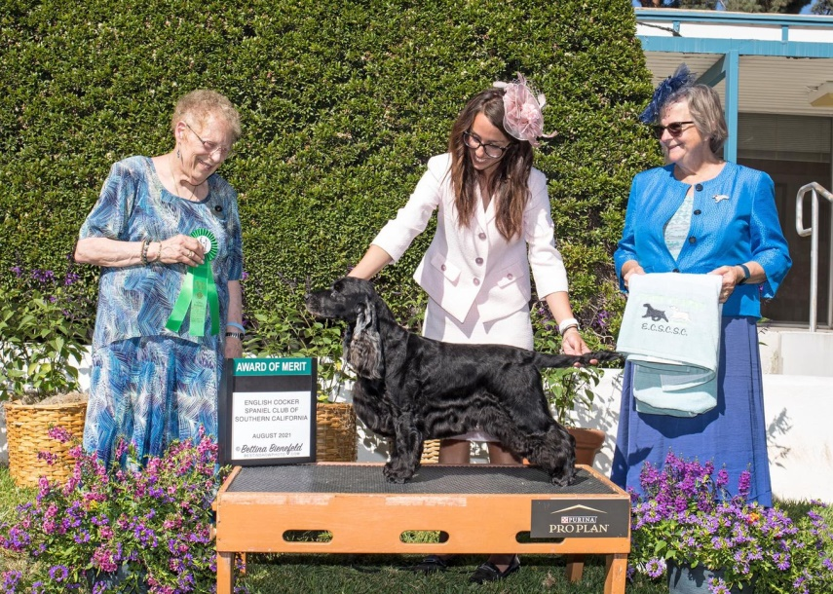

**(29) CH GALLINAGOS CAUSE NOTHING COMPARES**

**AWARD OF MERIT**

**(photo not taken at Specialty)**

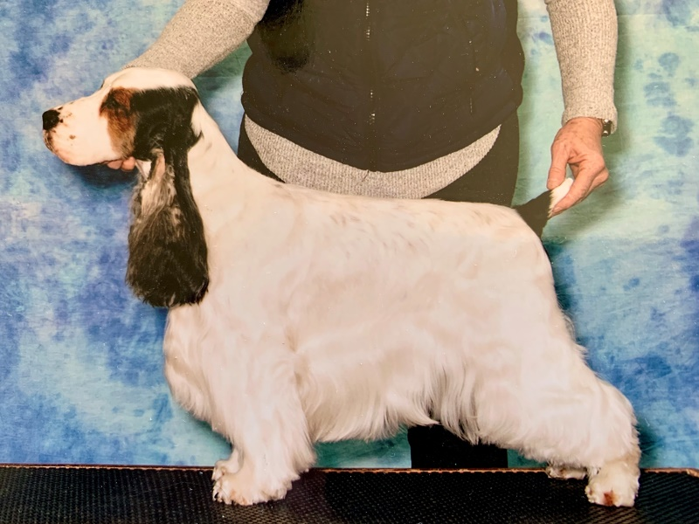

**(51) CH CEDARGLEN RELIANCE MEMORY SEEKER**

**BEST OF WINNERS, WINNERS DOG**

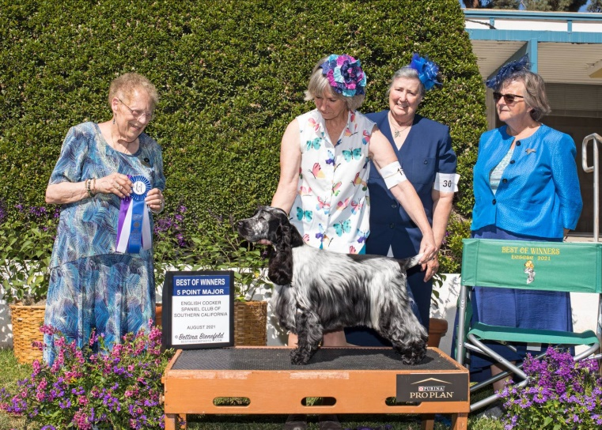

**(17) LYNANN'S SOUL MAN**

**WINNERS BITCH, BEST BRED BY**

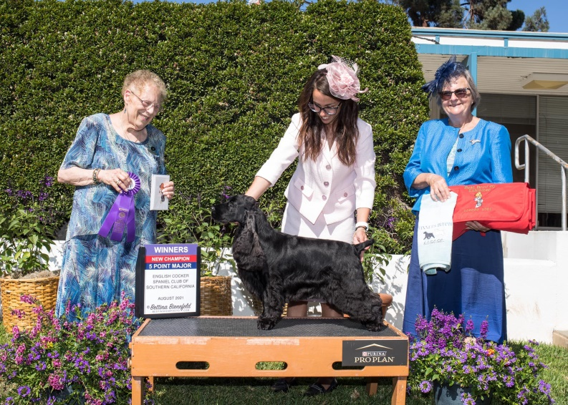

**(26) BELLAMY THE BLACK SWAN**

**RESERVE WINNERS DOG, BEST PUPPY**

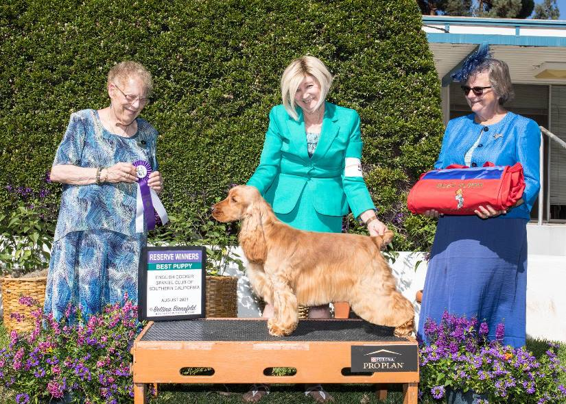

**(5) DAWNGLOW PLAYING THE FIELD AT TARRENDAYLE**

**RESERVE WINNERS BITCH**

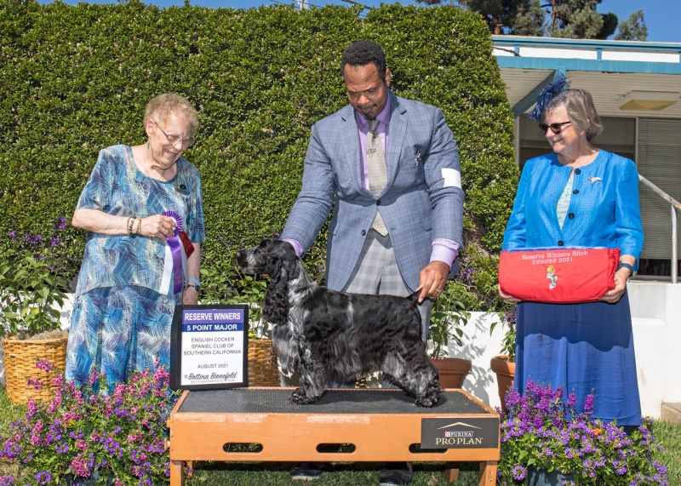

**(24) MANDERLEY'S ROSALIND FOUND IT FIRST**

**BEST IN PUPPY SWEEPSTAKES**

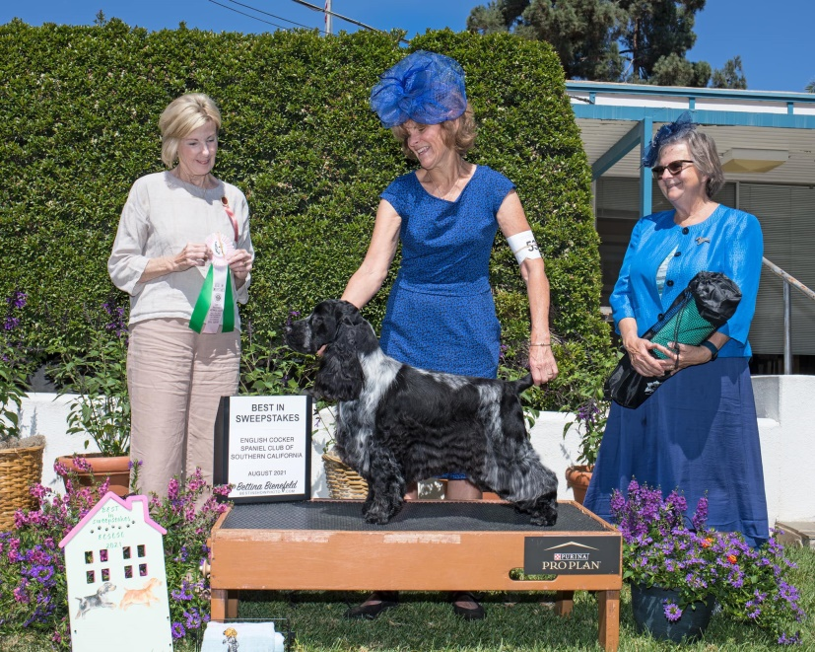

**(53) CH LYNANN'S RHYTHM OF MY HEART**

**BEST OPPOSITE SEX IN PUPPY SWEEPSTAKES**

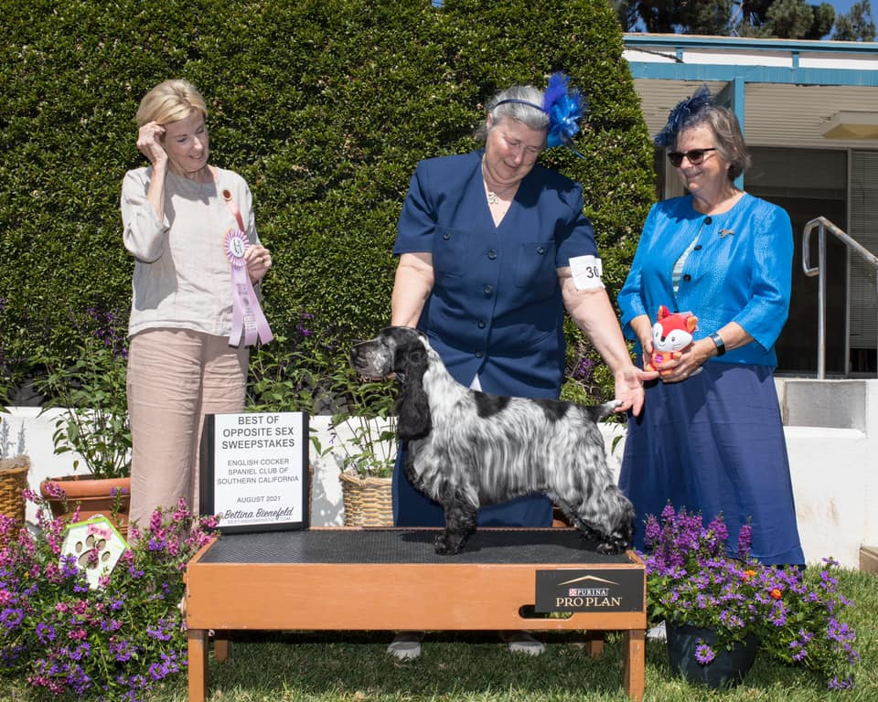

**(30) LYNANN'S DRAWN TO THE RHYTHM**

**BEST IN VETERAN SWEEPSTAKES**

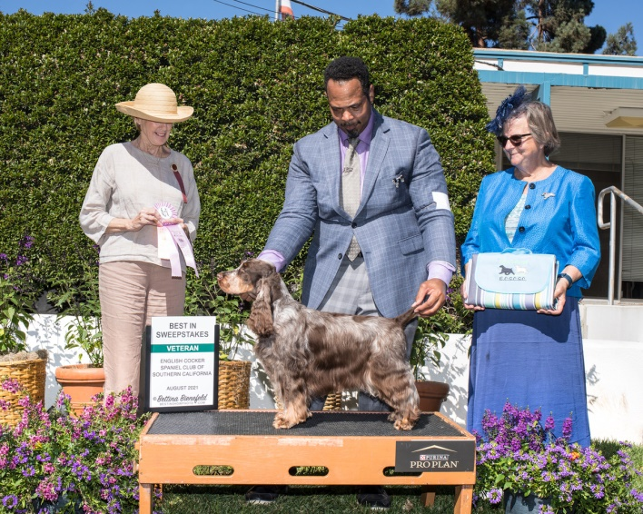

**(44) CH JARDE' N MANDERLEY'S CHOCOLATE BLISS**

**BEST OPPOSITE SEX IN VETERAN SWEEPSTAKES**

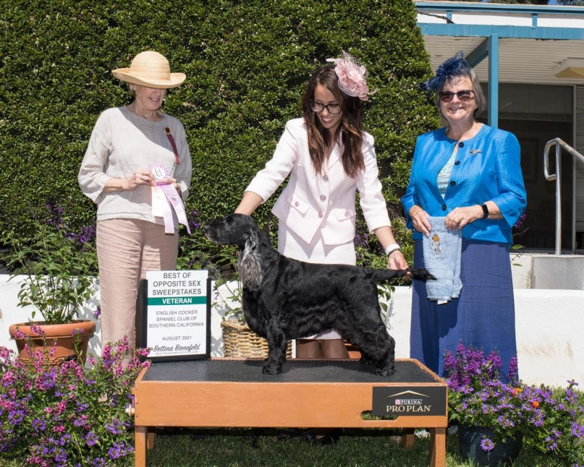

**(29) CH GALLINAGOS CAUSE NOTHING COMPARES**