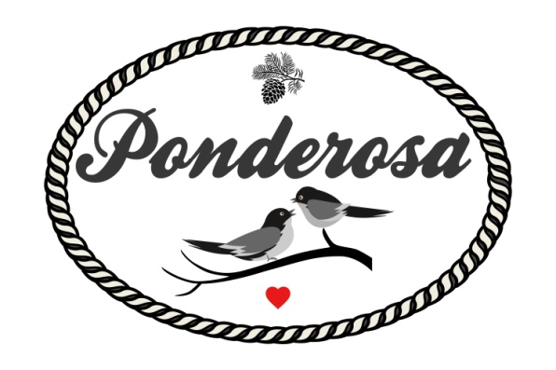

Micro Wedding Packages 2022

\*plus tax & applicable fees

All Inclusive of - Venue Rental, Bar Staff,

Catered Dinner, Table Linens, Lawn games

30-40 Guests $3999

40-50 Guests $4299

50-60 Guests $4599

60-70 Guests $4899

\*Add in Cocktail Hour appetizers starting at $6 pp

\*Add in our PA Bluetooth Speaker, Dance floor lighting & Uplighting Package for $200.00 / No DJ Provided

\*Add in a Day of planner for $800

\* Add in a mini dessert station for $5 per person

\*Add in a Professional DJ $1000

\*Add in pro photographer - varied rates apply please inquire