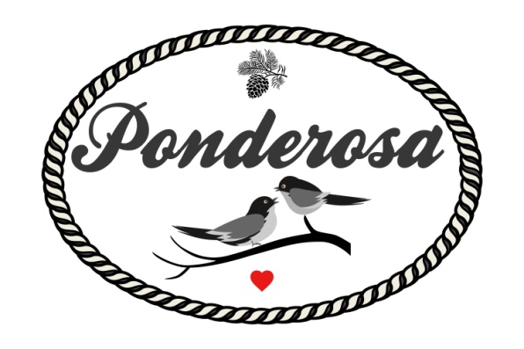
Standard Pricing Sheet 2022-2023
Email us ponderosaeventstx@gmail.com
Visit www.ponderosaeventstx.com for more information
Jan & Feb  Mon-Thurs $2999  Fri - Sunday $3700 | March - June  Mon - Thurs $3599  Fri - Sunday $4200 | July & August  Mon - Thurs $2999  Fri - Sunday $3700 | September - December  Mon - Thurs $3599  Fri - Sunday $4200  NYE - $5000
What's Included with your rate
*Venue is yours for the day, 10am - 11pm (NYE 12:30am) / 2 separate Changing suites
*Gorgeous outdoor ceremony site with cedar altar & barnwood benches facing our pond
*Up to 4 hours rehearsal time if needed (schedule with us) / overnight storage for next day
(Inside climate controlled barn 2400 Sq Ft, room for 150-ish guests / farm style & round tables)
Outside unlimited space for seating / dining / we can assist in renting more chairs/tables/tents etc
*Indoor Cedar Bar Area & Gravel Patio/Bar Area for Cocktail Hour & Acres for Lawn Games
*2 Changing suites - (2 separate dressing room cabins) / Overnight Quarters for 2 $120 pn
*Lots of Parking / Flat Surfaces / Gravel areas / Fire Pits / Parking Attendant
*6 ft Barn Wood Sign In Table, 6 ft Gift Table Provided, Buffet Tables Provided (ask us about catering!)
*Bring your own alcohol (TABC Bartenders are mandatory and security will be provided and scheduled by our staff for an added fee) No personal alcohol permitted / But it can be kept at bar
* Catering kitchen for food storage / On Site Caterer Urban Cowboy Provided at Discounted Rate, Food Truck also available! Outside grilling area for use
*Staffing provided for set up and break down of tables and chairs
*Clean up staff available if needed for any outside catering or provide your own
Al La Carte Extras
*Lawn Games Rental - Jenga, Corn Hole, Washers, Giant Dice, Lawn Bowling. Bucket Beer Pong $50
*Additional Trash Removal Fee for over 125 guests - $100
*Catering / Full Service / Limited Service / please inquire - Discounted Rate
*Outdoor Heaters $35 ea - Fire Pit $50
*LODGING - Stay in RV's (you provide/rent them), we have hookups. - $40 ea
Dry Camping (you provide tents) - $15 Per Tent
Inquire with us about special custom pricing based on how you stay! Meals can be arranged for your guests as well
*DJ - 6 Hours $1100 (NYE DJ Rate varies)
Catering packages start at $18.99 Per Person, plus labor
*In house Photographer, Noble Little - Rates Vary
Need more vendors / extras - just ask us for help!

