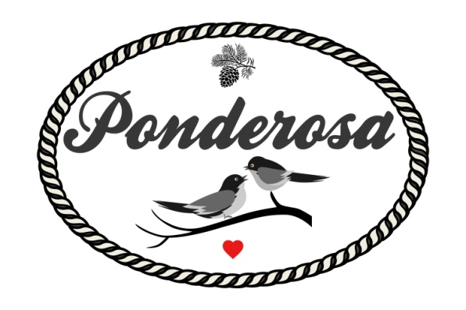
Standard Pricing Sheet 2020-2021
Email us ponderosaeventstx@gmail.com
Visit www.ponderosaeventstx.com for more information
Jan & Feb  Mon-Thurs $2199  Fri - Sunday $2499 | March - June  Mon - Thurs $2399  Fri - Sunday $2999 | July & August  Mon - Thurs $2399  Fri - Sunday $2799 | September - December  Mon - Thurs $2399  Fri - Sunday $2999  NYE - $3999
What's Included with your rate
*Venue is yours for the day, 10am - 11pm
*Gorgeous outdoor ceremony site with cedar arch & barnwood benches facing our pond
*Up to 4 hours rehearsal time if needed (schedule with us) / overnight storage for next day
(Inside climate controlled barn 2400 Sq Ft, room for 170-ish guests / farm style & round tables)
Outside unlimited space for seating / dining / we can assist in renting more chairs/tables/tents etc
*Indoor Cedar Bar Area & Gravel Patio/Bar Area for Cocktail Hour & Acres for Lawn Games
*Extra Large Bathroom for Bridal Party (Separate 600sq ft Suite-Cottage also available)
*Lots of Parking / Flat Surface / Gravel areas / Fire Pits / Parking Attendant
*6 ft Barn Wood Sign In Table, 6 ft Gift Table Provided, Buffet Tables Provided (ask us about catering!)
*Bring your own alcohol (TABC Bartenders are mandatory and security will be provided and scheduled by our staff for an added fee) No personal alcohol permitted / can be kept at bar
* Catering kitchen for food storage / On Site Caterer Urban Cowboy Provided at Discounted Rate, Food Truck also available! Outside grilling area for use
*Staffing provided for set up and break down of tables and chairs
*Clean up staff available if needed for any outside catering or provide your own
*RV Hook up - for ONE RV - additional needed please let us know
*Groom's hangout shack coming Fall 2020!
*Use of pond for fishing during rehearsal (must clean up)
Al La Carte Extras
*Security Guard $200 - 5 Hours / Required for all weddings and large events
*TABC Bartender(s) $180 - 6 Hours / $28 Per Additional Hour (1 Bartender per 60 guests)
*Day of Planner $750 - Week of $1200 - Month of $2000
*Lawn Games Rental - Jenga, Corn Hole, Washers, Giant Dice, Lawn Bowling. Bucket Beer Pong $50
*Additional Trash Removal Fee for over 125 guests - $50
*Catering / Full Service / Limited Service / Food Truck, please inquire - Discounted Rate
*Petting Zoo please inquire / Alpacas / Donkeys (Starting at $400)
*Shuttle Van to local hotels / please inquire for rates - Starts at $500 for 3 Hours
*Professional Fireworks Show (Please inquire) Rates start at $950 for a show ++ for more time

Need more vendors / extras - just ask us for help!

