Health History Questionnaire

Patient name Date

Have you ever been diagnosed or told you have any of the following? Circle the correct response.

- High blood pressure Yes No
- Hardening of the arteries (arteriosclerosis) Yes No
- Diabetes Yes No
- Tuberculosis Yes No
- Cancer Yes No
Where?
- Heart or blood diseases Yes No
- Bone spurs on the neck bones (cervical sprain) Yes No
- Whiplash injury (flexion-extension injury, cervical sprain) Yes No
- Have you or any of your relatives ever suffered a stroke? Yes No
- Were you ever a smoker? Yes No
From to
- Do you take medication on a regular basis? Yes No
- Visual disturbances (blurring, loss, double vision) Yes No
- Hearing disturbances (loss, ringing, other noise) Yes No
- Slurred speech or other speech problems Yes No
- Difficulty swallowing Yes No
- Dizziness Yes No
- Loss of consciousness, even momentary blackouts Yes No
- Numbness, loss of sensation, loss of strength or weakness in the face,
fingers, hands, arms, legs, or any other parts of the body? Yes No
- Sudden collapse without loss of consciousness Yes No

Indicate the location of your pain by shading in the appropriate area(s):
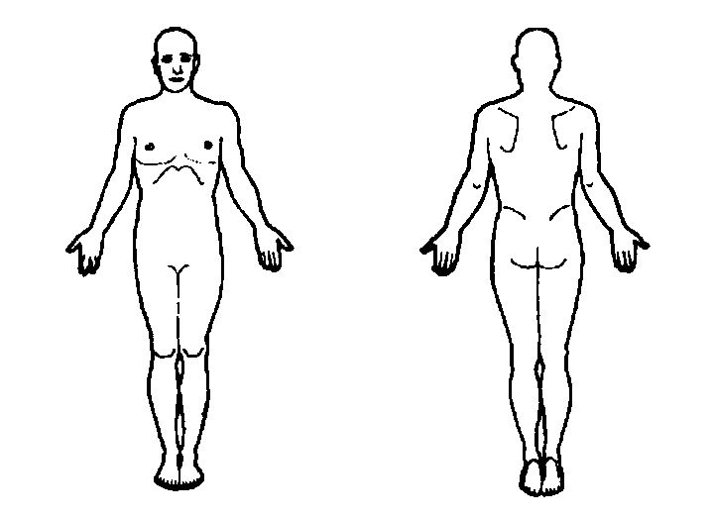
Indicate the severity of the pain by circling a number:

| 0 1 2 3 4 5 6 7 8 9 10 |
No pain Extreme pain

