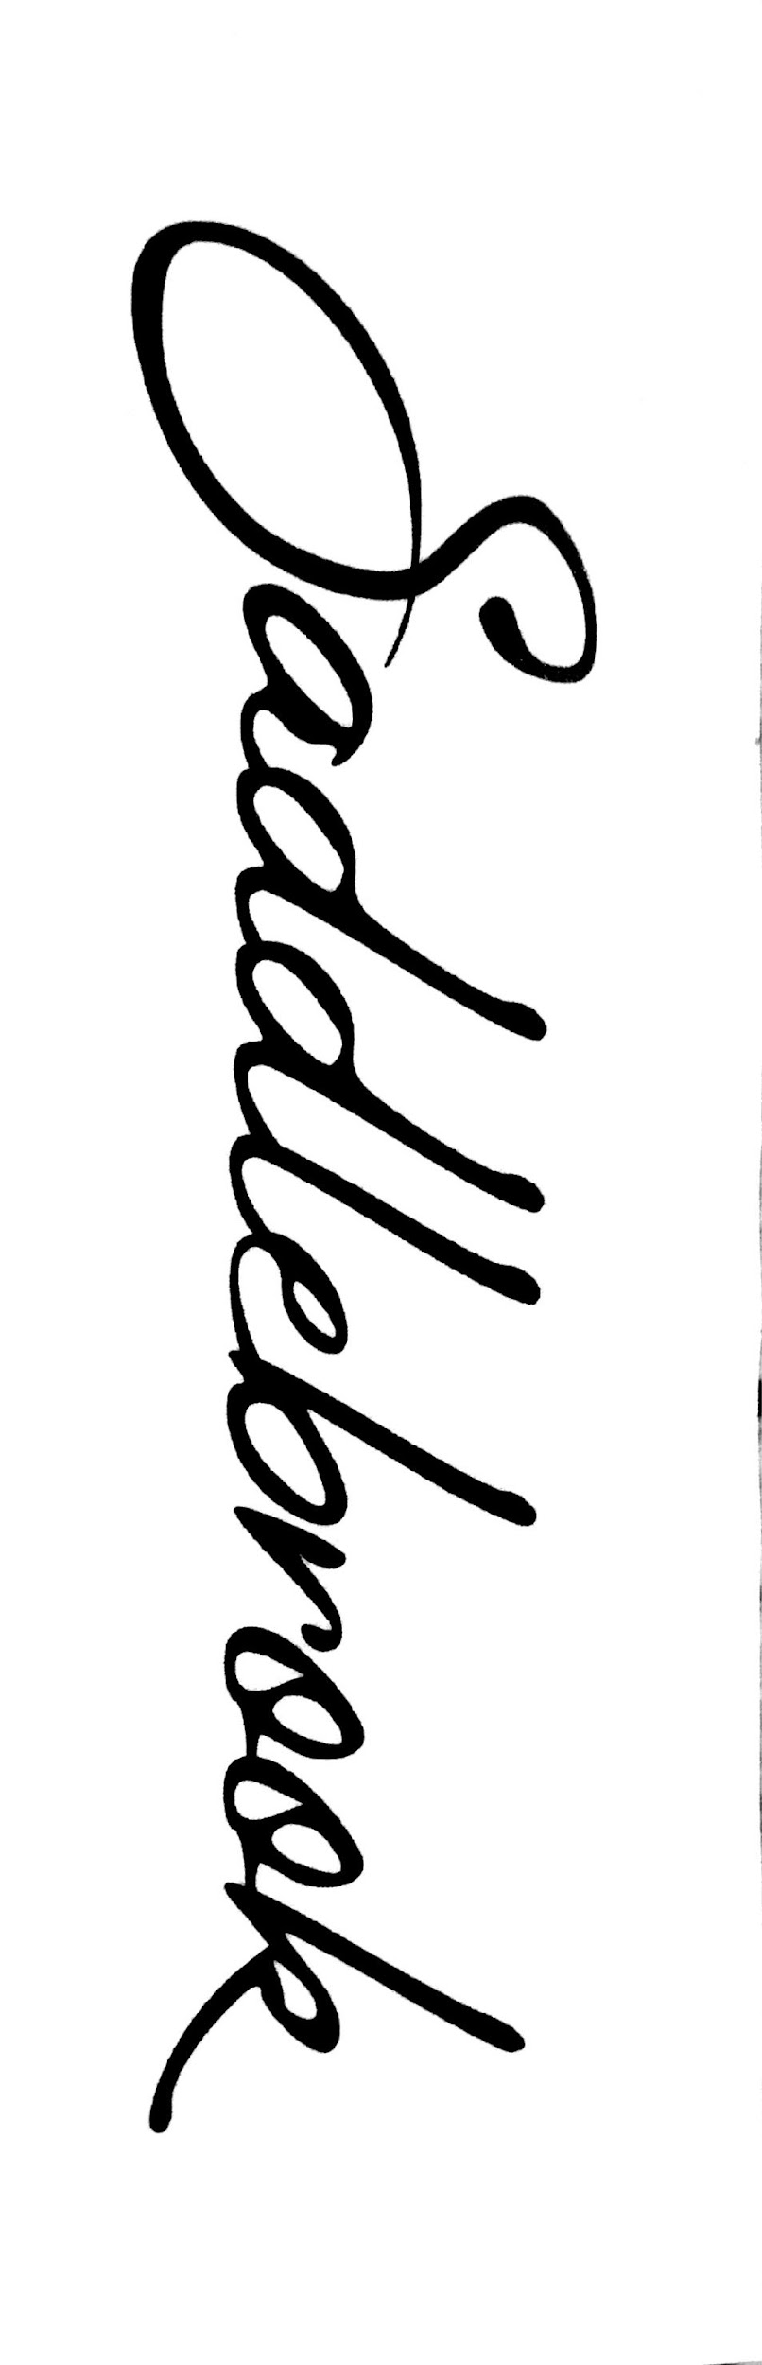

Current Resident Contact Form
Please complete this form and update so we always have current resident contact information on file.
You have the option to indicate whether we may share your contact information with other residents. We will never share your contact information with anyone outside our Saddlebrook community.

Property Address:
Owner’s Name:
Move In Date:

Who’s living at your house?
Who | Contact Info  For pets please put the species, breed, and color in place of phone/email | Share with Residents?
Primary Owner and Contact | Name: | ☐ Yes  ☐ No
Primary Owner and Contact | Phone: | ☐ Yes  ☐ No
Primary Owner and Contact | Email: | ☐ Yes  ☐ No
☐ Adult  ☐ Child  ☐ Pet | Name: | ☐ Yes  ☐ No
☐ Adult  ☐ Child  ☐ Pet | Phone: | ☐ Yes  ☐ No
☐ Adult  ☐ Child  ☐ Pet | Email: | ☐ Yes  ☐ No
☐ Adult  ☐ Child  ☐ Pet | Name: | ☐ Yes  ☐ No
☐ Adult  ☐ Child  ☐ Pet | Phone: | ☐ Yes  ☐ No
☐ Adult  ☐ Child  ☐ Pet | Email: | ☐ Yes  ☐ No
☐ Adult  ☐ Child  ☐ Pet | Name: | ☐ Yes  ☐ No
☐ Adult  ☐ Child  ☐ Pet | Phone: | ☐ Yes  ☐ No
☐ Adult  ☐ Child  ☐ Pet | Email: | ☐ Yes  ☐ No

Continued on back
Who | Contact Info  For pets please put the species, breed, and color in place of phone/email | Share with Residents?
☐ Adult  ☐ Child  ☐ Pet | Name: | ☐ Yes  ☐ No
☐ Adult  ☐ Child  ☐ Pet | Phone: | ☐ Yes  ☐ No
☐ Adult  ☐ Child  ☐ Pet | Email: | ☐ Yes  ☐ No
☐ Adult  ☐ Child  ☐ Pet | Name: | ☐ Yes  ☐ No
☐ Adult  ☐ Child  ☐ Pet | Phone: | ☐ Yes  ☐ No
☐ Adult  ☐ Child  ☐ Pet | Email: | ☐ Yes  ☐ No
☐ Adult  ☐ Child  ☐ Pet | Name: | ☐ Yes  ☐ No
☐ Adult  ☐ Child  ☐ Pet | Phone: | ☐ Yes  ☐ No
☐ Adult  ☐ Child  ☐ Pet | Email: | ☐ Yes  ☐ No
☐ Adult  ☐ Child  ☐ Pet | Name: | ☐ Yes  ☐ No
☐ Adult  ☐ Child  ☐ Pet | Phone: | ☐ Yes  ☐ No
☐ Adult  ☐ Child  ☐ Pet | Email: | ☐ Yes  ☐ No

Emergency Contact Info
In case there is an emergency situation with your property and we can’t get in contact with any of the adults above, please provide at least one emergency contact:
Name:
Phone:
Relationship:

Please email or deliver this form to a Board member.. Thank you!
Christina Mason, HOA President 6523 NE 1st St Email bod1@saddlebrookrenton.org
Kinita Yahia, HOA Treasurer 6606 NE 1st St
Julie Bills, HOA Asst Treasurer 6517 NE 1st
Mai Tran, HOA Secretary 6618 NE 1st St

