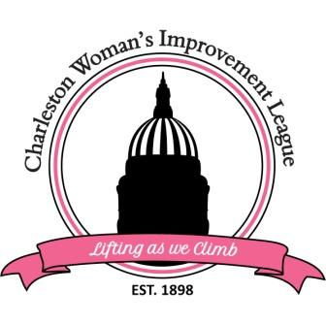

CHARLESTON WOMAN’S IMPROVEMENT LEAGUE, INC.
PO Box 11278, Charleston, WV 25339
Scholarship Programs
The Charleston Woman’s Improvement League, Inc. will be offering two scholarships. See scholarship qualifications below:

- Academic Scholarship - $1000

a. Must be an African American female student accepted or enrolled
full-time in a 4- year college or university
b. Resident of Kanawha or Putnam County
c. US Citizen
d. 2.75 GPA or better
e. Participant in community activities
f. Complete 500 Word Essay

2. Thelma McDaniel Technical Scholarship - $500

- Must be an African American female student accepted to or enrolled in a career or technical school
- Must have a high school diploma or GED certificate
- 2.50 cumulative GPA or better
d. Resident of Kanawha or Putnam County
e. US Citizen
f. Participant in community activities
g. Complete 500 Word Essay

Scholarship applications may be obtained at the following website: https://cwilwv.com/

All applications must be postmarked by April 15, 2026.

