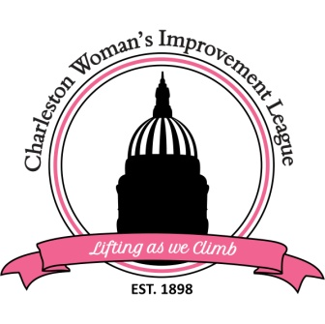
CHARLESTON WOMAN’S IMPROVEMENT LEAGUE, INC.
PO Box 11278 Charleston, WV 25339

2022 ACADEMIC SCHOLARSHIP APPLICATION
The Charleston Woman’s Improvement League is offering a $1000 Scholarship.

Applicant Name:

ACADEMIC SCHOLARSHIP ELIGIBILITY REQUIREMENTS
**You must adhere to all requirements for the Academic Scholarship. All of the following criteria must be met in order to be considered eligible. You must also submit other required documents as stated on Page 2 of this packet.

Criteria for The Charleston Woman’s Improvement League, Inc. Academic Scholarship:
- Must be an African American female who has been accepted or is currently enrolled as a full-time college student (at least 12 hours) at a four (4) year institution.
- Must be a Kanawha or Putnam county resident
- Must be a citizen of the United States
- Must have a cumulative grade point average (GPA) of 2.75 or better
- Must complete a 500-word essay
- Must participate in community activities, i.e., clubs, organizations, church, volunteer work.
- Must not be related by birth or marriage to an active CWIL, Inc. member.

Required Documents
Your application packet must include:
- A completed application including signature
- A completed and signed Release of Information Form
- Proof of college enrollment (college acceptance letter or current college schedule).
- An official transcript with school seal and signed by an official from your high school or a 4-year college or university (whichever was attended last).
- Two completed and signed Recommendation Forms mailed directly from the rater to the address listed below.
  - One letter from an official at your high school or the college/university currently attending
  - One letter from an employer, volunteer supervisor or religious/civic leader.
THE LETTERS OF RECOMMENDATION CANNOT BE FROM FAMILY MEMBERS!
- An essay with a maximum of 500 words: “How do you anticipate using your degree to impact the African American community?” The essay must be computer generated in size 12 Arial font double spaced.
All applications must be postmarked by May 15, 2022
Hand-delivered and incomplete applications will not be accepted.

Submit Completed Application to:
Attention: Scholarship Committee
Charleston Woman’s Improvement League, Inc.
P.O. Box 11278
Charleston, WV 25339

Section 1: Applicant Information

First Name | Middle Name |  | Last Name
Street Address

City |  | State |  | Zip
Home Phone |  | Cell Phone |  | Email
Parent/Guardian Name (18 and under)

Section 2: High School Information

Name of High School now attending

Street Address

City | State | Zip

Section 3: College/University Information

Name of 4-year institution applied to:

Street Address

City | State |  | Zip
Major |  | Expected date of graduation

Section 4: Current and past awards and special honors

1.

2.

3.

4.

5.

Section 5: Current & Past Community Service/Extra-Curricular Activities
(e.g., School, religious and/or social groups)
Name of Organization/Activity | Membership Dates
1.

2.

3.

4.

5.

Section 6: Certification

I certify that to the best of my knowledge, the application information I have completed is true and correct. I fully understand that any false information or misrepresentation may disqualify me from consideration for this scholarship. I also understand that all information submitted becomes the property of CWIL, Inc. and will be kept confidential.

Applicant Signature | Date
Parent/Guardian Signature (if under 18) | Date

