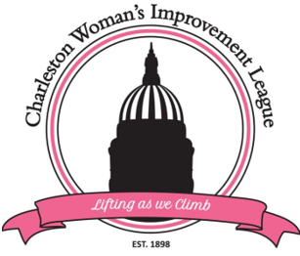

February 17, 2025

Greetings,

We are pleased to announce that the Charleston Woman’s Improvement League, Inc. (CWIL), is accepting applications for the 2025 scholarship program. The Charleston Woman’s Improvement League, Inc. is a non-profit organization with a 127 year history of giving back to the community. Our scholarship program provides scholarships annually to outstanding young women who are pursuing their educational goals. CWIL will be offering two scholarships: Academic Scholarship in the amount of $1000 and Thelma McDaniel Technical Scholarship in the amount of $500.
Attached are the applications with guidelines. Please feel free to circulate this exciting information to your churches, schools, academic providers throughout Kanawha and Putnam counties.
Completed applications must be post-marked no later than April 15, 2025 and mailed to:
CWIL Scholarship Committee
Post Office Box 11278
Charleston, WV 25339
If you have any questions, please contact Donna Walker-Campbell, CWIL Scholarship Committee Chair at cwilwv@gmail.com or (304) 421-4125.

