GRENADIER ISLAND GOLF TOURNAMENT
Rockport Fundraiser
Saturday, September 16, 2023
Rain Date: Sunday, September 17, 2023

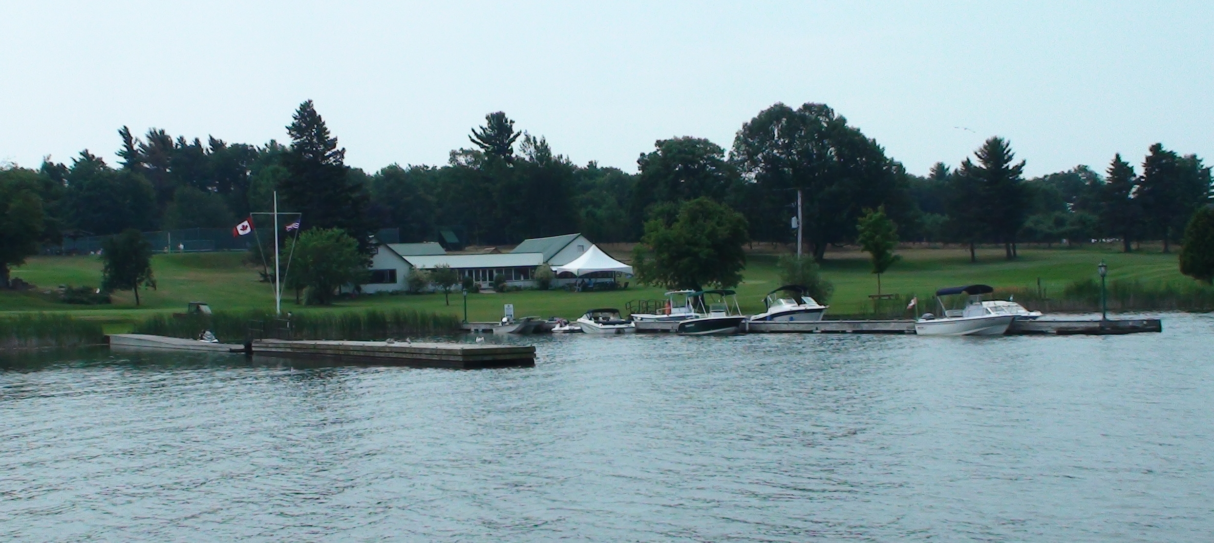
Looking for a unique experience? Come play a four person scramble, 18 holes, on an island! The Grenadier Island Country Club along with Friends of Rockport Customs and the Rockport Development Group is sponsoring this fundraiser tournament to help raise money for a history wall at the new Rockport Customs Park. GICC is only accessible by boat and is a private golf course. This is your opportunity to play this course!!! The first 52 people to register will get to enjoy this fabulous experience. You don’t want to miss out.
You can make your own team or we will place you with others to make a four person team. If you need a boat ride to the island, arrive at Andress Boat Works, 31 Front St., Rockport at 9:30 a.m. or after. River taxi will leave every 20 minutes. Last river taxi leaves shore for the island at 10:30 a.m. Cost is $15 per person for return trip thanks to Andress Boat Works.
Must have your own clubs. Pull carts are available for rent ($7.50) but can bring your own. Minimum number of riding golf carts available ($45). These will be offered first to those with mobility difficulties.
Registration: 10:00 – 11:00 a.m.  Tee-off: 11:00 a.m.  Cost: $150.00/person
Phone Dianne at 613-802-8606 to register
Along with a game of golf, each participant will enjoy a light lunch, an incredible home cooked dinner and will receive an official $50 income tax receipt at the tournament. A bar will be available. Award presentation following the golf.
We thank the Grenadier Island Country Club for allowing us this wonderful opportunity.

Registration
Team Members: (Name & address required for income tax receipt)
#1 | Name
Address
Email
Phone

#2 | Name
Address
Email
Phone

#3 | Name
Address
Email
Phone

#4 | Name
Address
Email
Phone

Require a boat taxi to Grenadier Island: Yes No
Number of pull carts needed for team: 0 1 2 3 4
Riding Golf cart needed: 0 1 2

