LKS2
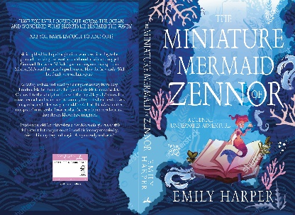
Text: The Miniature Mermaid of Zennor
Guided Reading (whole class example)

https://www.waterstones.com/book/the-miniature-mermaid-of-zennor/emily-harper/9781803781631
Publisher: Cranthorpe Millner Publishers
ISBN: 9781803781631

Lesson outcome | Warm up hook | Main activity | Adaptive offer | Vocabulary
To form my own response to a text. | What inspires a writer?  Children are to explore the story at the heart of The Miniature Mermaid of Zennor, which is the story of the mermaid’s chair in St. Senara’s church, in the village of Zennor. The book is based on this tale.  Read the story in chapter 4 with dramatisation (you could even have electric candles and act it out with an adult) trying to get the feeling of power which the story possessed when it was told orally over hundreds of years.  Children then learn about Cornish droll tellers who would roam from village to village, trading stories for food and warmth.  Children then explore the definitions of a myth, a legend and a folk tale. | Children are to form their own opinion of which genre they would place the tale.  Myth  Legend  Folk tale  As children to write down some points and justify their reasons.  Children then debate their choices in a class debate. | Working towards  Children to focus only on folk tales (fairy tales will do) have a couple on their table ready to investigate. Does this story sound like a fairy tale? Why do they think so?  Discuss whether the story sounds like any other known folk/ fairy tales and model writing reasons why in a mind map.  Challenge children are to explore their library or book corners to find any more books which they could list under the three categories. | Ancient  Rectory  Congregation  Gnarled  Revealing  Encircled  Glided
To make inferences about a character’s life based on what I know. | What is the purpose of a main character?  Children to read an extract of the story from chapter which describes the main character, Isla.  Children to make a mind map in groups of everything they know about Isla.  Teacher to model this first on flip paper. This can then be transposed into their tables later on in main activity or left on working wall.  What is the important information we need to know about this character? | Children have a table of what they know about the character, and they can write facts. They must use evidence from the text and direct quotations.  Children then go on to write what this tells us about Isla as a person.  For example. I know that Isla runs to see her Grandad on the market stall.  This tells me that Isla really enjoys seeing her Grandad as she is moving quickly to see him. | Working towards children to draw a picture of Isla in the centre of the page based on what they think she would look like based on what they have heard (they may draw main characters from stories they know or from films and make links here)  Children to then write three things they know around the character and inside the character they are to write feelings for the character.  Feelings charts may be necessary and adult support.  Challenge children to draw a picture of the mermaid based on the description in the text. Can children label the picture with words from the text? | Gazed  Delight  Iridescent  Miniature as a noun  Figurine  Pierced  Faerie
To use vocabulary to visualise a setting. | Painting a picture using words.  Children read the opening passage from the story and visualise Portobello Road Market.  Which words are key to the mental image of the market? Children can highlight these key words which they think are important.  As a group, children design a map of what they think the market could look like using evidence from the text. | Children use the descriptive vocabulary to form a visual image of the setting in the story of the mermaid village.  WAGOLL available and to be revealed part way through for AFL.  Extension: children to label their drawing with descriptive vocabulary of their own. | Working towards children to use the set of instructions on how to create a drawing of the mermaid castle to create their own drawing based on key vocabulary from the setting description.  This also enhances comprehension skills. Could be performed orally with an adult.  Challenge children look at the imagined picture of a Cornish village and write a small description of how they would describe it.  Children then compare the two images from the lesson, how are they different? | Sauntering  Bustling  Traders  Puppet-masters  Antiques  Overbearing  Tourists

