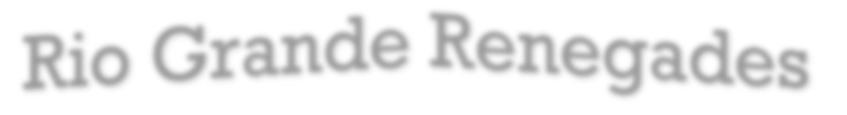





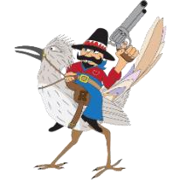
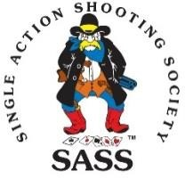

http://

RioGrandeRenegades

.org

Presents
Fall Fandango - September 18th – 20th 2026
The New Mexico State
Cowboy Action Shooting Championship
SASS Affiliated Event All SASS Rules Apply
Get your registration in today, Match is limited to 100 shooters
Fees include 10 stages, side matches, Fandango Feast & snacks, vendor booths, range fees, match fees, & insurance
The first 25 paid registrations will be entered into a special drawing.

Payment Received on or before… Aug 14th After Aug 15th
First Shooter in the Family | $105.00 | $115.00
Additional Family members at the same address | $85.00 | $95.00
Junior - Buckaroos & Buckarette’s | $15.00 | $15.00
Extra Fandango Feast | $20.00 | $25.00
Dry Camping (Lots of space) | Free | Free
Camping with Electric Hookup ($15/night)  (Limited availability) | Pay Range  Office | Pay Range Office
Wild Bunch side match (Friday afternoon) | $10.00 | $15.00
Ladies CAS Side Match. (Friday Morning) | $10.00 | $15.00
Canceling after 14 August refund less $25.00 per shooter.
Directions: I 40 West of ABQ to Atrisco Vista Blvd, Exit 149. Go north 4.2 miles to Shooting Range Road. Turn left (west), go 2.6 miles to Hayes City at CABQ Range.
Mail (a) Page 2 of this application(b) 2026 Release (Page 4) & (c) check payable to Rio Grande Renegades to:
Captain Jack Houston @ P.O. Box 5298 Albuquerque, NM 87185
Question? Email CLNORFOLK@MSN.com
Rio Grande Renegades is proud to announce that we will be a part of the Mayhem in the Rockies this year.

September 18th – 2oth 2026 Albuquerque Shooting Range Park

The first 25 paid registrations will be entered into a special drawing.

1st Shooter in Family** ________________________________________ SASS #_____________
Alias: ___________________________ Shooting Category: ________________________________
2nd Shooter** in Family __________________________________________ SASS #___________
Alias: ___________________________ Shooting Category: ________________________________
Is Shooter a member of the Albuquerque City Range pass program (Circle One) Yes or No
Wild Bunch
1st Shooter: Alias & Category: _____________________________________________________
2nd Shooter Alias & Category: ______________________________________________________
Home Club, City, State: ____________________________________________________________
Family Address: ___________________________________________________________________

City/State _____________________________ Zip ____________ Phone _____________________
__________________________ Your phone number (cell preferred) _______________________
Emergency Contact Name: __________________________________________________________
Emergency Contact (Cell phone preferred): __________________________________________
Email Address ____________________________________________________________________
Print legibly.
Please reserve dry camping spot for ____ days (free). Electric hookup camping spot is $15.00 per day and must be made at the Range Office
All SASS Rules Apply. http:// RioGrandeRenegades.org

Posse Request 1: __________________________ Posse Request 2:_____________________________

_____ I can be a Posse Marshal _____ I can be a Posse Deputy _____I am RO1 _____I am RO2 _____I can Volunteer

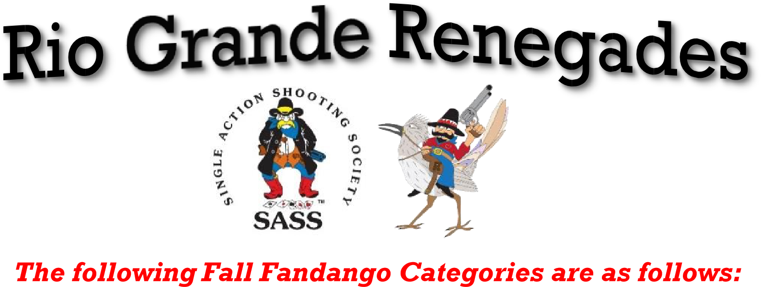

1. Buckaroo/Buckarette Junior Boy/Junior Girl | 2. Cowboy/Cowgirl
3. Wrangler/Lady Wrangler | 4. Forty-Niner/Lady Forty-Niner
5. Senior/Lady Senior | 6. Silver Senior/Lady Silver Senior
7. Elder Statesman/Grande Dame | 8. Cattle Baron/Cattle Baroness
9. El Patron/La Patrona | 10. Duelist/Lady Duelist
11.Gunfighter/Lady Gunfighter | 12. Classic Cowboy/Classic Cowgirl
13. Senior Duelist/Ladies Senior Duelist | 14. Silver Senior Duelist/Ladies Silver Senior Duelist
15. Frontier Cartridge/Lady Frontier Cartridge | 16. Frontier Cartridge Duelist/Lady FCD
17. Frontier Cartridge Gunfighter/Lady FCG | 18. Frontiersman/Lady Frontiersman
19. El Rey/La Reina | 20. B-Western/Lady B-Western
21. Shootist/Lady Shootist
WILD BUNCH | Circle One
Men’s Traditional | Ladies Traditional
Men’s Modern | Ladies Modern
Men’s Senior Traditional | Ladies Senior Traditional
Men’s Senior Modern | Ladies Senior Modern



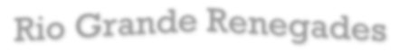






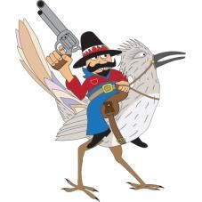

(Shooter/Observer) _________________________________________________________________________________________

SHOOTER

INFORMATION & RELEASE

(

Please Print Legibly

)

http://

RioGrandeRenegades

.org

General Release from Liability
Since the use of firearms is dangerous, we require all shooters and observers to assume all risk by reading, understanding, and signing this release.
I hereby acknowledge that I have voluntarily applied to participate in and/or observe the sport of cowboy action shooting and/or related activities.
AS LAWFUL CONSIDERATION of being permitted to enter upon the premises upon which the RIO GRANDE RENEGADES is conducted
and of being permitted to participate in or observe activities or otherwise, use the facilities, I, the undersigned, for my heirs, distributes, legal representatives, next of kin and assigns agree to the provisions set forth below.
I understand that I am participating in or observing a sport which contains dangers, and risks may arise, including but not limited to, accidental injury, the forces of nature and illness. In consideration of the right to participate in these events and the services provided for me by the RIO GRANDE RENEGADES and its agents, I have and do hereby assume the risks associated with such events.
As a contestant or observer, I shall, at my own expense, defend management and/or all members, employees, vendors, or sponsors, including the City of Albuquerque Shooting Range Park from any and all such claims and indemnity, from all liability, damage and costs of all claims for damages or indemnification arising from injuries to person or property occasioned by the act or omission of myself, the contestant or observer.

(Shooter/Observer)_________________________________________________________________________________________
Address: _________________________________________________________________________________________________
City: ____________________________________________________________________ State: ________ ZIP:_______________
Email: ___________________________________________@____________________________________________.__________
Phone (cell preferred): (_________) _________________-_________________________
Emergency Contact Name: _________________________________________________________________________________
Emergency Contact Phone (cell preferred): (________) _________________-___________________________
If signing on behalf of a Minor
Minor’s Name ____________________________________________________________________________________________
Relationship to Minor: _____________________________________________________________________________________
Releaser’s Name: _________________________________________________________________________________________
Signature: ________________________________________________________________ Date: ________________________
 Complete one signed and dated Release for each Shooter and Observer at the 2026 Fall Fandango.

