[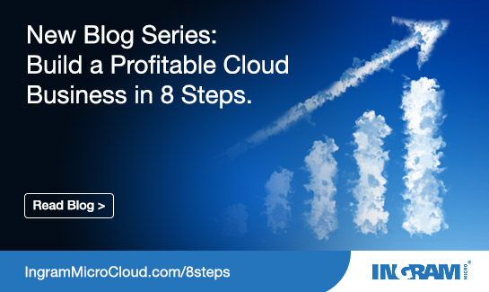](http://global.ingrammicrocloud.com/us/wp-content/uploads/sites/2/2017/03/545x325-soc-media-ad-blog-series-01.jpg)

**8 Steps to Help Channel Partners Build and Execute a Profitable Cloud Business**

**Posted by: Ingram Micro Cloud**

in [Thought Leadership](http://www.ingrammicrocloud.com/category/thought-leadership/), [Your Cloud Business](http://www.ingrammicrocloud.com/category/your-cloud-business/)

Tags: [Cloud Marketing](http://www.ingrammicrocloud.com/tag/cloud-marketing/), [cloud sales](http://www.ingrammicrocloud.com/tag/cloud-sales/), [marketing](http://www.ingrammicrocloud.com/tag/marketing/), [sales model](http://www.ingrammicrocloud.com/tag/sales-model/), [tips](http://www.ingrammicrocloud.com/tag/tips/)

**Overview**

Everybody wants to be in the cloud, right? Chances are your sales team is on the phone nearly every day with decision makers looking for cloud solutions for specific business challenges. So why are so many value added resellers (VARs) and managed services providers (MSPs) struggling with profitability and rising operational costs in an IT landscape where cloud is most definitely king?

Over the past decade, Ingram Micro has explored that question with the goal of helping our partners develop the best go-to-market plan for selling cloud services. We have found that there isn’t a single magic bullet, but rather eight steps based on best practices that add up to more successful cloud sales, marketing, profitability, and business growth. And over the next eight days, this blog will discuss each step to illustrate how the channel can capitalize on the growth opportunities in the cloud services market and accelerate their business.

**The following eight steps have been used at Ingram Micro to build and execute our own successful cloud marketing plan:**

1. [Build your solution](http://www.ingrammicrocloud.com/2017/03/28/step-1-build-your-solution/)
2. [Choose vendor partners](http://www.ingrammicrocloud.com/2017/03/28/step-2-choose-vendor-partners/)
3. [Develop a pricing model](http://www.ingrammicrocloud.com/2017/03/28/step-3-develop-pricing-model/)
4. [Establish KPIs as lead indicators](http://www.ingrammicrocloud.com/2017/03/28/step-4-establish-kpis/)
5. [Conduct financial planning and analysis](http://www.ingrammicrocloud.com/2017/03/28/step-5-financial-planning-analysis/)
6. [Build operational processes](http://www.ingrammicrocloud.com/2017/03/28/step-6-build-operational-processes/)
7. [Develop a marketing strategy](http://www.ingrammicrocloud.com/2017/03/28/step-7-develop-cloud-marketing-strategy/)
8. [Enable the sales team](http://www.ingrammicrocloud.com/2017/03/28/step-8-enable-sales-team/)

As you read each post, you’ll notice some common themes running throughout, such as the need to be proactive in cloud sales and marketing rather than reactive to every customer request. You’ll learn why it’s important to build a disciplined cloud sales model that aligns and scales with your business as it grows. Most of all, you’ll discover ways to gain optimal profitability from selling cloud services, as well as reduce operational costs.

Sound good? Then let’s get started with “[Step One: Build Your Solution.](http://www.ingrammicrocloud.com/2017/03/28/step-1-build-your-solution/)”

For more information about Ingram Micro Cloud’s channel partner program, visit [www.ingrammicrocloud.com/become-a-partner/](http://www.ingrammicrocloud.com/become-a-partner/).

[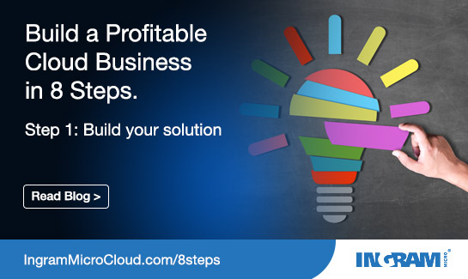](http://global.ingrammicrocloud.com/us/wp-content/uploads/sites/2/2017/03/545x325-soc-media-ad-blog-series-02.jpg)

**Step 1: Build Your Solution**

**Posted by: Ingram Micro Cloud**

in [Thought Leadership](http://www.ingrammicrocloud.com/category/thought-leadership/), [Your Cloud Business](http://www.ingrammicrocloud.com/category/your-cloud-business/)

Tags: [Cloud Marketing](http://www.ingrammicrocloud.com/tag/cloud-marketing/), [cloud sales](http://www.ingrammicrocloud.com/tag/cloud-sales/), [marketing](http://www.ingrammicrocloud.com/tag/marketing/), [sales model](http://www.ingrammicrocloud.com/tag/sales-model/), [tips](http://www.ingrammicrocloud.com/tag/tips/)

***This is part 1 of our 8-part blog series,*** [***8 Steps to Help Channel Partners Build and Execute a Profitable Cloud Business***](http://www.ingrammicrocloud.com/2017/03/28/overview-8-steps-profitable-cloud-business/)***.***

You can’t be everything to everybody when it comes to reselling cloud services – not if you want to grow your business, that is. In “Step One: Build Your Solution,” we’ll look at three “must do’s” when building your own scalable, disciplined cloud sales model:

**Pre-build for optimal profitability and drive operational support efficiency**

Saying “yes” to every customer’s need seems like the right thing to do, but don’t be reactive—you want to be proactive when selling cloud services. A customer may call and want a customized cloud solution, but it may be too difficult for your business to deliver technical resources cost effectively or scale for the future. The best way to optimize the profitability of cloud services is to proactively pre-build a solution and avoid customizing solutions for individual customers. By building your solution upfront, you can scale it up or down for every kind of customer need or number of users. In doing so, you’ll avoid unpleasant future surprises like escalating operational costs to support additional services or more users than planned.

**Determine on-premise conversion or focus on an organic solution**

Building a new cloud solution model from the ground up isn’t the only option. Many of our partners have sold software-and-server email solutions for many years and have grown their business in helping customers convert to cloud-hosted email solutions like Microsoft Outlook via Office 365 and others. Determine if you are already selling something you can convert to the cloud and if it makes good financial sense to do so. Or determine if you are going to offer a brand new solution—such as file sharing, for example. Just remember to focus on what you can sell with optimal profitability.

**Build for business outcomes and focus on vertical or horizontal markets**

The business outcomes of your cloud solution will be the key value-add in the minds of the decision makers rather than the bells and whistles of the technology. Again, don’t be everything to everybody. Focus on a certain market niche and build for it—whether it’s healthcare, human resources, sales and marketing, or any vertical or horizontal markets that align best with your business goals and capabilities. Build bundles of cloud solutions that deliver the best business outcomes to drive differentiation and predictable profit.

That’s not all. Here are some other important best practices to consider when building your cloud services solution:

* Conduct market research and analyze customer demand
* Determine on premise conversion or organic solution focus
* Factor technical and sales skills required
* Start with an anchor vendor for core solution and bundle complementary vendors
* Integrate professional and managed services to add value and margin
* Consider branding with anchor vendor, but white labeling the bundle

In the next post, we’ll look at “[Step Two: Choosing Your Vendor Partners](http://www.ingrammicrocloud.com/2017/03/28/step-2-choose-vendor-partners/).” Learn why it’s best to choose these partners after you build your solution, not before.

For more information about Ingram Micro Cloud’s channel partner program, visit [www.ingrammicrocloud.com/become-a-partner/](http://www.ingrammicrocloud.com/become-a-partner/).

[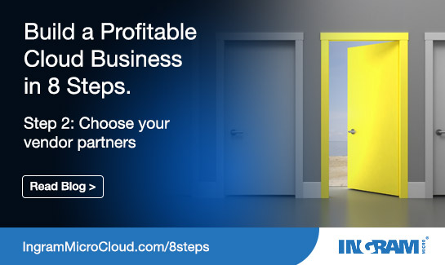](http://global.ingrammicrocloud.com/us/wp-content/uploads/sites/2/2017/03/545x325-soc-media-ad-blog-series-03.jpg)

**Step 2: Choose Your Vendor Partners**

**Posted by: Ingram Micro Cloud**

in [Thought Leadership](http://www.ingrammicrocloud.com/category/thought-leadership/), [Your Cloud Business](http://www.ingrammicrocloud.com/category/your-cloud-business/)

Tags: [Cloud Marketing](http://www.ingrammicrocloud.com/tag/cloud-marketing/), [cloud sales](http://www.ingrammicrocloud.com/tag/cloud-sales/), [marketing](http://www.ingrammicrocloud.com/tag/marketing/), [sales model](http://www.ingrammicrocloud.com/tag/sales-model/), [tips](http://www.ingrammicrocloud.com/tag/tips/)

***This is part 2 of our 8-part blog series,*** [***8 Steps to Help Channel Partners Build and Execute a Profitable Cloud Business***](http://www.ingrammicrocloud.com/2017/03/28/overview-8-steps-profitable-cloud-business/)***.***

A lot of partners make the mistake of picking the vendors first and then coming up with a solution to sell. Ingram Micro advises to do the exact opposite. Build your best go-to-market cloud solution and know exactly what you’re going to sell and to what markets, and then choose the best vendor partners to help you deliver the business outcomes your customers expect. Consider the following top three best practices when you’re ready to plug vendors into your cloud services solution:

**Consider relationship and channel strategy**

Instead of blindly choosing vendors based on what the customer has asked for, be sure you understand what those vendors are doing in the channel. What is their channel strategy and how will that affect your relationship to other vendors and your customers? In addition, consider how well you know the vendor and their reputation. Can you count on them to deliver what you need to derive optimum profitability from cloud sales?

**Conduct financial and technical due diligence**

Take the time to do the due diligence to ensure that the vendors you choose are financially viable. You want to work with partners who will continue to invest in the growth of their own business and have no restraints on access to funding. Also, are they technically able to do what they promise to do? In the end, you want to make sure that you, the vendors, and your customers all feel comfortable working together in a trusted relationship.

**Know service delivery requirements and support resources**

Make sure you know how you will operate with your vendors on a day-to-day basis before you sign on the bottom line. Determine who does what during the sales process and in post-sales support. For example, will this vendor expect you to take Level 1 support calls? If you want to do that, fine, but providing that level of support may not align operationally with your business.

But don’t stop there. You should also consider taking the following actions to ensure that you select vendors who will enhance the value of your cloud offerings and can scale up or back as required:

* Understand available partner programs and resources
* Learn the competitive landscape and positioning
* Consider integrations and ecosystem partners
* Validate operational requirements and automation
* Review contract terms and service level agreements
* Understand cost basis and discounts
* Select partners based on their ability to change vendors
* Partner with an aggregator based on value and cost savings

Next we’ll look at developing pricing for your cloud services model and how automation plays a key role in keeping operational costs down. [Read the next post](http://www.ingrammicrocloud.com/2017/03/28/step-3-develop-pricing-model/).

For more information about Ingram Micro Cloud’s channel partner program, visit [www.ingrammicrocloud.com/become-a-partner/](http://www.ingrammicrocloud.com/become-a-partner/).

[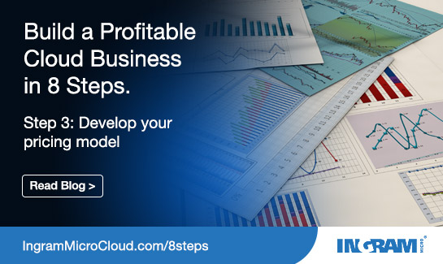](http://global.ingrammicrocloud.com/us/wp-content/uploads/sites/2/2017/03/545x325-soc-media-ad-blog-series-04.jpg)

**Step 3: Develop Your Pricing Model**

**Posted by: Ingram Micro Cloud**

in [Thought Leadership](http://www.ingrammicrocloud.com/category/thought-leadership/), [Your Cloud Business](http://www.ingrammicrocloud.com/category/your-cloud-business/)

Tags: [Cloud Marketing](http://www.ingrammicrocloud.com/tag/cloud-marketing/), [cloud sales](http://www.ingrammicrocloud.com/tag/cloud-sales/), [marketing](http://www.ingrammicrocloud.com/tag/marketing/), [pricing models](http://www.ingrammicrocloud.com/tag/pricing-models/), [tips](http://www.ingrammicrocloud.com/tag/tips/)

***This is part 3 of our 8-part blog series,*** [***8 Steps to Help Channel Partners Build and Execute a Profitable Cloud Business***](http://www.ingrammicrocloud.com/2017/03/28/overview-8-steps-profitable-cloud-business/)***.***

When it comes to pricing, the bottom line is to think about the future. How easily and cost effectively can you manage the operation of your cloud solution — and how can you cut the operational costs of manual processes by automating invoicing, provisioning, purchasing, subscription management, and reporting? It all starts with building a scalable cloud solution in [Step One](http://www.ingrammicrocloud.com/2017/03/28/step-1-build-your-solution/) that will align with your business growth and revenue goals. Here are two key best practices to help you ensure that the price is right:

**Understand your cost basis**

You need to understand what your cloud solution will really cost before you can price it. It’s a red flag if you are basing the cost of your solution only on what you are paying for the basic technology. Be sure to factor in the cost of doing business with your partners, operational costs for management and provisioning of services.

**Consider operational costs and automation benefits and model for future scale**

These two best practices go hand in hand in creating a cloud model for optimized profitability. One of the biggest mistakes a partner can make is building a solution that is not scalable for future growth and change. Not automating certain operational processes is another red flag. Often a partner will price their solution without realizing all of the operational “touch costs” that can escalate and eat up profits. For example, if your cloud solution has five vendors, you may need one or two extra full-time staff just to provision and manage each service each month, plus deal with invoicing and other paperwork from hundreds — maybe thousands — of end users. Automating these manual processes can reduce operational costs and add to the profitability of cloud sales.

Other things to consider when developing your pricing model are:

* Utilize value-based pricing methodology
* Research market price for anchor vendor
* Factor expenses related to services delivery costs
* Leverage volume discounts
* Develop promotions and trials
* Consider volume pricing tiers

You’ve built a scalable cloud solution, chosen the right vendors, and have a pricing model in place that can adapt to future changes. What’s next? Read on for [Step 4](http://www.ingrammicrocloud.com/2017/03/28/step-4-establish-kpis/), where we’ll discuss the advantage of establishing KPIs to help you best determine — and meet — your revenue goals for cloud sales.

For more information about Ingram Micro Cloud’s channel partner program, visit [www.ingrammicrocloud.com/become-a-partner/](http://www.ingrammicrocloud.com/become-a-partner/).

[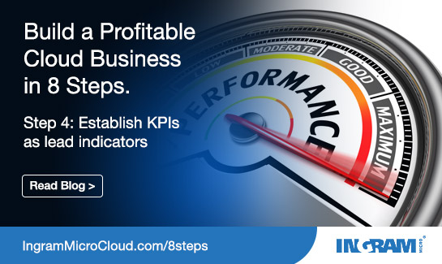](http://global.ingrammicrocloud.com/us/wp-content/uploads/sites/2/2017/03/545x325-soc-media-ad-blog-series-05.jpg)

**Step 4: Establish KPIs as Lead Indicators**

**Posted by: Ingram Micro Cloud**

in [Thought Leadership](http://www.ingrammicrocloud.com/category/thought-leadership/), [Your Cloud Business](http://www.ingrammicrocloud.com/category/your-cloud-business/)

Tags: [Cloud Marketing](http://www.ingrammicrocloud.com/tag/cloud-marketing/), [cloud sales](http://www.ingrammicrocloud.com/tag/cloud-sales/), [KPIs](http://www.ingrammicrocloud.com/tag/kpis/), [marketing](http://www.ingrammicrocloud.com/tag/marketing/), [tips](http://www.ingrammicrocloud.com/tag/tips/)

***This is part 4 of our 8-part blog series,*** [***8 Steps to Help Channel Partners Build and Execute a Profitable Cloud Business***](http://www.ingrammicrocloud.com/2017/03/28/overview-8-steps-profitable-cloud-business/)***.***

$1,000,000 – or any number that aligns with your cloud sales strategy – sounds like a great revenue goal, but how will you get there? It’s not a good strategy to pull a number out of thin air without an actionable plan. Here are several best practices for partners that focus on establishing key performance indicators (KPIs) for achieving – and even exceeding – your cloud sales goals:

**Develop a financial plan based on KPIs**

A financial plan driven by KPIs can give you the best understanding on how to reach your cloud revenue goal. For example, consider how many deals, the size of the average deal, and the average number of deals closed per month to reach that goal. Overall, taking a KPI-based approach makes it easier to manage revenue targets because the KPIs are the only variables that you can change, while your dollar figure remains the same.

**Focus on measurable and actionable KPIs**

Actions speak louder than words – or numbers in the case of building your cloud revenue goals upon KPIs. The following KPIs are great examples of measurable and actionable indicators that you can mix and match according to your cloud sales strategy. In any combination, actionable KPIs will lead you in the right direction to optimal profitability:

* Number of leads per month
* Lead conversion rate
* Win rate
* Number of wins
* Average deal size
* Number of calls per lead
* Number of calls per opportunity
* Cost per lead
* Cost per associate
* Attrition rate

**Roll out a tracking system and scorecard for the KPIs**

Tracking is as easy as picking a couple of KPIs and doing the math. Let’s say you get a couple hundred leads per month and you convert 10% of those. One hundred leads provides up to 10 sales opportunities. If you win 33% of those opportunities, you win three deals, and if the average deal size is $1,000, you sold $3,000 that month. Even in this simplistic example, you can see how tracking KPIs is an effective and real-world method for planning cloud sales revenue numbers.

A KPI scorecard goes hand-in-hand with tracking KPIs in helping you see how your sales performance is affecting your cloud revenue goal month-to-month. For example, compare your actual results against your set KPIs. Did you reach your goal of 100 leads per month, or was it fewer, or more? The advantage of using KPIs as lead indicators is that you can easily adjust the actions they represent from month-to-month – even mid-month – if you see you’re not on track. Let’s say you exceeded your goal and gained 140 leads in a month and you want to challenge yourself to get 140 next month, too. Just look at your KPI scorecard and make adjustments that are actionable.

Without establishing KPIs as lead indicators, you’re only guessing and wondering why if you are not meeting your cloud revenue goal. When you track and score KPIs you can get down to the real numbers – and then make real changes to make that $1,000,000 goal a reality.

**Here are additional best practices that you can incorporate into KPI tracking and scoring:**

* KPIs become the lead indicators used to execute the plan
* Build a model using KPIs as variables
* Make sure your KPIs are reasonable and achievable yet challenging!
* Use industry averages if you do not have historical reporting specific to your business

In our [next blog post](http://www.ingrammicrocloud.com/2017/03/28/step-5-financial-planning-analysis/), we’ll look at how your KPI-based financial plan will help you get your executive leadership team on board to approve and support your cloud sales model.

For more information about Ingram Micro Cloud’s channel partner program, visit [www.ingrammicrocloud.com/become-a-partner/](http://www.ingrammicrocloud.com/become-a-partner/).

[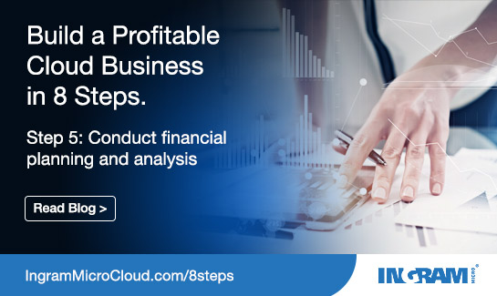](http://global.ingrammicrocloud.com/us/wp-content/uploads/sites/2/2017/03/545x325-soc-media-ad-blog-series-06.jpg)

**Step 5: Financial Planning and Analysis**

**Posted by: Ingram Micro Cloud**

in [Thought Leadership](http://www.ingrammicrocloud.com/category/thought-leadership/), [Your Cloud Business](http://www.ingrammicrocloud.com/category/your-cloud-business/)

Tags: [Cloud Marketing](http://www.ingrammicrocloud.com/tag/cloud-marketing/), [cloud sales](http://www.ingrammicrocloud.com/tag/cloud-sales/), [financial planning](http://www.ingrammicrocloud.com/tag/financial-planning/), [marketing](http://www.ingrammicrocloud.com/tag/marketing/), [tips](http://www.ingrammicrocloud.com/tag/tips/)

***This is part 5 of our 8-part blog series,*** [***8 Steps to Help Channel Partners Build and Execute a Profitable Cloud Business***](http://www.ingrammicrocloud.com/2017/03/28/overview-8-steps-profitable-cloud-business/)***.***

You’ve built a cloud sales financial plan based on KPIs, reviewed it, and you’re satisfied with it. Your sales team is ready to dive in and get started. But is everyone on the leadership team on board? Here are some key best practices to help ensure that your KPI-based financial plan will be successful and embraced by executive management:

**Do not adjust results – adjust the KPIs that create results**

This best practice deems repeating from Step 4 because it shows the leadership team that you’re serious about optimizing profitability for cloud sales. If your previous cloud sales reached $700,000, but you’re increasing that goal to $1,000,000, you need to do more than just write down the new number on next quarter’s projections. Look at the KPIs that got you to $700,000 and determine what you need to change to reach $1,000,000. You can’t just say you want more profit – but you can create the results you want by adjusting your KPIs as lead indicators.

**Plan for investments and funding sources**

Reselling cloud services is an investment in the business. There’s an old adage – which in this case is true – that you need to spend money to make money. And that’s another reason to get executive buy-in on your cloud financial plan upfront. Determine your funding sources and be ready to show executive management how your cloud sales will generate a return on that investment. Will the money come from the core legacy business, from outside investment sources or personal wealth? Or perhaps outside vendor investments? Regardless of the funding source, be ready to present your best go-to-market plan for cloud sales.

**Secure executive commitment based on your financial plan**

So how can you convince executive management that selling cloud services is a great and profitable idea? Every step you’ve completed up until now – from building your cloud solution, to pricing, to developing a KPI-based financial plan – will help to make your case for investing in the cloud. In addition, management should be aware that transitioning from older, on-premise technology to the cloud will probably interrupt cash flow, at least temporarily, so you need to be prepared to show the CFO how the business will survive during that transition. Most of all, not just the CFO, but everyone from the CEO, VP of Marketing, VP of Sales, on down needs to understand and buy off on your cloud financial plan, your revenue goals and how you’re going to get there – before you launch your cloud sales model. Otherwise, you’re looking at problems and obstacles down the road.

It’s a good idea to also consider these best practices when presenting your cloud sales model to your leadership team:

* Review the financial output of the plan
* Make sure it meets ROI expectations
* Review short term, long term, and trending
* Understand cash flow impact
* Conduct risk assessment and develop mitigation plan

Now that you have executive buy-in, it’s time to look at the operational aspects of making your cloud sales model a success. Our [next blog post](http://www.ingrammicrocloud.com/2017/03/28/step-6-build-operational-processes/) will talk about best practices for scaling, automating, and tracking operational processes for optimal cloud sales.

For more information about Ingram Micro Cloud’s channel partner program, visit [www.ingrammicrocloud.com/become-a-partner/](http://www.ingrammicrocloud.com/become-a-partner/).

[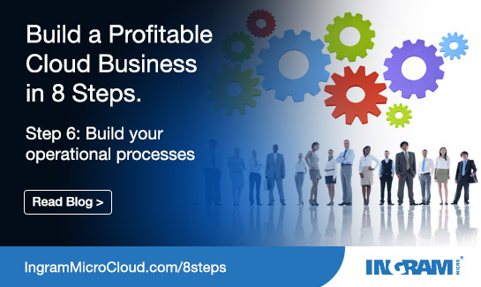](http://global.ingrammicrocloud.com/us/wp-content/uploads/sites/2/2017/03/545x325-soc-media-ad-blog-series-07.jpg)

**Step 6: Build Operational Processes**

**Posted by: Ingram Micro Cloud**

in [Thought Leadership](http://www.ingrammicrocloud.com/category/thought-leadership/), [Your Cloud Business](http://www.ingrammicrocloud.com/category/your-cloud-business/)

Tags: [Cloud Marketing](http://www.ingrammicrocloud.com/tag/cloud-marketing/), [cloud sales](http://www.ingrammicrocloud.com/tag/cloud-sales/), [marketing](http://www.ingrammicrocloud.com/tag/marketing/), [operations](http://www.ingrammicrocloud.com/tag/operations/), [tips](http://www.ingrammicrocloud.com/tag/tips/)

***This is part 6 of our 8-part blog series,*** [***8 Steps to Help Channel Partners Build and Execute a Profitable Cloud Business***](http://www.ingrammicrocloud.com/2017/03/28/overview-8-steps-profitable-cloud-business/)***.***

You’ve come a long way since building your cloud solution, picking your vendors, developing your KPI-based financial plan, and getting executive buy-in. But this is where many VARs make the mistake of thinking they’re done with making changes to the sales model and their business. Instead, this is a critical point where you need to keep moving forward. You need to make some changes in the way you sell cloud services. Here are more best practices to help you do it right:

**Determine a customer contracting process for cloud (master services agreement)**

With traditional IT sales you’ve been able to work on a project basis where you pull resources and make investments as needed for winning each deal. Selling the cloud is different. It requires recurring, ongoing service delivery with specific operational processes, and if you don’t plan the customer contracting process properly at the beginning it can hurt your profitability down the road. Instead of scaling your business to each customer – which can be problematic in many ways – have a master services agreement in place that covers all the cloud services you purchase and sell. That’s the way to ensure predictable and optimal profitability for cloud sales.

**Choose a scalable automation platform**

Some VARs make the mistake of skipping the step of creating a scalable automation platform and service delivery tool. A lot of times they don’t want to invest in it and try to find an alternative “back door” way to manage subscription provisioning, invoicing, and other key operational processes. But they soon find out that it becomes more expensive to manage all of those multiple services and processes manually as they offer additional cloud services and the customer base grows. So don’t underestimate how difficult it may be to manage your customers’ operational requirements as your business grows. Consider investing in a partner or a software automation platform that does all of it for you. Ingram Micro has built its cloud business based on an automated platform and our customers can leverage our investments to support their efforts.

**Implement service delivery tools**

Service delivery is at the core of customer satisfaction in cloud services sales. Make an investment up front in the right service delivery tools and use them to drive your business. Think ahead when selecting these tools. You may have 10 customers today and 1,000 five years down the road. It is difficult and expensive to change service delivery tools, so once again the scalability factor comes into play when determining the best operational processes to support cloud sales.

**Develop a reporting and financial tracking process**

Continue the KPI-based tracking that we discussed in Steps 4 and 5 and combine it with automated reporting processes for key areas like financials, KPIs, customer on-boarding and training. Consider starting with a platform that automates the tracking and reporting of purchasing, provisioning, subscription management, as well as invoicing.

In addition, consider these best practices which also focus on automating processes that enable you to serve customers efficiently:

* Understand A/P and A/R requirements
* Outline customer onboarding and training process
* Determine post-sale support process
* Establish vendor management plan and resources
* Design quality assurance process

Next, [Step 7](http://www.ingrammicrocloud.com/2017/03/28/step-7-develop-cloud-marketing-strategy/) in our series on improving VAR profitability for cloud sales will focus on the all-important marketing strategy – and it’s not your grandfather’s word-of-mouth approach.

For more information about Ingram Micro Cloud’s channel partner program, visit [www.ingrammicrocloud.com/become-a-partner/](http://www.ingrammicrocloud.com/become-a-partner/).

[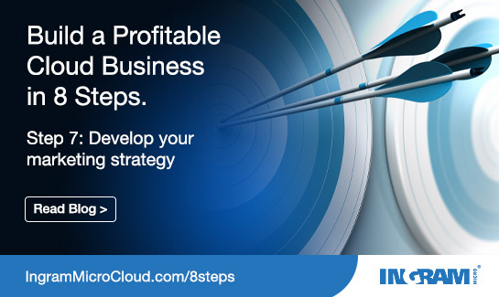](http://global.ingrammicrocloud.com/us/wp-content/uploads/sites/2/2017/03/545x325-soc-media-ad-blog-series-08.jpg)

**Step 7: Develop Your Cloud Marketing Strategy**

**Posted by: Ingram Micro Cloud**

in [Thought Leadership](http://www.ingrammicrocloud.com/category/thought-leadership/), [Your Cloud Business](http://www.ingrammicrocloud.com/category/your-cloud-business/)

Tags: [Cloud Marketing](http://www.ingrammicrocloud.com/tag/cloud-marketing/), [cloud sales](http://www.ingrammicrocloud.com/tag/cloud-sales/), [marketing](http://www.ingrammicrocloud.com/tag/marketing/), [strategy](http://www.ingrammicrocloud.com/tag/strategy/), [tips](http://www.ingrammicrocloud.com/tag/tips/)

***This is part 7 of our 8-part blog series,*** [***8 Steps to Help Channel Partners Build and Execute a Profitable Cloud Business***](http://www.ingrammicrocloud.com/2017/03/28/overview-8-steps-profitable-cloud-business/)***.***

“We do word of mouth marketing. We have a ton of customers and we stay busy all the time.”

That kind of marketing strategy might have been just fine for reselling traditional IT products, but it’s not good enough for the cloud. Today, you need to reach many new types of decision makers – technical and non-technical – with a new story to tell about your cloud services solution. Many of these decision makers may not know who you are, or even know that you are now in the business of cloud services. It’s time to adopt the following best practices for marketing your business as a cloud provider:

**Target new buyers and lines of business with digital marketing**

Selling cloud services is a great way to attract new customers and fuel growth. As you expand your customer base with new cloud customers, you can sell existing customers on converting hardware-based IT solutions to the cloud – resulting in growth and success. Digital marketing is one of the best marketing tools you can use to target and reach buyers of cloud services. These buyers have done their research online, and your goal is to be a part of that research and education at multiple touchpoints on the Web.

**Focus on market education and thought leadership**

Enhance your use of digital marketing by positioning your business as a cloud expert. Have your top people publish white papers, host webinars, speak at conferences that are streamed on the Web. Build a reputation as a cloud expert who not only provides market education, but who is also a thought leader who can help customers advance their business. Also, leverage the cloud technology you sell to drive traffic to your website, tap into social media, launch email blasts, and get the word out that your VAR sales team are experts on the cloud and have the best-in-class cloud solution. You’ll soon have people talking about your business and talking to your sales team.

**Track your leads as you execute them and adjust your master lead catalog and monthly plan based on real results**

First, tie this practice to understanding your monthly lead requirements in your KPI-based financial plan. Then create a master catalog of marketing activities. As you track and execute your leads, you can increase the marketing activities in the master catalog that are helping you meet your lead goals, or scale back on those that are not getting a good response, just as you adjust your KPIs with your financial goals. In addition, meet with your marketing and sales teams and brainstorm new ideas to add to your master catalog. Talk about how your company can be a thought leader on social media. And be sure to track results from social media, or from leads generated through webinars and events. Are you using search engine optimization (SEO) key words to drive more people to your website? Why not tap into your company’s own business intelligence to determine which prospects are the most likely to want cloud services? The sky’s the limit when marketing cloud services, so don’t hold back.

Here are some more best practices that will help you develop a strong cloud marketing strategy:

* Estimate the number of leads and costs for each activity
* Align costs with expected cost in the KPI plan
* Activities must be quantified and actionable
* Identify funding sources

In our next post, we’ll conclude with the [eighth and final step](http://www.ingrammicrocloud.com/2017/03/28/step-8-enable-sales-team/) in this strategy to help optimize profitability of cloud services sales. You’ll learn how to enable and motivate your sales team to become proactive sellers of cloud services rather than just reacting to customer requests.

For more information about Ingram Micro Cloud’s channel partner program, visit [www.ingrammicrocloud.com/become-a-partner/](http://www.ingrammicrocloud.com/become-a-partner/).

[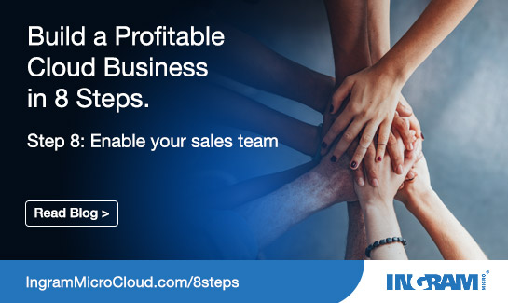](http://global.ingrammicrocloud.com/us/wp-content/uploads/sites/2/2017/03/545x325-soc-media-ad-blog-series-09.jpg)

**Step 8: Enable Your Sales Team**

**Posted by: Ingram Micro Cloud**

in [Thought Leadership](http://www.ingrammicrocloud.com/category/thought-leadership/), [Your Cloud Business](http://www.ingrammicrocloud.com/category/your-cloud-business/)

Tags: [Cloud Marketing](http://www.ingrammicrocloud.com/tag/cloud-marketing/), [cloud sales](http://www.ingrammicrocloud.com/tag/cloud-sales/), [marketing](http://www.ingrammicrocloud.com/tag/marketing/), [sales team](http://www.ingrammicrocloud.com/tag/sales-team/), [tips](http://www.ingrammicrocloud.com/tag/tips/)

***This is the final post in our 8-part blog series,*** [***8 Steps to Help Channel Partners Build and Execute a Profitable Cloud Business***](http://www.ingrammicrocloud.com/2017/03/28/overview-8-steps-profitable-cloud-business/)***.***

In the old sales model before the cloud, customers told Sales what they wanted, and then Sales had it built or found a partner to provide it. But as we’ve discussed in the previous seven steps, you can’t achieve an effective cloud sales model if you are constantly reacting to every customer need. You need to first build a scalable cloud solution, develop a KPI-based financial plan, adopt automated operational processes, and launch a new digital marketing strategy — and only then train the sales team on how to take cloud services to market and convert solid leads to business wins. Here are the key best practices for enabling your sales team to get on board and optimize the profitability of cloud sales:

**Adjust your compensation and incentive plan**

Your sales team is highly motivated to sell a $10,000 software and server hardware solution for email, but now you expect them to also sell a $500 per month subscription to cloud-based email. Guess which solution the salesperson will present to the customer first? The one that pays them faster. So make sure your cloud sales compensation and incentive program pays them as fast as any alternative ways to deliver the solution. Cloud solutions are not monetized in the way that traditional IT is sold, so you have to adjust your compensation plan to excite and motivate your team to sell more cloud services.

**Conduct business outcome training to help Sales engage non-IT decision makers**

Remember that being a thought leader in the cloud marketplace is a best practice for attracting new customers and converting others to the cloud. So give your sales team the training to gain more business acumen and cloud expertise to strengthen their sales pitch. Research shows that nearly 70% of cloud decisions are made by non-IT decision makers. So train your people to guide non-IT prospects through the process of understanding the business outcome benefits of the cloud for their company.

**Design an engagement process to drive consumption**

Motivate your sales team to constantly engage customers to ensure that they are getting the full benefits of the cloud and understand how to use the solution to the advantage of their business. This proactive engagement approach helps to ensure that customers will stay with the service and perhaps activate additional features and functions that could generate additional cloud sales revenue.

Here are seven more best practices for motivating your sales team to sell more cloud services:

* Provide training for overall cloud value and financial acumen
* Deliver solution and technical training
* Communicate pipeline management and forecasting process
* Outline pre-sales opportunity support process
* Develop up-sell / cross-sell process
* Determine customer business review process
* Develop customer experience and win back process

**Next step: Get started with your cloud sales model**

Maybe it’s time to add cloud services to your VAR sales portfolio — or increase your existing cloud sales revenue. Ingram Micro can help you build the best go-to-market cloud sales model that aligns with your business. We’ll show you how to take these eight best practice action steps and make them a reality. Most of all, we can help you fulfill all of the cloud services sales you’ll be making if you join us an Ingram Micro VAR partner. Contact us today and find out how to get started.

For more information about Ingram Micro Cloud’s channel partner program, visit [www.ingrammicrocloud.com/become-a-partner/](http://www.ingrammicrocloud.com/become-a-partner/).